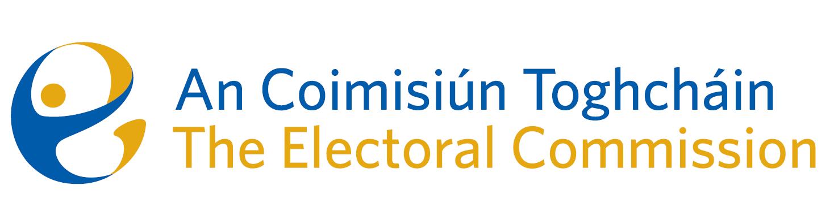

Minutes

Meeting of An Coimisiún Toghcháin

8.00am – 10:00am | 19 March 2026 | Dublin Castle

Attendance
An Coimisiún:
The Honourable Ms. Justice Marie Baker (Chairperson), John Curran (JC), Ger Deering (GD), Elaine Gunn (EG) and Maura Quinn

Executive:
Diane Duggan (DD)- Legal, Seán Garvey (SG)- Supervision and Enforcement, Karen Kehily (KK) – Corporate Services, Muireann Ní Thuairisg, (Secretariat)
Eunice Delaney, Electoral Research and Integrity – Item 2
Claire Lowney – Communications – Item 2

Apologies: Art O’Leary, Chief Executive, Dr Mary-Clare O’Sullivan, Electoral Research and Integrity, Kieran Lenihan, Electoral Operations and Education

  - Draft Minutes

The draft minutes of the meeting held on 12 February 2026 were agreed.

It was agreed that a single set of minutes would be prepared for all meetings related to the ongoing appeal to the Registrar of Political Parties.

  - Matters Arising

One amendment was proposed and agreed regarding the Matters Arising and Actions List.

  - Conflict of Interest

There were no conflicts of interest.

2.1 Transparency and Targeting of Political Advertising (TTPA) Update

Members discussed the latest updates on Transparency and Targeting of Political Advertising.
4 TTPA webinars have been scheduled to take place on 25th and 26th March, including an in-person session at Leinster House. Registration links will be circulated to members.

Members were updated on a complaint regarding an alleged breach of TTPA. A report on the matter will be considered by An Coimisiún at their next meeting on 16 April.

Due to SG’s retirement in April, the newly recruited staff member will assume the role of authorised officer pursuant to the political advertising regulations.

3.1 Political Finance

Commission members discussed a document circulated in advance of the meeting entitled ‘Reforming Ireland’s Political Finance Regime’ which included 2 options for An Coimisiún to consider – (i) Public Briefing & Proposal for Consultation an (ii)
Option 2: Letter to Minister.

It was agreed to hold a meeting with Professor Oonagh Breen to discuss the matter in greater detail. It was also agreed the Chairperson will contact the Chairperson of SIPO, to have a preliminary discussion on the work of SIPO and will give an update at the next meeting.

4.1 Post Electoral Events Review

ED gave an overview of the Post Electoral Event Review for the Presidential Election in 2025.

Subject to 2 minor amendments, members agreed the report and expressed their gratitude to MCOS, ED and the team for their work on the report.

5.1 Bye-election campaign

It was agreed that the presentation on the bye-election campaign would be circulated to members, who are welcome to email any feedback or observations.

6.1 Subcommittee Terms of Reference

It was agreed that the ICT Subcommittee and Governance Subcommittee terms of reference would be circulated to members, who are welcome to email any feedback or observations.

7.1 Any Other Business

The term of membership for Prof Caroline Fennell and Alex Attwood concluded on 8 February 2026. The executive is seeking clarification on the matter of reappointment.

The Chairperson informed members of her participation in the ODIHR Election Observation Mission in Hungary in April 2026 alongside BD. As the mission coincides with the next meeting of An Coimisiun Toghcháin, the Chair will attend the meeting remotely and the meeting will be chaired by MQ.

_________________
Ms. Justice Marie Baker
Chairperson

