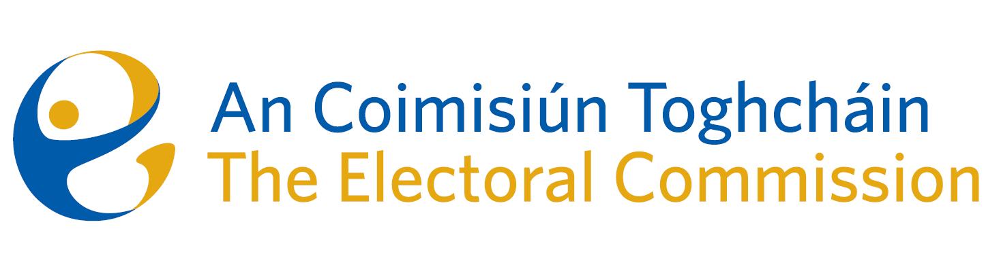

Minutes

Meeting of An Coimisiún Toghcháin

8.00am – 10:00am | 16 April 2026 | Dublin Castle

Attendance
An Coimisiún:
- The Honourable Ms. Justice Marie Baker (MB) (Chairperson) (joined virtually)
- John Curran
- Ger Deering
- Maura Quinn (MQ)

Apologies:
- Elaine Gunn

Executive:
- Art O’Leary (AOL) - Chief Executive
- Diane Duggan (DD)-Head of Legal
- Karen Kehily (KK) – Corporate Services
- Kieran Lenihan, Head of Electoral Operations and Education
- Dr Mary-Clare O’Sullivan, Head of Electoral Research and Integrity
- Sarah Keaveney, Operations and Education
- Dáithí Mac Suibhne (DMS)- Regulator, Political Advertising, Supervision and Enforcement
- Muireann Ní Thuairisg, Secretariat

- Welcome
MQ chaired the meeting, and MB joined the meeting virtually as she was participating in the ODIHR electoral observation mission in Hungary.

  - Draft Minutes

The draft minutes of the meeting held on 19 March 2026 were agreed.

  - Matters Arising

There were no matters arising.

  - Conflict of Interest

There were no conflicts of interest.

2.1 Commission Membership

Commission members (with AOL and KK) discussed the membership of the Commission, including the recruitment of 2 new members who are expecting to join shortly.

3.1 Transparency and Targeting of Political Advertising (TTPA) Update

- Warrant of Appointment

The warrant of appointment to appoint DMS as authorised officer pursuant to the political advertising regulations was signed and sealed by MQ and AOL.

- Update on Complaint

Members received an update on a complaint regarding an alleged breach of TTPA. It was agreed An Coimisiún will consider a draft decision on the complaint at the meeting in May. An Coimisiún were supported in their discussions with circulated TTPA initial procedures and a TTPA enforcement guide

  - Governance

- Printing contract approval

In accordance with internal procurement policy thresholds, An Coimisiún are required to approve contracts over €1m. An Coimisiún were asked to review the competitive procurement process that was carried out to select a successful tender from the open competition for a print contractor. The process was reviewed and the Commission approved the signing of the contract.

- ICT Subcommittee Terms of Reference
- Governance Subcommittee Terms of Reference

The Terms of Reference were approved in draft form, with a view to formal approval at a future meeting. It was agreed that this item would be included on the agenda for a subsequent meeting once new Commission members are appointed.

5.1 Corporate Update

- Corporate Dashboard

Commission members reviewed the corporate dashboard for January – March 2026, including an overview on finance, strategic priorities, procurement, human resources, learning and development and governance.

- Audit and Risk Committee (ARC) report to the Commission including ARC Annual Report

Members noted the report of the Audit and Risk meeting which took place on 9 March 2026 and the 2025 ARC annual report.

- Schedule of matters 2026

Members noted the formal schedule of matters for Commission meetings in 2026, acknowledging that the document is a live schedule and will be updated in line with the An Coimisiún’s priorities.

6.1 Political Finance

Commission members discussed documents originally circulated for the previous meeting - ‘Reforming Ireland’s Political Finance Regime’ which included 2 options for An Coimisiún to consider – (i) Public Briefing & Proposal for Consultation an (ii)
Option 2: Letter to Minister. The discussion was informed by the contributions by Dr. Oonagh Breen, Professor of Law, UCD at an information session held on 15 April.

The recommendations set out by DD in a subsequent note to An Coimisiún were approved and the matter will be discussed again at the next meeting in May.

7.1 Research programme update

An Coimisiún were provided with an update on the Research Programme.

Postering research has been completed and will be considered by members at the next meeting in May. The report and a summary of submissions will be circulated in advance of the meeting to give members time to consider the report.

8.1 Education Update

An Coimisiún were provided with an update on education, including working group 3 Groups Experiencing Barriers and working group 4, General Public. Members were updated on the process, including public submissions received from a broad range of stakeholders, common themes and the recommendations arising from the working groups.

9.1 Any Other Business

Commission members were informed of correspondence received regarding the accuracy of the electoral register in Dublin South Central. The matter has been referred to Dublin City Council and An Garda Síochána.

_________________
Ms. Justice Marie Baker
Chairperson

