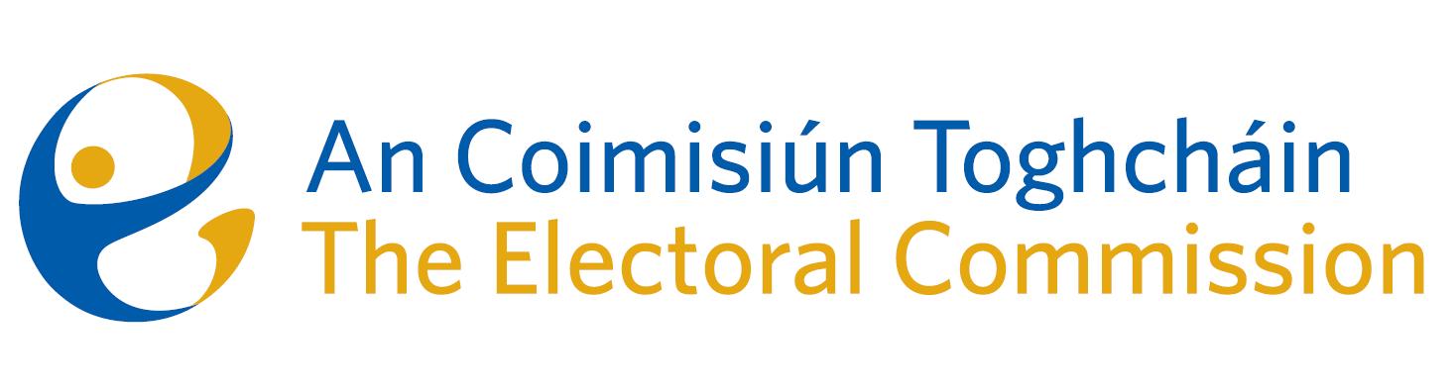

Draft Minutes

Meeting of An Coimisiún Toghcháin

8.00am – 10:00am | 21 May 2026 | Dublin Castle

Attendance

An Coimisiún:
- The Honourable Ms. Justice Marie Baker (MB) (Chairperson)
- John Curran
- Ger Deering
- Elaine Gunn
- Maura Quinn

Executive:
- Art O’Leary - Chief Executive
- Diane Duggan-Head of Legal
- Karen Kehily (KK) – Corporate Services
- Kieran Lenihan, Head of Electoral Operations and Education
- Dr Mary-Clare O’Sullivan, Head of Electoral Research and Integrity
- Dr Adam Whittle, Research and Integrity
- Dáithí Mac Suibhne- Regulator, Political Advertising, Supervision and Enforcement
- Muireann Ní Thuairisg, Secretariat

In attendance:
- Dr. Eoin O’Malley and Dr. Dawn Wheatley, Dublin City University – Item 2

- Welcome
The Chair welcomed everyone to the meeting.

  - Draft Minutes

The draft minutes of the meeting held on 16 April 2026 were agreed.

  - Matters Arising

There were no matters arising.

  - Conflict of Interest

There were no conflicts of interest.

2.1 Postering Research Presentation and Discussion

Dr. Eoin O’Malley and Dr. Dawn Wheatle of Dublin City University gave a presentation to members on the research report, ‘Election posters- practices, attitudes and impact -research report’.

Members were also provided with a background paper, ‘Postering: summary of the submissions to the public consultation’. The public consultation resulted in 1,104 submissions, and a summary report of these submissions will also be published alongside the Research Report and the Recommendations paper.

Members discussed the research report and agreed to review a draft of the recommendations on election postering, which is to be circulated shortly, and to provide comments or feedback prior to submission to the Minister.

3.1 Transparency and Targeting of Political Advertising (TTPA)

Members received an update on alleged breaches of TTPA and the levels of compliance with TTPA among the Dublin Central and Galway West Bye Election Candidates.

Candidates updated posters using labels or attachments, though text was often too small to read. While amended posters and compliant transparency notices were observed, some non-compliant posters remained.

It was agreed that a summary of matters will be circulated and considered at the next Commission meeting.

  - Political Finance

Members discussed a draft letter to the Minister regarding the Review of the Electoral Act 1997 and political finance in Ireland.

It was agreed to seek confirmation that responsibility for political finance currently exercised by the Standards in Public Office Commission (SIPO) will be transferred to An Coimisiún Toghcháin in order to undertake the necessary planning in relation to staffing, resources, operational arrangements and systems development.

The final draft of the letter will be circulated to members prior to submission to the Minister.

5.1 Any Other Business

Election Observation reports on Slovenia and Hungary were circulated to members for their information. Dr Catherine Lynch of the Research and Integrity team travelled to Ljubljana in March 2026 to observe the Slovenian parliamentary elections.

The Chair and Brian Dawson, Communications Manager travelled to Hungary as part of the ODIHR Election Monitoring Mission in April 2026.

