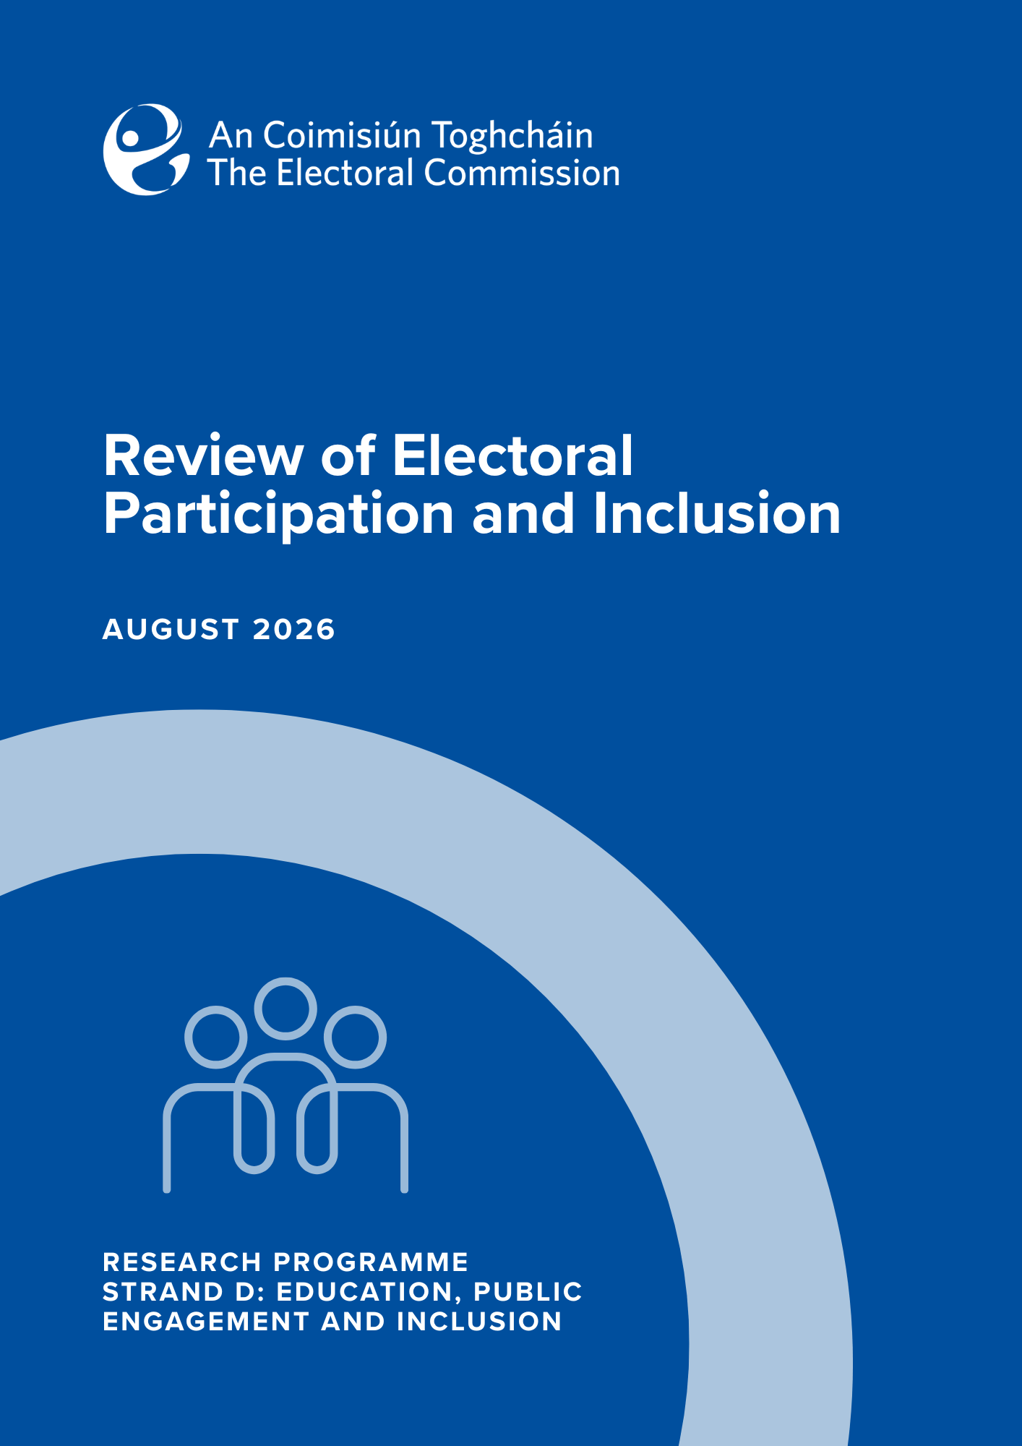

Research Report

Review of electoral participation and inclusion

August 2026
Contents
Introduction 1
Summary of key findings and next steps 2
1.Method and approach taken in this report 8
1.1 Measuring turnout 8
1.2 Measuring turnout for potentially under-reached groups in society 9
1.3 Research approach 10
2. Explaining electoral participation 11
2.1 What explains participation and what factors are associated with turnout? 11
2.2 Electoral participation and inclusion in Ireland 13
2.3 Conclusion on factors associated with electoral participation and enabling policies 18
3. Electoral participation and barriers to participation amongst groups 21
3.1 Disabled persons 21
(i) Legislative and policy context legislative context 21
(ii) Data on electoral participation 22
(iii) Electoral participation by people with disability 22
(iv) Electoral participation by disabled people in Ireland 24
(v) Explaining low electoral participation 26
(v) Key points and next steps 30
3.2 People from a migrant background 32
(i) Legislative and policy context 32
(ii) Data on electoral participation 32
(iii) Electoral participation by migrant communities 33
(iv) Explaining low levels of participation 37
(v) Key points and next steps 39
3.3 Travellers 41
(i) Legislative and policy context 41
(ii) Data on electoral participation and data on correlates of turnout 41
(iii) What could cause low levels of participation 42
(iv) Key points and next steps 43
3.4 Young people 44
(i) Legislative and policy context 44
(ii) Data on electoral participation 44
(iii) Electoral participation by young people 44
(iii) What appears to explain lower levels of participation among young people and is low turnout more pronounced among certain groups of young people? 48
(iv) Key points and next steps 53
3.5 Prisoners 55
(i) Legislative and policy context 55
(ii) Data on electoral participation 56
(iii) Explaining low levels of participation 57
(iv) Key issues and next steps 59
3.6 People experiencing homelessness 61
(i) Legislative and policy context 61
(ii) Data on electoral participation and data on correlates of turnout 62
(iii) Key points and next steps 63
4. Concluding remarks 64
APPENDIX 1 –Statement on methodology 66
Glossary 70
BIBLIOGRAPHY 70
ENDNOTES 85

This Research Report was prepared by Dr. Catherine Lynch of An Coimisiún Toghcháin’s Research Team, and by Anthony Trindle, Ciara O'Riórdan and James Clarke also from An Coimisiún's Research team, and with input from Dr Kevin Saudé, University of Limerick. Members of An Coimisiún’s Research Advisory Group provided some very helpful comments on earlier drafts.

Introduction
Our Research Programme 2024-2026 identifies a need to deepen understanding of inclusion in the electoral process in Ireland. It sets out our intention to review existing research and datasets regarding electoral participation, including participation by sections of society or groups identified as potentially under-reached, and to identify any established baselines, barriers to participation, and any strategies which may already have been identified or actioned, to increase participation. In delivering on this objective, this paper draws on existing research and data sets with a view to:
- Identifying any systematic patterns in voter turnout which suggest unequal participation, in particular exploring the participation of sections of society identified as potentially under-reached in the literature on turnout, and in submissions to An Coimisiún (described in 1.2 below).
- Identifying barriers or other factors that may explain low turnout, especially amongst potentially under-reached groups; and
- Highlighting enabling policies, or where additional, more focused research is needed to fully assess inclusion and the barriers to or enablers of participation.
While other modes of political participation (Box 1) are mentioned where relevant, the study focuses primarily on electoral participation through voting (turnout).
Box 1: Modes of political participation
Defining political participation as “activities of citizens that affect politics,” Van Deth presents four variants: (1) voting and registration, party membership, contacting a party (2) actions targeted at institutions (3) actions targeted at community problems (civic engagement) and (4) motivational actions (political consumerism, boycotts). Of all modes, Dalton describes voting “as the most accessible, and the activity that binds the individual to the political system and legitimises the rest of the democracy process.”
Voter turnout is an indicator of democratic health; low turnout risks loosening the link between the electorate and public representatives. Low turnout is particularly problematic if those who abstain from voting over-represent certain sections of society (for example, on the basis of demographic, socio-economic, geographical, cultural, ethnic or other factors) thereby creating a participation gap which raises questions about whether all those eligible have equal opportunities to exercise their right to vote. Further, participation gaps can lead to unrepresentative electoral outcomes and the possibility arises that those known to vote in higher numbers have a disproportionate voice in policy-making. Unequal participation in voting is often magnified when it comes to other forms of political participation; detailed analysis of cross-national data has found that where there is unequal participation in voting, there is even more unequal participation in other modes (Box 1). Inclusive participation in voting is therefore critical to avoiding the political inequality which prevails where there are “systematic differences in citizens’ abilities to influence the political process.”
Candidacy and the barriers to or enablers of candidacy are not explored in this study, while it is acknowledged that a level of descriptive representation may influence turnout for some eligible voters.
This research falls under Strand D of An Coimisiún Toghcháin’s Research Programme, the purpose of which is to inform An Coimisiún in its statutory duty to “promote public awareness of and participation in the State’s electoral and democratic processes” through educational and information programmes” (Section 67, Electoral Reform Act 2022). As well as adding to our understanding of inclusion in electoral participation, the review helps to set future research priorities under Strand D. It also informs research related to electoral policy or procedure (Strand B)^{[i]} and helps set the direction of work under Strand A (National Election and Democracy Study - NEDS).
Having introduced methodological approaches to measuring turnout (section 1), the report summarises key findings of the vast literature on electoral participation before reviewing the literature and data on what affects and explains electoral participation in Ireland (Section 2). Using Section 2 as a framework, focus is brought onto the electoral participation of potentially under-reached sections of society in Ireland (Section 3). An explanation for groups considered and a note on language used is at 1.2.
A summary of our findings and next steps (i-x) on each research objective is set out below in advance of the full report.

Summary of key findings and next steps

Are there systematic patterns to turnout?
The evidence presented in 2.2 suggests that there are systematic patterns to turnout in Ireland on the basis of socio-economic and spatial factors. Higher income, employment, and higher educational attainment levels, have all been linked to a higher propensity to turnout by studies using survey and aggregate-level data in Ireland (though the link between educational attainment and turnout is less clear in recent research). This is not unusual when compared with other countries.
An analysis of the most recent electoral study – An Coimisiún’s NEDS data for 2024 and 2025 - points to homeownership as one of the strongest predictors of turnout, this confirming the findings reported by earlier aggregate-level studies (defined in 1.1). Homeownership is seen as an indicator of relative socio-economic advantage – denoting stability of tenure and a sign of income. Homeownership is also a proxy for population/residential stability, an important correlate of turnout in the international literature (see 2.1). It is argued that homeowners are more likely to reside in settled, non-transient communities and that the stability and the community networks this gives rise to are conductive to voting and to being informed about voting. Higher propensity to vote in rural communities – which is frequently found in aggregate-level studies and some survey-based studies in Ireland, is explained as in part a consequence of the stable, non-transient communities that characterise rural areas.
To further understand how turnout is related to socio-economic, demographic and spatial factors we have commissioned an aggregate level study – Mapping Turnout Project – which will match census 2022 data and turnout data from the 2024 General Election at the electoral division level. Drawing on the experience of this project we can consider whether such an analysis should be conducted regularly. This work will be completed by the end of 2026 and published thereafter (i).
Moving to participation by potentially under-reached groups, this review (section 3) identifies a turnout gap for people with severe disabilities (3.1), for people from a migrant background – both Irish citizens and non-Irish citizens (3.2) - and for young people (3.4). There are very low levels of registration by prisoners (3.5) and, while we lack data about the level of participation, there is much evidence that variables associated with low electoral participation are experienced by Travellers and by people experiencing homelessness (Sections 3.3 and 3.6 respectively).
Looking at the individual voter level, ‘political interest’ is a key predictor of voting in Ireland (2.2) and, notably, our analysis of the NEDS data (2024 and 2025) finds that political interest is highly correlated with ‘internal political efficacy’ – meaning an individual’s confidence in the ability to vote and in their understanding of voting and politics. It would appear that political interest does not arise in a vacuum and may be stimulated by greater knowledge and confidence (although we cannot be sure of the direction of causality). Knowledge and confidence are, in turn, related to civic skills and to exposure to networks of mobilisation (concepts which are discussed in 2.1, 2.2 and 2.3 which concludes with a framework for explaining electoral participation).

Explaining low levels of participation, in particular for potentially under-reached sections of society, and identifying next steps
Our analysis of electoral participation by the potentially under-reached groups is nested in the broader framework of electoral participation and what seems to explain it (2.1, 2,2 and 2.3 and Figure 2).
Our analysis of ESS data for Ireland over several waves (2002-2023) finds that those with a severe disability (see Section 3.1) are 10 percentage points less likely to vote than the general population.
We lack survey data that allows us to fully explore how severe disability may be affecting electoral participation.
A severe disability may be physical, or for a smaller, but still relatively large proportion, is not physical but related to a psychological/emotional /mental health issue, or a cognitive or an intellectual disability (according to Census data). It is clear that administrative and institutional arrangements for registration and voting can present distinct challenges. International and national policy instruments therefore emphasise the importance of making voting physically and cognitively accessible. Measures to enhance accessibility are monitored, and there is a constant effort to improve them by stakeholders and legislators alike. An Coimisiún’s Post Electoral Event Reviews have focused on the experience of people with disabilities, incorporating accessibility indicators in our checklist, and conducting case studies with disabled people at polling stations. Questions about disability have been included questions in the NEDS. This work will continue.
While these measures are aimed at improving the experience of disabled voters, we do not have conclusive information about their effect on turnout. In other words, do the measures designed to enhance accessibility simultaneously encourage severely disabled people who do not ordinarily vote, to vote?
This is an important question because it is possible that factors other than the severe disability, but which arise in part as a consequence of living with a severe disability, are presenting barriers to voting. There is evidence that severely disabled people experience higher levels of deprivation and social exclusion; both predicted to present barriers to voting (see section 2). Our analysis of the ESS data for Ireland (2002-2023) found that social connectedness measured in this instance by a proxy - “living with or being married to a partner” - significantly reduced the negative association between severe disability and turnout i.e. this person is more likely to vote (see Section 3.1).
There is a case therefore for consulting directly with severely disabled people with a view to understanding how measures to enhance accessibility of voting, social inclusion/connectedness, and socio-economic factors, affect electoral participation and whether non-voting is primarily circumstantial, voluntary, or related to “low political efficacy” (all of which are described in 2.1) (ii).
Measures which increase social inclusion for disabled people–a key goal of the Government’s recently-published National Human Rights Strategy for Disabled People 2025-2030 - may also reduce any barriers to voting associated with social connectedness and capital. Bearing this in mind, consideration should be given to including questions on electoral participation in the National Disability Survey proposed in this new Strategy and on the agenda of its Data Advisory Group. (iii)
It is clear from our analysis of electoral register and NEDS data that people from a migrant background vote less in elections than the general population (Section 3.2). Perhaps most notably, reported turnout in the NEDS among migrants who are Irish citizens is low, including for second-generation Irish citizens from a migrant background (citizens for whom at least one of their parents was born outside of Ireland).
Studies both in Ireland and internationally, suggest that a unique set of factors explain low levels of participation amongst migrants connected to:
  - lack of political knowledge about the new state’s political system and electoral administration (registering),
  - lack of perceived stake in society (at least initially),
  - weak connectivity to society/social networks, and
  - political culture which was developed prior to arrival.
In addition, socio-economic and demographic variables associated with lower participation – in particular age and residential instability (migrants are more likely to live in rented accommodation) – may partly explain lower levels of participation. International research, and research amongst specific migrant communities in Ireland, have identified as enablers of turnout:
  - the more time a migrant has resided in the country, and
  - the more migrants belong to community/social networks (in particular cross-community networks which involve contact with local-born citizens).
It is likely that the administrative and social barriers identified in the literature can explain the significant participation gap in turnout at the 2024 and 2025 elections between citizens born in and outside of Ireland. However, migrants’ propensity to turn out is predicted to increase with the length of time they spend in the country. It is unclear if this is happening in Ireland; Irish citizens of a migrant background (who must have resided for a considerable time in the State) are up to 10 percent less likely to report voting according to NEDS data.
An Coimisiún has funded research under Taighde Éireann/Research Ireland’s New Foundations Programme which is exploring barriers and enablers of electoral participation by people from a migrant background in the 2024 Local Election. It will be published towards the end of 2026. We believe there is potential for further projects that build on what is known to design strategies or interventions to encourage participation.
Our findings suggest that there is a case for directly engaging with new and second-generation Irish citizens of a migrant background to further explore barriers to and enablers of voting. In addition to reducing administrative and informational barriers, research points to engagement through social networks as promising for promoting electoral participation by people from migrant backgrounds. There is also a role to be played by political parties (iv).
The absence of surveys that directly engage with the migrant community has been highlighted by the ESRI as a challenge to the production of its European Migration Network report on the integration of the migrant community. Given the linkages between social inclusion, integration and electoral participation, there are obvious opportunities for collaboration between those studying the integration and the political participation of people from a migrant background (v).
In line with much previous research, we find (section 3.4) that younger people (18-24) are less likely than older age groups to vote, and NEDS data suggests that this effect is more pronounced in local and European elections. There is a socio-economic dimension to electoral participation among young people demonstrated by Growing Up in Ireland data (regarding registering to vote), and European Social Survey data (in the latter case, both when data relating exclusively to Ireland is examined, and when comparative data across Europe is explored). And it would appear that an individual’s socio-economic and civic context at a very young age influences the likelihood to participate when one turns 18.
Apart from socio-economic variables, “political interest” appears to be an important factor in predicting turnout by younger people, even more so than for the rest of the population. There is some evidence to suggest that political interest may be connected, at least for some people, to “internal political efficacy” which relates to knowledge and understanding of voting and politics in general.
Political interest and dis-interest may mean something different for young people than the general population; the evidence from the ESS shows that younger people in Ireland participate more than older age groups in political activity beyond electoral participation such as wearing a badge, attending a public demonstration, posting or sharing a political post online and signing a petition. protests and marches.
Policies that facilitate/make it more convenient for young people to vote – for example, by offering a postal vote for students – will have a limited effect on reducing barriers related to political interest and social capital and civic skills. There is much value in the approach to research taken by Think-tank for Action on Social Change (noted in Section 3.4) when aiming to deepen understanding of whether barriers are circumstantial or more related to apathy or to low internal political efficacy and deepen understanding of attitudes to the political system in general.
Recognising the need for further exploration of the engagement by young people with elections and with the democratic process in general, an Coimisiún has partnered with Taighde Éireann to fund a Public Service Research Fellowship. The Fellow will commence in January 2027 and examine electoral participation and democratic engagement by younger people in Ireland and explore ways to increase it (vi).
We have also commissioned empirical research which is assessing the impacts of reducing the voting age including any evidence that reducing the voting age increases youth electoral participation at the time of enfranchisement and in the future. This will be published later in 2026 (vii).
While Travellers (section 3.3) experience many of the socio-economic and demographic variables that are predicted to cause low levels of participation, there has been no recently-published dataset or study which investigates turnout, or reported turnout, by Travellers. Evidence of societal and institutional marginalisation, and international evidence regarding the lack of political engagement among Traveller communities in other countries, all point to a particular need to further research this field in the Irish context.
An Coimisiún has therefore identified electoral participation by Travellers as a priority for further research under Strand D. We will commence a study which will explore and seek to explain electoral participation by the Traveller community (including understanding circumstantial, voluntary or other types of abstention), identify barriers to participation where they exist and evaluate measures to enable electoral engagement. There may be an opportunity to glean some information on turnout by Travellers through our research at the 2026 bye-election in Galway West and from our aggregate-level study mentioned above which will map turnout at the general election (viii).
People experiencing homelessness (PEH) (section 3.6) is not a cohesive or homogeneous group with some people experiencing long-term and others temporary homelessness. PEH do disproportionately experience the socio-economic and other factors associated with low turnout, and homelessness co-occurs with other factors which may reduce tendency to vote. Yet a number of studies in other countries found high levels of interest in politics among PEH or groups with co-occurring experiences.
Practical barriers to voting for people experiencing homelessness existed prior to the 2022 Electoral Reform Act and the limited data we have suggests low levels of participation.
While administrative barriers have been reduced and the process for registration is less onerous than before, registration remains highly self-directed. Administrative barriers – even with their reduction – should not be under-estimated given the complex set of challenges experienced by PEH. Intuitively, voting will rarely be the impetus for initial engagement with social services.
There are bespoke voting solutions for PEH, such as mobile polling stations or automatic registration, which could be considered to help achieve concrete increases in turnout. The symbolic relevance of such solutions beyond the target population might also be worthy of exploration.
Given the number of homeless, and the many people in precarious housing situations, there is a case for a survey or focus group research to confirm the extent to which barriers are practical or related to dis-interest or lack of engagement before the next election and any associated registration drives. The former could establish a baseline and identify possible enablers of inclusion (ix).
We find very low registration levels among the prison population (section 3.5), in spite of the legislation enacted in 2006 which enabled prisoners to exercise their franchise.
Our review of literature identified institutional/administrative barriers and barriers related to socio-economic and social context for prisoners. Further, the voting experience may affect the level of participation; the introduction of in-person (in prison) voting for prisoners in France, to replace proxy voting, has resulted in a remarkable increase in turnout amongst prisoners in France.
Some barriers identified may be addressed by practical reforms or the allocation of modest resources to the electoral administration. These include barriers that arise because (i) limited candidate information is received by prisoners, (ii) because prisoner populations are transient and mobile. and (iiii) prisoners rely on institutional support from the Irish Prison Service to exercise their franchise (x).
In conclusion, this research has been a worthwhile exercise in enabling us to map what we know to date about levels and patterns of electoral participation and about participation by potentially-under reached or marginalised sections of society.
The research mostly stops short of identifying specific enabling policies or initiatives as the adequate policy or initiative is best identified when barriers are fully understood. We acknowledge there is much more to be done and to learn in this respect and we identify next steps for this purpose (i) to (x). As noted above, some of these initiatives are being/ will be achieved through further research which we are committed to conducting, undertaking with partners, or funding. Other work will build on what we know about participation levels and barriers to explore the type of initiatives that enable participation. Our forthcoming Education Strategy will allow us to target interventions towards the sections of society experiencing barriers. It is crucial that our work and initiatives reflect the perspectives and views of all through direct involvement in our work. We would welcome feedback on this paper and any ideas or initiatives which emerge from it.

1.Method and approach taken in this report

1.1 Measuring turnout
Whether a member of the electorate votes or abstains from voting is not public knowledge, so studies that explore variation in turnout tend to rely on one or all of the methods below to study turnout.
Firstly, ‘reported turnout’ is obtained from surveys which ask respondents about voting or intended voting and simultaneously gather data on a variety of other factors which may explain voting behaviour. In many countries (e.g. USA, UK, France, Netherlands, Norway, Sweden) reported turnout has been consistently recorded in electoral studies conducted over decades. The National Election and Democracy Study (NEDS) launched by An Coimisiún Toghcháin under Strand A of the Research Programme in 2024 has introduced a regular set of election studies for Ireland and complements studies which predate An Coimisiún Toghcháin - primarily the Irish National Election Study (INES). Other national representative surveys which ask respondents about voting behaviour include the European Social Surveys (since at least 2002) and Eurobarometer. Studies use statistical analysis to identify the variables that are associated with, or significantly affect, reported turnout.
There are drawbacks to ‘reported turnout’ as an indicator of voting. There is a tendency for respondents to over-report voting for social desirability reasons, unreliable recall, or biases associated with the selection of respondents who may be more likely to over-represent voters. However, in most states reported turnout is the most reliable estimate of who votes/does not vote, and weights and other measures are used to address the potential drawbacks. In some states – for example, the Nordic countries - it is possible to explore the relationship between actual (anonymised) turnout at the individual level alongside demographic variables such as age, nationality at birth, education level, socio-economic resources using administrative data. This data enables studies to reach more robust findings on the association between turnout and demographic variables (because it does not encounter the problems associated with reported turnout). However, this data does not include attitudinal variables (e.g. why someone votes/does not vote, trust, political knowledge and a range of other attitudinal variables). This can only be gleaned from survey data.
Another approach uses turnout at an aggregate level. Rather than exploring the individual voter, the level of registration and/or turnout at a specific geographical level is explored alongside demographic, spatial and other characteristics of small areas and/or regions. Drawing on data at the aggregate level, studies identify significant associations between the type of area (for example, socio-demographic composition) and the level of turnout or registration. Studies taking this approach can draw stronger conclusions when turnout or registration data is available at small area levels and when there is rich corresponding data about the socio-demographic characteristics of the same area.
Many studies combine methods. For example, survey data over several decades and from several countries is examined alongside empirical data on turnout at an aggregate level, to explore the validity of different explanations for voting/not voting.

1.2 Measuring turnout for potentially under-reached groups in society
As noted in An Coimisiún’s Research Programme, large-scale sampling models used for surveys - such as some of those discussed above – may be inadequate to explore participation levels among certain sections of the population. There is a risk that they will not reach those who are particularly marginalised or socially excluded. For example, an identifiable group of people that is small in number and/or relatively socially excluded is quite unlikely to be represented in large sampling models involved in national surveys. They are also unlikely to be explored in aggregate-level studies unless geographically concentrated.
There are methodological ways to address the problem. For example, using quantitative methods, a survey can apply a different sampling method, one designed to reach these sections of the population (e.g. boost samples). Alternatively, or additionally, a qualitative approach employing semi-structured interviews or focus groups can gain further insights into political attitudes and behaviour. Or questions regarding electoral participation and engagement may be added to surveys which are dedicated exclusively to this group. Regardless of the approach, the analysis of electoral participation by those who are potentially under-reached should be framed within the broader context of the societal, demographic and other factors identified in the literature as important determinants of turnout (Section 2).
The groups explored in further detail in this review are those which, following an initial analysis, either appear to vote in lower numbers, or are groups on which we have little information. They may also be disproportionately affected by the socio-economic and other experiences associated with low levels of participation in electoral politics set out below (Section 2). They are:
- Disabled persons
- People from a migrant background
- Travellers
- Young people
- People experiencing homelessness
- Prisoners.
Note on language
In line with the Government of Ireland’s National Human Rights Strategy for Disabled People 2025-2030, the term ‘disabled person’ rather than person with a disability is primarily used in this Paper except when quoting from literature. People from a migrant background includes (i) people who migrated to Ireland and have since become Irish citizens, (ii) second-generation Irish citizens born to migrant parents, and (iii) non-Irish citizens who live in Ireland. This is in line with the Immigrant Council of Ireland’s broad definition of people from a migrant background and, unless indicated, we do not examine the electoral participation of sub-groups of the migrant population (defined by ethnicity or race). We use the terms Travellers and the Traveller Community, the preferred terms of the Community itself, and those used by the Joint Oireachtas Committee on Key issues affecting the Traveller Community. Young people for the most part refers to those in the 18-24 age bracket and, where possible, we include data about older young people. A variety of terms are used in legislation, the media and in academic literature to refer to people experiencing homelessness such as “unhoused,” “homeless,” people “without a fixed address/abode.” We use “people experiencing homelessness” recognising that it is an experience, rather than a defining characteristic, and that this may include people living in precarious housing. While we use the term prisoner, we also use the prison population in recognition that being a prisoner is a temporary status rather than a permanent descriptor.

1.3 Research approach
A statement on the methodologies used to access and interpret literature and data over the course of the research, which is guided by An Coimisiún’s Research Integrity and Ethics Statement, is set out at Appendix 1. Where primary research was undertaken, we set out the method used and link or provide access to the Working Papers in which original data and analysis is presented.

2. Explaining electoral participation

2.1 What explains participation and what factors are associated with turnout?
The question of why eligible voters vote/do not vote has received “unabated empirical attention” in the literature on political behaviour and “few topics in political science have generated a comparable volume of literature.”
Studies at the individual (usually survey and sometimes using administrative data) and at the aggregate levels (explained in 1.3 above) have identified a range of variables that are consistently found to explain turnout. Table 1, which is drawn from three meta-analyses and a further review of the international literature (see Appendix 1), presents the most significant correlates of voting/not voting and categorises them into three broad groups: (1) socio-economic, demographic and spatial variables; (2) socio-cultural, civic and/or social capital including mobilisation; and (3) institutional/administrative variables (see Appendix 1). The variables capture citizens’ resources, civic skills and social capital, level of political mobilisation as well as psychological factors such as political interest and attitudes such as civic duty, external and internal efficacy, political trust, cynicism and self-efficacy. The association between electoral participation and variables which approximate socio-economic constraints, clear from Table 1, is acknowledged in the literature.
Table 1: Variables found to be predictors of voting
Socio-economic, demographic and spatial | Socialisation - social capital including mobilisation | Institutional
- Age (and age squared)  - Higher income level (to some extent)  - Higher education attainment level (and this is related to other variables such as political interest and civic knowledge),  - Residential stability, also referred to as high population stability | - Civic duty, political interest and political knowledge and civic skills  - Voting habit (family tradition, vote in previous election)  - Reside in a community with high levels of associational life (urban/rural is a proxy for this)  - Mobilisation by party/candidate/campaigner/social network (eleven indicators)  - Media exposure (consumption of media /news media) | - Ease of registration and ease of voting  - Concurrent elections  - Compulsory voting (whereby not voting is punishable)  - Type of electoral system (and perceived level of influence)
Sources: adapted from Smets and Van Ham (2014) (see Appendix 1)
Core theories seek to explain the decision of an individual to vote/not vote drawing on these correlates. Voting is presented as a cost/benefit rational decision by an individual with the benefits including the possibility of influencing the outcome, the sense of civic duty satisfied, the expressive thrills of participation, or the desire to support democracy. An individual who is primarily motivated by influencing the outcome may be deterred if they see little difference between the parties/candidates or where the outcome seems to be a foregone conclusion (e.g. a non-competitive election). On the other hand, an individual motivated by civic duty or the thrill of participation will not be.
A variation of this rational decision approach is a cost-benefit resource model which proposes that individuals decide to participate/not participate on the basis of the resources they possess; those with more resources - measured by socio-economic factors such as income, education level, skills and knowledge - will have more capacity to access information about politics and the election and are therefore more likely to vote. A variation of the resource model focuses primarily on psychological factors; citizens who are interested in politics and who have ‘internal efficacy’ (meaning who have sufficient knowledge and understanding of the system to vote) tend to vote. These latter factors could also be interpreted as determined by the “resources” they possess.
Continuing with the assumption that voting/not voting is a rational choice made by an individual, other models place more focus on the voters’ political context to explain the decision. For example, an institutional approach sees the decision as affected by institutions and rules - such as the ease of the registration process, the type of electoral system, or voting is explained as the outcome of mobilisation. For example, an individual is more likely to vote if they (or their family or peers) are connected to, or identify with, a party or a candidate and/or if they are contacted by candidates or campaigners over the course of the campaign, if they live near a candidate. When parties are deeply rooted in social life, turnout will be higher.
Another approach sees the decision to vote/not vote as primarily dependent on the social context which is itself the outcome of socialisation, social identity and social ties. Rolfe argues that, rather than it being an individual rational decision, citizens are likely to vote where they are “embedded in social networks that are more conducive to the spread of voting and similar sorts of relatively-undemanding and somewhat public-cooperative behaviour.” Rolfe presents voting/not voting as conditional on the behaviour of the social network. Franklin, amongst others, demonstrates that living with parents and parental history of voting is central to this social network. Social connectedness is sometimes measured by membership of a union or other collective organisation, also used to measure certain types of social capital.
No one model fully explains individuals’ decisions to vote/not vote. What one person perceives as a “cost” and as a “benefit” will differ from individual to individual and it would appear that an individual’s socio-economic, social and political context (set out in Table 1) affect this perception. This understanding is central to Verba, Schlozman and Brady’s civic voluntarism model which explains how background characteristics translate to differences in political participation. They argue that the unequal distribution of resources (time and money), engagement (interest in politics/belief in the efficacy of political action, level of information held and identification with a political party) and recruitment (meaning being asked by someone to take part e.g. a party/a social network of friends/voluntary organisation/community family) make it easier for some and harder for others to participate in politics (including voting).
Finally, within the context of the above, there is some consensus in the literature that reasons for voting or not voting can be usefully categorised into circumstantial (unavailable, on holiday, work commitments) and voluntary (my vote does not count/won’t make any difference/not interested in politics). Somewhere in between circumstantial and voluntary abstention we propose a sub-category which encompasses individuals with low “internal political efficacy” and who lack the opportunity or capacity to gain it. Internal political efficacy refers to a belief that one can understand and therefore participate in politics. This person may not be apathetic, may in fact wish to vote, and/or be interested in political issues. but may not have the “resources” or the “social network” to do so. While this is frequently categorised as a circumstantial’ abstention, we see it as fundamentally different to the temporary nature of other circumstantial factors and thereby to warrant a separate category (low internal political efficacy) (Table 2).
Table 2: Reason for voting/not voting
Reason for not voting (decision) | Elaboration
Circumstantial | On holidays/away with work/too busy because of other commitments
Voluntary abstention | My vote does not count/elections are pointless/no politician represents me
Low internal political efficacy | Voting is not for me/uncertain how I would vote/my friends and family do not vote/I don’t understand the system/how would I register and vote

2.2 Electoral participation and inclusion in Ireland
To what extent do these variables explain electoral participation in Ireland?
An analysis of the literature on electoral participation in Ireland, including primary analysis of recent NEDS data from the 2024 general and 2025 presidential elections, finds that many are associated with electoral participation in Ireland. This analysis is next presented with the correlates of turnout highlighted as they arise.
Preliminary analysis of data from NEDS (Box 2), finds that age had a linear effect whereby in the 2024 electoral events with younger voters least likely to vote. That age is one of the strongest predictors of voting is consistent with the evidence from previous studies in Ireland which have found that younger people vote in lower numbers than older age groups. This is the case for both studies using survey data and studies using turnout at the aggregate level.
There is some evidence in the literature that turnout among younger people is contextual i.e. it can be higher than usual in some referendums (for example, those on Marriage Equality and Repeal the 8th), and that younger people participate in issue-orientated organisations at a similar rate to other age groups. Consistent with these earlier findings, the effect of age (i.e. that younger people are less likely to vote) was strongest in local and European elections in 2024. In fact, provisional analysis of the NEDS data for 2024 found that when internal efficacy (confidence in ability to vote and understand electoral context) and political knowledge are included, they absorb the effect of age in the general election. Note that young people and participation is considered in greater detail below (Section 3.4).
Box 2: Findings from NEDS 2024
Provisional statistical analysis of pooled data from An Coimisiún’s NEDS of local, European, general elections and two referendums in 2024 find age, homeownership (socio-economic, demographic factors), urban/rural dweller (spatial) and political interest (socialisation/social capital) have the strongest (statistically significant) impacts on turnout. Figure 1 below shows the average marginal effect (calculated using logistical regression models) of predictors of turnout for the general, European and local elections election pooled. The wide confidence intervals suggest a significant amount of variance for many explanatory factors. As elaborated below, these findings are quite consistent with earlier studies. Figure A (Appendix) adds data from presidential elections to the analysis.

Figure 1: Average marginal effect of predictors of turnout general, local, European 2024
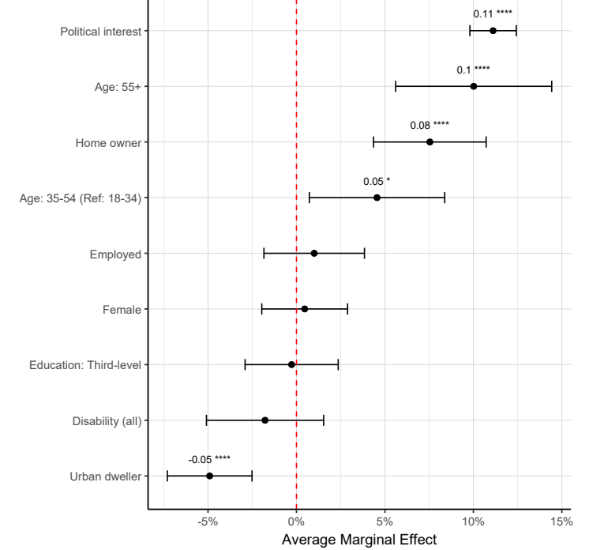
Source: Saudé Kevin (2025b) for An Coimisiún’s Research Unit (see also Appendix 1).
Concerning socio-economic factors, the Irish National Election Study data 2002, 2007 and 2011 showed that the propensity to vote increases with educational attainment and income level. This was also found by Redmond et al who drew on data from the 2004 Living in Ireland Survey, by Lyons and Sinnott, who combined constituency-level data and a two wave IMS survey and concluded with a profile of a typical non-voter - young, single, student, working class, unemployed and living in an area with low levels of home ownership.
Studies at the aggregate level have also found strong associations and statistically significant relationships between turnout and the socio-economic characteristics of areas such as education levels, middle or working-class areas, occupation and deprivation levels. Using an employment-based definition of social class, Durkan’s analysis of 2016 and 2019 turnout data found a significant negative relationship between unemployment and turnout. And in urban areas the type of employment was found to matter; turnout was higher in areas where professional-type employment was prevalent and lower where employment was concentrated in “less skilled” categories. This effect was not found in rural areas, a point which is developed below. Using TILDA data (Irish Longitudinal Study on Aging), a study by the ESRI found that individuals with more education are more likely to vote and that the effects of more education on turning out are larger for individuals whose parents have low levels of education completed and for individuals growing up in a poor family. Higher educational attainment was also found to be a predictor of voting in studies drawing on the Irish National Election Study (2002-2011) data and research on younger people in Ireland using the European Social Survey (see section 3.4 of this report).
While educational attainment level does appear to partly explain turnout, it does not always. For example, rurality is frequently associated with lower education levels especially among older people, yet turnout is frequently higher (a point discussed further below). Further, we do not find a statistically significant relationship between education level attained and reported turnout in the pooled NEDS data for 2024 electoral events. And in general, as the number accessing third-level education increases across democratic states there has not been the corresponding increase in turnout that might be expected if education level is a predictor of turnout. Seeking to explain this, Rolfe argues that education combines with other less tangible correlates of voting including the wider social network in which people live. These include family background and voting tradition (which are influenced by the socio-economic background of parents), political knowledge and the extent to which “civic duty” (the perception that voting is a civic obligation, a signal of commitment to and support of democracy) is a driving factor in decisions to vote/not vote. These variables are broadly termed as civic skills and social capital.
Homeownership is one of the strongest predictors of turnout according to an analysis of the NEDS data (general, local and European elections 2024). This is consistent with some earlier studies – for example by Kavanagh, by Lyons and Sinnott, by the ESRI and by Durkan. In fact, Kavanagh et al suggest that residential stability – which is associated with homeownership - it is a more significant predictor of voting in Ireland than social class. Using data from 2016 and 2019 elections, Durkan observed “some of the strongest associations” between turnout levels and homeownership and residency tenure. Durkan found “a much lower level of participation in areas with a lot of renters, and much higher levels in areas that have high levels of homeownership.” Participation in areas with pronounced levels of Local Authority rented accommodation were also comparatively low but, he noted, that this was not low in all cases which suggests that stability of tenure and the extent to which the community is settled may be key.
This raises the question about what homeownership indicates in the context of electoral participation. There are a number of possible interpretations. Firstly, homeownership is an indicator of relative socio-economic advantage - denoting a level of economic stability and a sign of income. As an indicator of socio-economic advantage, homeownership has a stronger relationship with turnout than any other socio-economic indicator in NEDS 2024 data. This is perhaps not surprising. Recent research published by the ESRI has noted that the indicators of advantage and disadvantage in Ireland may be shifting; disadvantage may be less well indicated by education level than in the past and more reflected in indicators such as housing tenure, health, civic engagement and social context. And sociologists point to a transformation in social structures of advanced OECD democracies whereby labour market conditions (income and employment) are not the only, or most important determinant, of socio-economic security or wealth. Using UK household panel data and UK electoral survey data, Goddard explores the growing importance of housing status - primarily measured by ownership/non-ownership – as a predictor of voting behaviour and argues for an updated conceptualisation of social stratification to understand political behaviour.
Homeownership is simultaneously a proxy for residential (population) stability, an important correlate of turnout in the international literature because of the community networks it tends to lead to and the barriers to registration that it eliminates. Homeowners are more likely to reside in settled, non-transient communities and it is argued that the stability and the community networks this gives rise to are conducive to voting and to being informed about voting.
The effect of strong community ties is used to explain why turnout is frequently higher in rural areas and sometimes regardless of socio-economic context. The analysis of 2024 NEDS data found that rural dwellers were more likely to vote than urban dwellers and this effect of rurality was also stronger in the local and European elections than in the general election and more so again in the local (see Box 2). This is consistent with earlier survey-based and aggregate-level studies of electoral participation in Ireland. Lower turnout in some urban areas has been explained as the result of the “weakening of inter-personal bonds, primary social structures and consensus on norms” brought by urbanisation and higher turnout in rural areas is explained by the “pervasive participatory norms and networks, and stronger political organisations and traditions.” In fact, research in Ireland has found that rural/urban differences appear to confound the expected effect of education level and type of employment on voting which is noted above. Durkan’s research on turnout in 2016 and 2019 elections confirmed an urban/rural dimension to turnout while it does point to a decline in participation in some rural areas and an increase in some urban communities which traditionally have low engagement.
Political interest and political knowledge, key individual-level predictors of voting in the international literature, are important in the Irish context. Using data from the Irish National Election Study (2011), Blais, Reidy and Galais found that perceiving voting as a civic duty had a strong effect on the probability of voting and that this effect was particularly significant for those with low levels of political interest (measured on a 1-4 scale). Political interest had a statistically significant effect on turnout in the pooled data of electoral events in 2024 (NEDS) (Figure 1). Notably, our analysis of the NEDS data found that internal political efficacy (meaning confidence in the ability to vote i.e. understand voting and politics) is highly correlated with political interest (Figure B, Appendix). Both are related to ‘civic skills,’ a concept described by Verba et al as “communicative and organisational capacity that enables political participation.” Using data from a UK Privilege and Participation Survey (2025) and further qualitative interviews and focus groups, Greenwood-Hau points to “a lack of confidence, the idea that ‘politics is not for me’ and a lack of knowledge about politics” as influencing participatory decisions. In fact, he concludes that the key individual constraints on participation for those unlikely to participate were lack of knowledge, lack of interest, or having other priorities.
While not yet explored in detail for the recent NEDS data, earlier studies in Ireland consistently find campaign exposure and experience of elections do matter for individual level turnout in Ireland - having had contact with a candidate during a campaign and identifying strongly with a particular party have been demonstrated to be predictors of voting, and knowing that a candidate lives locally as a predictor of voting in some elections. Durkan’s empirical work at the aggregate level finds a positive association between a candidate’s location and voter turnout levels and notes a decline in turnout between 2016-2019 as more common in areas that were geographically removed from a candidate. While not included in our analysis of NEDS to date, campaign exposure and experience of elections may be related to membership of a social network in which voting is the norm (see Section 2.1).

2.3 Conclusion on factors associated with electoral participation and enabling policies
The correlates of voting set out at 2.1 are to a considerable degree borne out in the literature on electoral participation in Ireland (2.2). Age, socio-economic variables (measured by income, educational attainment level, employment and increasingly by homeownership) are associated with voting/not voting in Ireland and there is some evidence that residing in more settled, less transient communities (often correlating with homeownership) coincides with a higher propensity to turnout. This is consistent with the international literature that presents non-transient residential communities - and the stability and the community networks this gives rise to - as creating environments that are conducive to voting and to being informed about voting.
Looking beyond the socio-economic dimensions of turnout to variables related to social and political capital (column 2, Table 1), past and recent analysis of INES, ESS and NEDS data find “political interest” to be a key individual predictor of voting and, notably, our analysis of the NEDS data (2024 and 2025) finds that political interest is highly correlated with “internal political efficacy” – meaning the confidence in the ability to vote and understanding voting and politics. Political interest does not arise in a vacuum and may be stimulated by greater knowledge and confidence (although we cannot be sure of the direction of causality).
The variables found to explain voter turnout and abstention in Ireland (2.2) are important in that they highlight unequal patterns of electoral participation as well as providing important context within which to explore the electoral participation of the groups below. The barriers to participation encountered by the groups are nested, and perhaps best understood, in a broader context defined by socio-economic, spatial and socio-cultural factors - including socialisation and social capital - which the literature has found to affect the likelihood that an individual votes or abstains from voting. Drawing on these variables and recalling the presentation in 2.1 of an individuals’ decision to vote/abstain as being affected by circumstantial, voluntary or factors related to internal political efficacy, Figure 2 presents a framework for understanding the electoral participation of the sections of society explored below.
Figure 2: Depiction of decision and factors affecting decision to vote/abstain
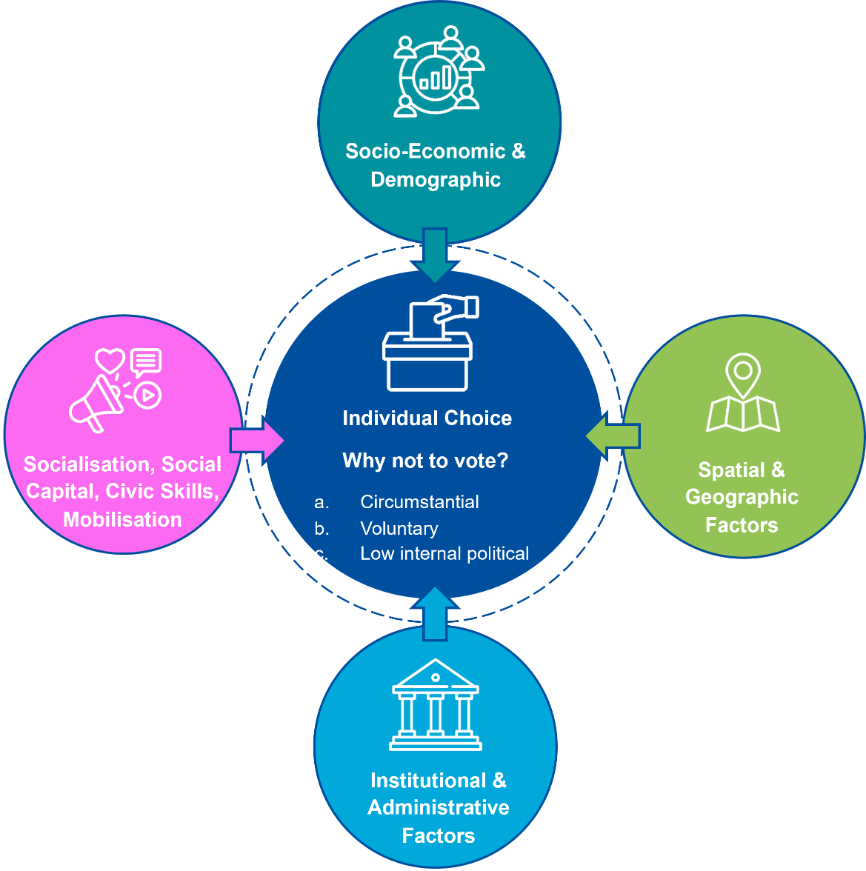

In Sections 3.1-3.6 we explore the levels of electoral participation by each group and use the framework set out above to identify barriers to participation, where possible.
The Paper stops short of identifying specific enabling policies or initiatives as the adequate policy or initiative is best identified when barriers are fully understood. Enabling policies or initiatives can usefully be placed into one of three categories (Table 2b). The first includes initiatives pursued through electoral laws or changes to how elections are administered. For example, introducing rights to advanced or postal voting, increasing the number of polling stations in an area, lengthening the hours in a polling day. The second includes policies pursued through informational resources and outreach such as objective information campaigns about the electoral process. The third comprises more deeply-rooted educational initiatives which aim to provide civic education skills and/or aim to support social networks which see voting as a norm.

Table 2b: Examples of initiatives which aim to enhance inclusion presented in three categories (for illustrative purposes only)
Electoral law | Informational | Deeper educational initiatives
Examples  Franchise – setting out who has the right to vote  Compulsory voting  Compulsory registration  Mechanisms of voting e.g. advance voting, postal voting  Specific mechanisms to help potentially marginalised to vote (e.g. disabled voters, speakers of minority language)  Changes/investment in the organisation of the electoral event e.g. regarding polling stations, staff etc. | Examples  Wide dissemination of objective information about  - Voting process  - Polling day, location of polling station, opening and closing of polls,  - What is required for registration and voting  - Candidates running in election | Examples  Education and outreach designed to promote:  - civic skills,  - internal and external political efficacy  - Media and social media literacy,  through formal and informal network and either targeted or universal.
Source: Adapted from James and Garnett (2021) pp.8-9.

3. Electoral participation and barriers to participation amongst groups
In Sections 3.1-3.6 we explore the levels of electoral participation by each group and use the framework set out above to identify barriers to participation, where possible. In each, we set out the legislative and policy context, sources of data for estimating turnout, the level of turnout and extent to which there is a participation gaps, and the factors which may explain low levels of turnout where they appear to exist.

3.1 Disabled persons

(i) Legislative and policy context legislative context
Box 3: Disability – population reporting disability
22% of population (1.1 million people) reported having a disability to a small, medium or great extent. Of this, 407,342 (8% of the population) reported experiencing a disability (long-lasting condition or difficulty) to a great extent, 371,496 of whom were aged 15 and over in 2022. Older age groups experience disabilities to a greater extent; the percentage of each age group experiencing disability to a large extent increased sharply after the age of 74.
Disability affects up to 22% of the population in Ireland (Box 3). There are many dimensions to disability even within the categories used by the Central Statistics Office (CSO) which are - disability as blindness or vision impairment; deafness or hearing impairment; difficulty with physical activities; difficulty with pain, breathing/chronic illness or condition; intellectual disability learning disability; psychological/emotional condition or mental health issue. Further, the CSO enquires about the degree of disability - whether a person experiences a disability “to a small, medium or to a great extent.”
The Electoral Act 1992 and electoral administrative practice have been amended in ways intended to reduce barriers to voting for people with disabilities. This includes providing measures for people with visual impairments (providing by regulation for tactile ballot papers with raised braille), providing a postal vote for those with a physical disability which prevents them from attending a polling station (section 14(d) 1992 Act) and extending this right to a person with any disability which prevents them from attending a polling station (Electoral Reform Act 2022 section 90).
The UN Convention on the Rights of Persons with Disabilities, signed in 2007, and ratified by Ireland in 2018, promotes a legislative and policy-making framework which addresses the everyday physical structures, societal norms and public attitudes which disable individuals with disabilities and aims to remove institutionalised inequalities. Article 29 of the Convention guarantees equal opportunity to participate in public and political life. In its reporting on compliance with Article 29, The National Disability Authority monitors how the legislative framework and the administration of elections creates barriers for, or enables, people with disabilities. The National Human Rights Strategy for Disabled People 2025-2030 was published in 2025 and commits to maximising the participation of disabled people in all areas of Irish life. And the post-electoral event reviews (PEERs) which are prepared by An Coimisiún under section 68 of the Electoral Reform Act 2022, must include a focus on supports offered to electors who may require special assistance on polling day.

(ii) Data on electoral participation
Despite the legislation, and the adoption of some policy and administrative practices designed to make voting more accessible for disabled people, information on the extent to which disabled people participate in voting is not at all complete. There is currently no clear way to assess whether work to improve accessibility enhances turnout. The available data does show that a small number of people with a disability apply for a postal vote; 3,564 people and 3,415 people were given a postal vote for reasons of illness or disability in the 2024 General Election and the 2025 Presidential Election respectively. While turnout among all postal voters was 56% in the 2025 election, we do not know the % turnout amongst those with a disability or illness.
Table 3 : Data on postal voting 2004 and 2025
Electoral event | Garda Síochána | Defence Forces | Diplomats | Illness or Disability | Occupation and Students | Prisoners | Anonymous | Total Postal
Referendum | 276 | 8390 | 500 | 1495 | 34 | 216 | 3 | 10914
Locals | 312 | 8565 | 575 | 2714 | 3933 | 409 | 30 | 16538
General | 315 | 8334 | 638 | 3564 | 2131 | 492 | 25 | 15499
Presidential | 314 | 8117 | 732 | 3415 | 1108 | 557 | 47 | 14290
Source: Supplied to An Coimisiún by Department of Housing, Local Government and Heritage
On the other hand, there is data going back over several waves about reported turnout among disabled people from the European Social Surveys and the European Quality of Living Study (explored in more detail below) which helps us to establish the extent to which there is a ‘disability gap’ in electoral participation in Ireland. Further, survey data is available on reported turnout by disabled people at the most recent general and presidential elections from An Coimisiún’s NEDS.
Before exploring this data for Ireland (iv below), it is useful to report the findings from international studies.

(iii) Electoral participation by people with disability
We look first at the international (iii) and then at data on Ireland (iv).
Electoral studies in the USA have included disability as a variable for decades. This has enabled in-depth analysis of the relationship between disability and political participation. Studies have consistently reported a disability turnout gap, although the gap fluctuates depending on the election and the state in question. The gap was far more pronounced in some states than in others. In spite of it fluctuating, and in spite of many policies to address it, the disability gap was found to persist in US election studies from 1980-2008. Reports on more recent congressional elections (2018 and 2022) found that turnout among disabled voters increased but that a turnout gap still exists. There are many dimensions to disability; the disability gap in voting in the USA has been found to be largest for people with cognitive and mobility-related disabilities and smallest for individuals who are deaf or hard of hearing. In general, the disability gap has been found to hold when the authors control for variables already known to affect the probability of voting - such as age, income, and political efficacy.
National election studies in most European states have not included disability as a variable in the same way as the USA studies do. However, the European Social Survey (ESS) which has been conducted every two years since 2001, has questions on reported turnout amongst people with a disability. In the ESS, disability and turnout are self-reported as explained in Box 4 below, and is, therefore, subject to the measurement drawbacks discussed in Section 2 of this report. It can also be subject to participation bias (e.g. disabled persons may be less likely to take part in surveys than others). The European Quality of Life Survey (EQLS) measures level of engagement using questions about trust in parliament and government and reported voting behaviour, and self-reported ‘impairment,’ the latter which is coded as mild or severe.
Box 4: ESS questions for measuring disability turnout
Variable 1 - Disability and health status
Q. Are you hampered in your daily activities in any way by any longstanding illness, or disability, infirmity or mental health problem? - enables coding of respondents as having no disability, having a moderate disability (yes, to some extent) or having a severe disability (Yes, a lot) (ESS, Source questionnaire (2023)).
Variables 2 – Political participation (self-reported) from Core B1- B45 on political interest, trust, electoral and other forms of participation.
Q. Some people don’t vote nowadays, for one reason or another. Did you vote in the last national election [insert date]? - is asked as part of the module and
Q. There are different ways to trying to improve things. or help prevent things from going wrong. During the last 12 months have you done any of the following:
- contacted a politician government or local government official?
- taken part in a lawful public demonstration?
There are other questions concerning trust and political interest. Confounding/control variables are also included in the ESS (these are discussed in the text below).
Using data from six rounds of ESS (2006-2016), Teglbjaerg et al found that turnout was significantly lower for those reporting a “severe disability” than it was for individuals with no disability across all years at a European level (e.g. reported turnout was 78.17% compared to 72% for those with a severe disability.) This remained the case when control variables were included in the model - age, gender, income, sense of political efficacy and political interest (the latter two variables were self-reported).
Priestly et al, using data from 28 states from EQLS, 2003, 2007, 2012, 2016, found that the average trust in parliament score amongst those reporting a severe impairment was 3.7 compared to 4.1 for those reporting none and that severe impairment decreased voting probability by 8 percentage points compared to people without impairments. Consistent with the findings in the studies cited above, Priestley et al found that a moderate impairment was not associated with low turnout. Priestly et al suggested that their findings pointed to a need for facilitative measures i.e. policies designed to enhance access for those with severe disability.
Using ESS data covering 32 European states, Matilla and Papageorgiou found that having a severe disability can be a barrier to voting and that having a disability that coincides with a perceived experience of discrimination amplifies the barriers to voting. They do not report at a country level.
Studies have also used ESS data to examine the relationship between disability and other forms of political engagement. Mantilla et al found that disability has a positive effect on other forms of political participation; people without a disability were less likely than disabled people to contact a politician, and far less likely than a disabled person who has experienced perceived discrimination to do so. Likewise, they find that disabled people who have experienced discrimination, are more likely (5-6 percentage points) than those with no disability, or disabled people with no experience of discrimination, to take part in a protest. They were unable to explain the direction of the effect when it comes to ‘perception of discrimination’ i.e. whether people participate politically and then experience discrimination or become involved because they have experienced perceived discrimination.

(iv) Electoral participation by disabled people in Ireland
When examining EES data at a country level, Teglbjaerg et al’s study (discussed above) found lower turnout amongst those with severe disabilities in 20 of the 24 countries and it was far lower in some (e.g. in Italy there was a 23% gap and in Poland a 17% gap). This gap remained statistically significant in most EU states when controlling for standard predictors of voter turnout (consistent with studies in the USA). Notably in that study Teglbjaerg et al did not find a statistically significant disability turnout gap in Ireland between those with severe disability and no disability.
To better understand the Irish case, An Coimisiún’s research staff and Kévin Saudé, University of Limerick, drew on the European Social Survey data (described above), adding more waves and adding control variables.
With the dependent variable self-reported turnout and the independent variable self-reported disability and health status (see Box 4), we used all waves (bar wave 4) of ESS data 2002-2023 for Ireland. Applying logistic regression analysis (which take account of the multi-level structure of the data and design effects (weights)), a sizeable disability gap was found for Irish people living with severe disabilities; respondents with severe disabilities were 10% less likely to report having voted than respondents with no disability and this effect is highly statistically significant (Figure 3 ).This is a slightly larger gap than the European average (8%). On the other hand, and consistent with the findings in other studies, we found that Irish respondents with mild disabilities are marginally more likely to report casting a vote compared to the European average (of mildly disabled people) and are equally as likely to vote as Irish people without a disability.
Figure 3: Regression model of turnout with disability
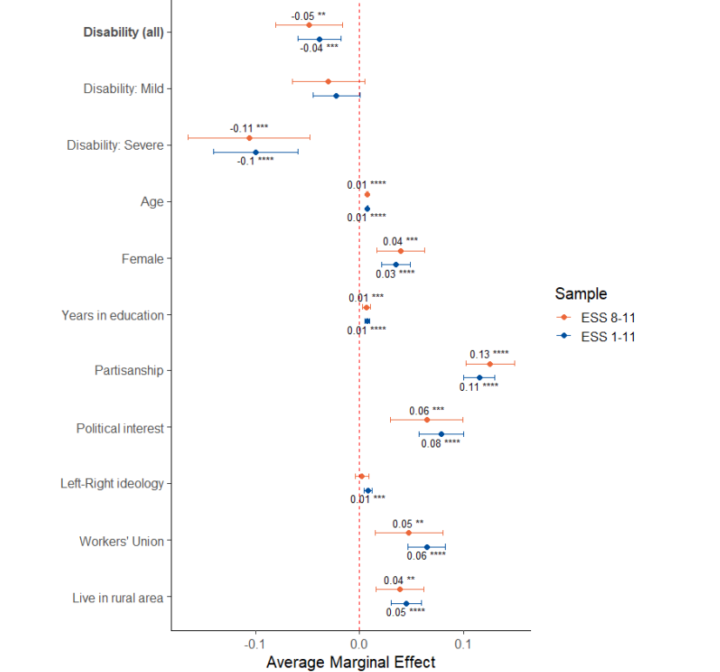
Source: Saudé for An Coimisiún (2025a) Results from a cluster-robust logistic regression model of turnout on disability. Weights are used to correct for unequal probabilities of sampling and non-responses. Full results (control model) are in Saudé (2025a).
Similar to international studies above, our analysis of all ESS data for Ireland finds that people living with a severe disability are more likely than the rest of the population to engage in alternative forms of political participation (contacting TDs, signing a petition, wearing a badge). Those with severe disabilities are 13% more likely to report having contacted their local TD compared to those with no disability (and those with any disability are 7% more likely to contact their local TD than those with no disability) (Figure 4). This effect is three times larger than the European average. This does not mean that those with a severe disability supplant voting with such channels of participation; rather, a higher percentage of disabled than non-disabled people engage in these activities.
Figure 4: Regressions of disability and different forms of political participation
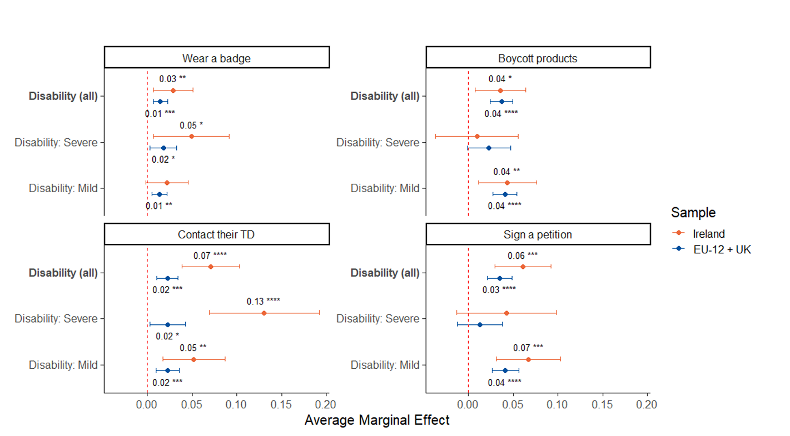
Source: Saudé (2025a) Average marginal effect of disability on political participation (summary of sets of cluster-robust logistic regressions using different dependent variables). ESS8-11 for Ireland and EU.
The ESS identifies people who experience a disability “to a great extent” but it does not allow us to identify the type of disability experienced. As noted above, election studies in the USA found that the turnout gap was considerably largest for those with cognitive and mobility-related disabilities (and lowest for those who were deaf or hard-of-hearing). An Coimisiún’s National Election and Democracy Study (2024) asks about the type, rather than severity, of disability. Respondents were asked if they had a disability and whether a condition was an (a) intellectual/mental health condition, (b) physical or (c) emotional/ psychological. While the findings were inconclusive because the sample size for each is small, the data suggested that people living with an emotional disability (n=162) were least likely to cast a vote and those with physical disabilities marginally less likely to vote than general population. Because of the small sample size, this finding should be interpreted with care and included as a consideration in any further research with larger sample sizes.

(v) Explaining low electoral participation
What might explain the significant relationship between ‘experiencing a disability to a great extent’(severe) and low reported turnout identified in many studies, including the analysis of all waves of ESS data for Ireland?
While there is no large-scale survey of attitudes and behaviour around electoral participation by disabled people, we can draw on the information we do have to tentatively answer this question and highlight where more research would be beneficial.
When considering the possible barriers that severe disability may present to participation, it is helpful to conceptualise severe disability as related to mobility and other physical conditions (including visual or hearing impairments) or to difficulty reading/filling out/handling voting materials whether for visual, intellectual or dexterity (recognising that some people experience both). Census data shows that for just over 62% of those reporting disability to a great extent, the disability is physical - pain/difficulty breathing, difficulty with basic physical activities, followed by those with hearing or visual impairments. For a smaller, but still relatively large proportion of those reporting a severe disability, the disability is not physical but related to a psychological/emotional/ mental health issue, is cognitive or is an intellectual disability (just over 37%) (Figure 5).
Figure 5: Number with a disability ‘to a great extent’
Source: CSO Census 2022, Profile 4 – Disability, health and Carers
From what we know about people who experience a disability “to a great extent,” it is clear that administrative and institutional arrangements for registration and voting can present distinct challenges. A social model of disability (as opposed to a medical model of disability), which is generally accepted as best practice, examines how administrative and environmental factors turn an impairment into a disability, and has been used to identify several possible points at which barriers to registration and voting may emerge. Some of these, which are clearly experienced differently depending on the type and severity of a disability, are below:
- voter registration requirements
- non-availability of feasible or easily-attainable alternative voting method to voting in person such as postal
- inadequate training and guidance on how to vote for people with learning disabilities
- lack of voting assistance or no training for election officials in non-discrimination (which can increase perception of discrimination which itself decreases turnout for some)
- inaccessible election information
- inaccessible polling places and
- legal restrictions, including a lack of clarity on procedure, for individuals who have been deprived of their legal capacity.
On this basis, several international and national policy instruments mentioned above emphasise the importance of making voting physically and cognitively accessible. As noted, An Coimisiún’s Post-Electoral Event Reviews, which involve collaboration with DPOs, evaluate the extent which infrastructure is accessible, and voting aids exist/are adequate for electors with disabilities.
While measures to enhance accessibility are monitored and constantly improved, we do not have information in Ireland about their relationship to turnout among severely disabled people; does enhancing accessibility improve the experience of voters who are severely disabled or does it simultaneously improve the experience and encourage severely disabled people who don’t ordinarily vote, to vote?
This is an important question because it is possible that factors other than a severe disability, but which arise in part as a consequence of living with a disability, are presenting barriers to voting for severely disabled people. Much international literature, and evidence from Ireland establishes a socio-economic dimension to electoral participation – in general, those with lower incomes, comparatively lower levels of education and who reside in more transient communities with comparatively low social and political capital - vote less. As noted by the ESRI and IHREC, the link between disability and poverty has been well documented, with evidence showing that in general disabled people are more likely to be in poverty and outside of the labour force. This is consistent with the international literature. Priestly et al point to “compelling evidence that disabled people experience systematically higher risks of household poverty and social exclusion in terms of unemployment, education, relative income and material deprivations.” Further, EQLS and SILC data consulted by Priestly et al indicated that disabled people were overall less likely to report participation in voluntary work, educational, social and political organisations, political parties and trade unions.
Further, as voting is associated with higher social capital and civic skills and connectedness with society and a community (Section 2), it is possible that in some cases a severe disability prevents participation in, and connectedness with, community and that this extends to participation in voting. The National Disability Authority (NDA)’s Wellbeing and Social Inclusion Survey Report (2022) found that those reporting disability to a great extent experience lower levels of social inclusion and community connectedness and were more likely to be dissatisfied with their non-participation in social, political and other activities. The concern is that for some people with a disability, social or physical barriers, as well as individual health limitations, may impede full participation in society in general and, as a consequence, in voting.
We further explored the ESS data to examine potential moderators of the disability gap in turnout in Ireland with a view to understanding what else might explain lower voting by those with a severe disability. In particular, we explored the extent to which the socio-economic and social/political capital variables associated with low turnout (set out in Section 2) apply to severely disabled people. A number of tentative findings emerged in this analysis which warrant further investigation.
Firstly, while living in a rural area is generally a predictor of voting in Irish literature, people living in rural areas who suffer from a severe disability are not more likely to vote than the general population. While the effect is small, it is statistically significant, and while it may be connected to distances from polling stations or other such logistical factors, it may also be indicative of marginalisation. Secondly, social connectedness – when measured by one proxy - “living as married (co-habiting) or married”- is a positive moderator of the effect of disability on turnout; in other words, the analysis found that the negative association of a severe disability with turnout is less pronounced when the severely disabled respondent is living with or is married to a partner. While our model did not include other proxies for social connectedness, we acknowledge that ESS questions designed to capture frequency of meeting socially and being involved in social activities could also serve as proxies for social connectedness.
Figure 6: Turnout by disability status and partnership status
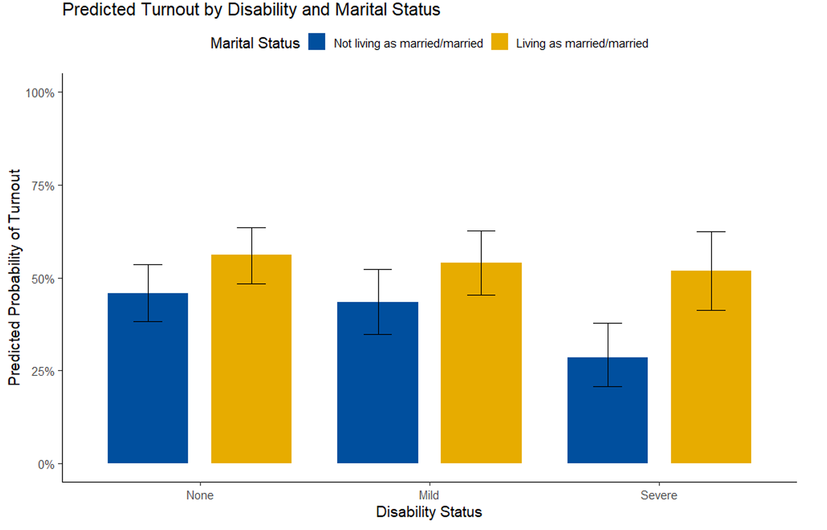
Source: Saudé (2025) analysis of ESS data for An Coimisiún Toghcháin
Finally, as noted above studies drawing on ESS data for all of Europe have found that reported turnout reduced further when a severe disability coincides with an experience of perceived discrimination. This suggests that social barriers interact and may reinforce institutional and administrative barriers to voting. Research by ESRI in Ireland finds that experience of discrimination by disabled people in Ireland varies substantially depending on the type of disability. Controlling for other variables, and exploring trends over time, the report concludes that people with blindness or serious visual impairment and with psychological/emotional disabilities are the most likely to experience discrimination, and that for all types of disability the likelihood of experiencing discrimination increases with age. If perception of discrimination is associated with reduced voting, this provides important context to identifying barriers.
Table 3A: Percentage of people with each type of disability and percentage of those with each type who experience discrimination
 |  | Adult People with disability | Experienced discrimination | Experienced discrimination
 |  | (%) | (%) | Margin of error  (± %)
People with no disability |  | 88.2 | 11.4 | 0.3
Any type of disability |  | 11.8 | 15.0 | 1.1
Blindness or a serious vision impairment |  | 0.6 | 22.5 | 5.1
Deafness or a serious hearing impairment |  | 0.7 | 8.2 | 3.3
A condition that limits one or more basic physical activities |  | 4.0 | 13.9 | 1.8
A learning or intellectual disability |  | 0.5 | 13.0 | 5.2
Psychological or emotional condition |  | 0.9 | 19.1 | 4.4
Other, including chronic illness |  | 7.4 | 15.5 | 1.4
Source: | Own calculation based on the QNHS Equality module (2010 and 2014); population aged 18 and over. Margin of error for the proportion of people with disability rages between 0.08 percentage points for people with learning or intellectual disabilities and 0.35 percentage points for people with any type of disability
Source: Banks, J., Grotti, R., Fahey, É., Watson, D. (ESRI and IREC, 2018) p.46.

(v) Key points and next steps
The studies consulted, and An Coimisiún and Saude’s analysis of European Social Survey data for Ireland, find that those living with a severe disability (defined in Box 4) are significantly less likely to vote than the general population (10 percentage points). This turnout gap is consistent with findings in international literature on other countries and slightly higher than the European average when using European Social Survey data.
While we lack direct survey data that specifically focuses on electoral participation by severely disabled people, the evidence does point to physical (mobility or cognitive) and social/psychological barriers to voting for those with severe disabilities.
The former relate to how accessible voting is both physically and cognitively including how easy it is to arrive at, enter and move around the polling station; to read and engage with the electoral materials; as well as to physically cast a vote. Where barriers relate to mobility or visual issues, administrative and institutional measures to improve accessibility have been put in place and are monitored (as noted above). There is a case for an empirical study which directly consults with severely disabled persons on the extent to which institutional and administrative factors continue to present barriers to participation, on the level of awareness of these measures and on their impact on turnout.
Regarding social/psychological barriers, the evidence suggests that a variety of other factors, many arising as a consequence of being severely disabled, intersect to present barriers to voting. For example, there is evidence that severely disabled persons are, on the whole, more likely than others to experience social exclusion and deprivation both of which are associated with lower turnout. Our analysis of the ESS data for Ireland (2002-2023) found that social connectedness measured in this instance by a proxy - “living with or being married to a partner”- significantly reduced the negative association between severe disability and turnout i.e. this person is more likely to vote. Measures which increase social inclusion for disabled people - which is a key goal of the National Human Rights Strategy for Disabled People 2025-2030 - may reduce the barriers to voting associated with social connectedness and political capital.
There is also a case for consulting directly with severely disabled people with a view to understanding how social inclusion/connectedness, and socio-economic factors, affect electoral participation and whether non-voting is primarily voluntary, circumstantial or related to low political efficacy. In this respect, consideration should be given to including questions on electoral participation in the National Disability Survey, proposed in the National Human Rights Strategy for Disabled People 2025-2030.

3.2 People from a migrant background
Box 5: Migrant population
According to the most recently available data (ESRI, 2025), 21.7% of the population in 2024 was born outside the State. Just over half of this subgroup was born in the EU or in the United Kingdom, including Northern Ireland (4.75% in the UK, 1.82% in the western EU, 4.86% in the eastern EU). A further 1.74% of the population were born elsewhere in Europe. This data did not include those living in communal settings such as beneficiaries of temporary protection (BoTPs) arriving from Ukraine or international protection applicants.” These figures do not include second-generation people of a migrant background. Between 2005 and 2023, over 140,467 non-EEA nationals aged 16 and over became citizens.

(i) Legislative and policy context
“People from a ‘migrant background” include (i) people who migrated to Ireland and have since become Irish citizens, (ii) second-generation Irish citizens born to migrant parents, and (iii) non-Irish citizens who live in Ireland. This is the definition used by the Immigrant Council of Ireland and the approach taken by the ESRI’s European Minority Network (EMN) Report. The definition includes migrants who are, and who are not, from a minority ethnic background. The implications of using this broad definition for our understanding of electoral participation are further discussed throughout.
People from a migrant background who fall into categories (i) and (ii) above are entitled, as Irish citizens, to vote in all electoral events. The last category – non-Irish citizen residents of Ireland – may vote in local elections and, if they are a citizen of an EU member state, may also vote in European elections (Box 6). UK citizens residing in Ireland may vote in local and general elections.
Box 6: Franchise for “non-Irish citizen residents” in Ireland
Under the Electoral Act 1992 (Section 10), “a person shall be entitled to be registered as a local government elector in a local electoral area if he has reached the age of eighteen years and he is, on the qualifying date, ordinarily resident in that area.”
Those ordinarily resident in a state who are not citizens of that sate are frequently referred to in the literature as “non-citizen residents” to distinguish their enfranchisement rights from citizen residents.

(ii) Data on electoral participation
Because of the constraints on the number of variables that can be reflected in a random sample, and because election surveys tend to focus on general and not local elections, the Irish National Electoral Studies (2002-2020) did not provide data on voter participation amongst people of a migrant background. As the proportion of the population who are from a migrant background who are also citizens (the latter can vote in general elections) increases, this is likely to change.
There is some data on electoral participation. An Coimisiún’s NEDS for the 2024 General Election and the 2025 Presidential Election included a question designed to determine whether a respondent is from a migrant background. And for local elections, it is possible to use registration rates as an indicator for the levels of participation of non-Irish citizen migrants in local elections. Further, a number of qualitative studies have explored participation rates amongst different migrant communities in Ireland. We next use this data to set out what we know about electoral participation.

(iii) Electoral participation by migrant communities
As noted above, Irish citizens from a migrant background are enfranchised for all elections. An initial analysis of the NEDS data shows that respondents born in Ireland were 10% more likely than eligible people not born in Ireland to vote in the general and presidential elections. This suggests that being an Irish citizen from a migrant background had a powerful negative and statistically significant effect on turnout in the general and presidential elections (Figure 6A). The effect of having at least one parent born outside of Ireland, which denotes second-generation citizens, also has a negative effect on turnout in both the general and presidential elections; people with at least one parent born outside of Ireland were 4% less likely to report voting (after accounting for other explanations). The size of the sample not sufficient enough that to further assess whether the level of participation among migrant and second-generation-migrants with Irish citizenship differs according to other socio-demographic variables (e.g. rural/urban constituency, age, county of origin, residential status).
Box 7: Data for assessing level of registration
The voting-age population (VAP) is the number of people aged 18+ residing in a country (where the legal voting age is 18+). The voting-age population is the number of people who are eligible to register to vote. It is frequently used to measure turnout i.e. the total number of people who cast a vote is expressed as a percentage of the VAP.
To obtain the VAP for non-Irish citizen migrants, we use the number residing in each local authority area aged 18+ using Census data broken down by age, local authority area and nationality. Note that as UK citizens are eligible to vote in general elections, they are excluded from the “non-Irish citizen” population.

The number of non-Irish citizen migrants registered, and the proportion of the full register they make up, can be calculated from the full electoral register because it is possible to discern the number on each register who are only eligible to vote in local, or local and European, elections.
An analysis of registration rates for migrants who are not Irish citizens in local elections also suggests relatively low levels of engagement. If all non-Irish citizen migrants in Ireland were registered to vote, the number of non-Irish citizens of voting age resident in a local authority area would be equal to their number on the electoral register (the voting-age population - VAP). This data is available and explained in Box 7.

Figure 6A: Average marginal effect of independent variables on turnout based on NEDS data for general (2024) and presidential election (2025) (see “born Ireland” and “second-generation immigrant”)
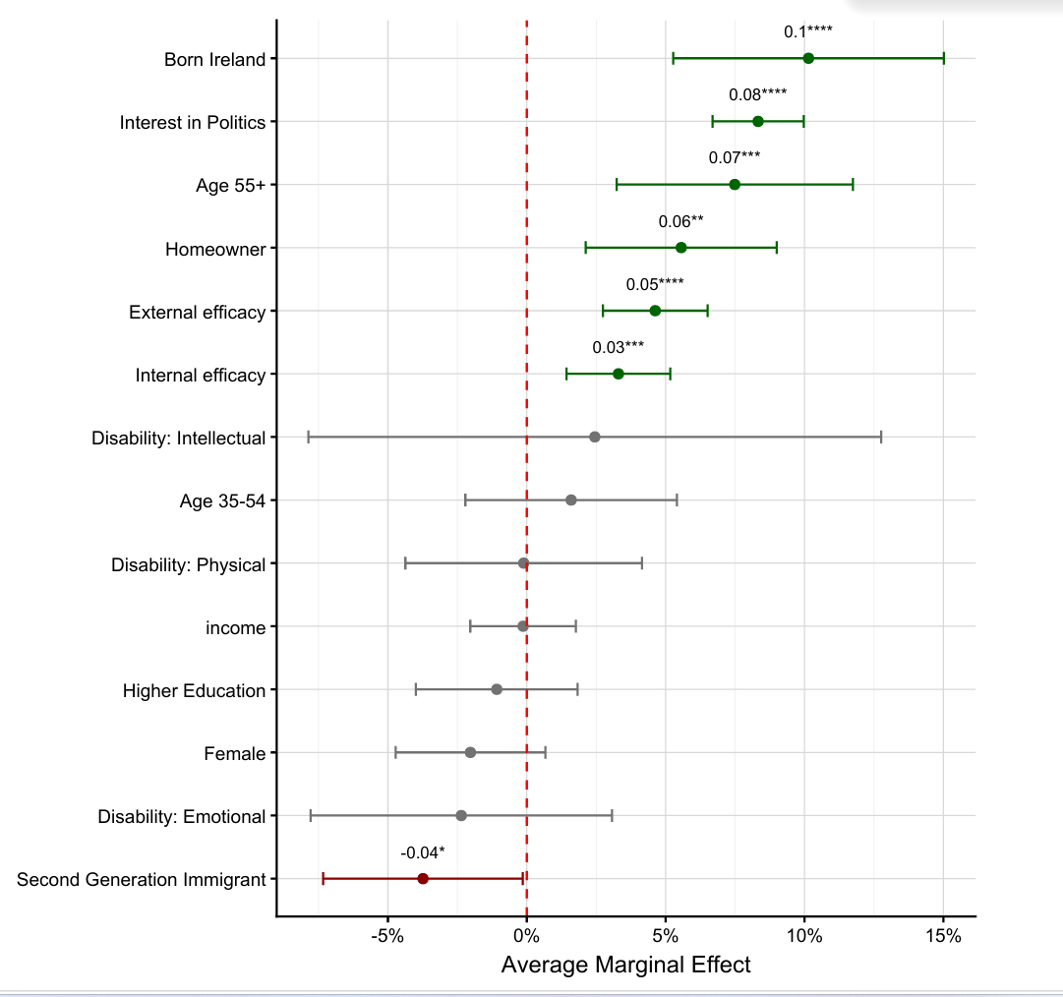
Source: Saudé (2026)
Figure 7 compares the percentage of the total voting age population made up of non-Irish citizen migrants in each local authority area with the percentage of non-citizens on the electoral register for the local elections in 2024. It shows that in the vast majority of the local authority areas, the non-Irish citizen migrant percentage share of the population was more than double their percentage share of the local electoral register and in the case of Dublin City, it was almost four times.

Figure 7: Migrants (non-Irish citizen) as % of voting-age population and as % of registered voters 2024.

Source: See Box 7
When aggregated, the proportion of the local electoral register made up of non-Irish citizen migrants is just under 6% (5.7%). Table 4 shows more clearly the extent to which the voting-age population of migrant non-Irish citizens exceeds their proportion of the electoral register. Data from the 2019 Local Elections, calculated by Lima, showed a similar picture and, if anything, non-Irish citizens migrants made up even less of the electoral register in 2024 than their share of the voting-age population for local elections. This can be explained by an increase in the non-Irish citizen migrant population.
Table 4: Extent to which the “voting age population” of (non-Irish citizen) migrants exceeds number of migrants listed on the local electoral registers
Local Authority | Registration gap
Carlow County Council | 2.8
Cavan County Council | 2.8
Clare County Council | 2.4
Cork City Council | 2.9
Cork County Council | 2.3
Donegal County Council | 1.8
Dublin City Council | 3.7
Dún Laoghaire-Rathdown Council | 2.8
Fingal County Council | 2.4
Galway City Council | 2.1
Galway County Council | 3.4
Kerry County Council | 1.6
Kildare County Council | 3.9
Kilkenny County Council | 3.1
Laois County Council | 1.9
Leitrim County Council | 1.6
Limerick City & County | 2.3
Longford County Council | 1.8
Louth County Council | 1.9
Mayo County Council | 2.1
Meath County Council | 2.9
Monaghan County Council | 1.5
Offaly County Council | 2.7
Roscommon County Council | 2.5
Sligo County Council | 2.1
South Dublin County Council | 2.2
Tipperary County Council | 2.1
Waterford City & County | 3.6
Westmeath County Council | 2.6
Wexford County Council | 2.5
Wicklow County Council | 2.9
Source: See Box 7
Survey and qualitative research exploring electoral and political participation amongst different migrant communities in Ireland have also pointed to low levels of registration and voting. For example, Pszczolkowska and Lesinska found that the relatively strong socio-economic integration of Polish people into Ireland took place in spite of very low formal engagement with the political system; just 12% of Poles in Ireland declared that they had voted in every election in which they were entitled to (2021). Among African communities, Fanning and O’Boyle found high interest in civic and political engagements but low actual political and electoral participation. Research in 2022 indicated that the number of Muslim residents in Ireland who take up voting rights is low. A study by William Durkan (UCC) and the Immigrant Council of Ireland, funded by An Coimisiún under Research Ireland’s New Foundations Programme, is exploring electoral participation by migrants (2026) and will add to this knowledge.
Lower participation is not exclusive to Ireland; research on the participation of immigrants consistently shows lower turnout than that of people born in the home state even when controlling for the age and class variables that are found to predict political participation. Rolfe notes that electoral studies in the USA since the 1920s have found that immigrant status is negatively associated with turnout and extensive comparative studies by Bird, Saalfeld and Wust and by De Rooij find low immigrant turnout in Europe to cite just a few.

(iv) Explaining low levels of participation
Recalling the participation framework in Section 2, socio-economic and demographic variables predicting low participation (e.g. age, income, education level, residential status) may in part explain low participation by migrants in Ireland. Migrants are younger (except for migrants from the UK), are much less likely to be homeowners, and are concentrated in the private rental sector (rather than in local authority or social housing), all factors associated with lower turnout (Section 2.2).
Yet the migrant community in Ireland is diverse in terms of these socio-economic variables. Evidence from the ERSI’s European Migrant Network Monitor shows that at a general level the migrant population does not exhibit some of the socio-economic characteristics associated with lower turnout; the migrant population as a whole has higher levels of educational attainment and employment than Irish born. Migrants overall were more likely than the Irish-born group to report being in good health. On the other hand, migrants have a higher risk-of-poverty rate compared to Irish-born residents - 14.5% compared to 11%. This rate is primarily driven by a very high at-risk-of-poverty rate for migrants born outside the EU, one in five of whom are income poor (20.4%). Material deprivation, the enforced lack of two or more of eleven essential items, is also higher for migrants, at 23%, compared to just under 16% for Irish-born residents. These estimates do not include migrants living in communal accommodation, who, if they are not employed, are likely to be income poor.
As such, socio-economic and demographic variables may partly explain low levels of participation, and especially among some migrant communities highlighted above. But the literature in Ireland and internationally suggests that other factors better explain barriers to electoral participation for migrants.
Research in Ireland identifies reasons for low engagement which broadly fall into the sociological/social capital and institutional categories (see Table 1 and Figure 2 above). A study on the Polish community found that political culture, attitude towards politics (often learnt and developed in the country of origin) and lack of awareness of their right to vote and how to exercise it - including lack of education about PR-STV - explained low take-up. In addition to social exclusion, barriers identified by members of the African community concerned language, insecurity of residential status and distrust of institutions, and some of those surveyed had experienced racism. Qualitative research undertaken with the Muslim community in Ireland found that there were high levels of civic participation and engagement at a community level in spite of low take up of voting rights and the study highlighted a role for political parties in better building on this engagement.
The link between electoral engagement and the social network in which a migrant is located, including the level of integration they experience with society generally, is emphasised in the international literature. Political knowledge, involvement in associations and, especially, in social networks which include frequent contact with “host country community’s citizens” as well as social factors (tradition of voting of parents or self in home country) have been highlighted as predictors of engagement. Blais et al, in a study based on administrative data in Finland, found that social inclusion - measured by marriage and/or parenthood with a person who has grown up in the state in question – and previous experience of democracy were the strongest predictors of turnout among migrants. Engdahl’s research in the UK and Sweden found that the length of time one is resident positively affects political participation rates. This is consistent with De Rooij’s findings. De Rooij, who uses data from the European Social Survey, finds the length of time a migrant has lived in the state in question is positively associated with political participation and that reasons for participation are associated with “access to recruitment networks.”
Engdahl (2019) also suggests higher levels of participation by migrants who become Swedish citizens than those who do not; turnout amongst non-Swedish nationals entitled to vote in Swedish local elections in 2014 was 46.1% and 29.1% respectively among the African and Asian communities compared to 89.2% for Swedish-born eligible voters. In legislative elections that same year turnout amongst migrants who had become citizens was 72.8% compared to 89.2%, this a far smaller turnout gap. This may not be surprising; acquiring citizenship is an indicator of perceived connection with the new state. In Switzerland, where some cantons grant voting rights to non-Swiss citizen migrants and others do not, Kayran and Nadler explore the effect of granting these rights on turnout among migrants who are citizens. Using house-hold panel data, they found that granting voting rights to non-citizens at canton level, while they may not be frequently exercised at that point, appears to boost political participation rates overall and particularly enhances turnout among citizens with a migrant background.
Further exploring social inclusion and networks, Engdahl’s study of Polish and Somali migrants living in Ealing (UK) and Malmo (Sweden) concluded that the development of a type of dual identification, often nurtured through participation in cross-national community groups or projects, determines political participation by “non-citizen residents.” High levels of civic engagement may be a building block towards greater political engagement if cross-national links with the citizen community are supported or encouraged. A study of Turkish and Moroccan migrants in Rotterdam found that civic participation was an important determinant of voting in local elections and more important than trust in institutions; participation in co-ethnic organisations was indirectly positively related to voting through cross-ethnic participation. For Moroccan migrants, client-orientated organisations mattered, while for Turkish migrants, authority-orientated mattered. Engdahl concluded that formal opportunity structures - such as voting and candidature rights and active engagement by political parties with migrants - are important but insufficient to mobilise migrant groups; rather they argue that “a dual identification with the recipient society and with their in-group promotes the desire to use political rights and positively affects participation.”
Similarly, Fanning and O’Boyle’s research among African and Polish residents of Ireland found evidence that membership of social networks, especially outside of the community of origin, helped to foster political participation including participation as a candidate in an election. In later research, Fanning and Michael report that migrants face different challenges and barriers to integration. These differences, they note, are in part determined by their formal rights and entitlements (which affect access to housing, employment and education) and are also determined by experiences of racism or discrimination. These challenges are likely to affect access to the social networks that appear to be conducive to electoral participation.

(v) Key points and next steps
There is limited data on electoral participation by the migrant communities available, but it is clear that electoral participation is comparatively low:
- Registration rates by non-Irish citizen migrant communities in Irish local elections are lower, and in some cases much lower, than the wider population
- Perhaps most notable is that our analysis of NEDS data (general and presidential elections 2024-25) suggests low turnout among Irish citizens who are migrants, and among Irish citizens who are second-generation migrants (citizens for whom at least one of their parents was born outside of Ireland).
- Qualitative research studies with Polish, African and Muslim communities have reported relatively low levels of engagement.
The apparent low level of participation is consistent with studies on electoral participation by migrants from international election studies.
Studies, both in Ireland and internationally, suggest that there is a unique set of factors that explain low levels of participation by migrant communities connected to:
- lack of political knowledge about the host state’s political system,
- lack of perceived stake in society (at least initially),
- weak connectivity to society/social networks, and
- political culture which was developed prior to arrival.
And international research, and research amongst specific migrant communities in Ireland, have identified as enablers of turnout:
- The more time a migrant has resided in the country, and
- the more migrants belong to community/social networks (in particular cross-community networks which involve contact with local-born citizens).
It is likely that the administrative and social barriers identified in the literature (above) explain low levels of registration by migrants for local elections and the significant participation gap in turnout at the 2024 and 2025 elections between citizens from a migrant background and all other Irish citizens. In addition to reducing administrative and informational barriers about voting and politics in general, research points to engagement through social networks as promising for promoting electoral participation by people from migrant backgrounds. There is also a role to be played by political parties.
However, that migrants’ propensity to turn out is predicted to increase with the length of time they spend in the country may be at odds with the turnout gap we find between Irish citizens born in and outside of Ireland. There is a case for directly engaging with new and second-generation Irish citizens of a migrant background to further explore barriers to voting, including whether the barriers faced differ depending on a migrant’s background. The ESRI has highlighted the absence of surveys that directly engage with the migrant community as a challenge to the production of its EMN report on the integration of the migrant community. Given the linkages between social inclusion, integration and electoral participation, there is an opportunity for collaboration.

3.3 Travellers

(i) Legislative and policy context
32,949 people in Ireland identified as Travellers in Census 2022, approximately 0.6% of the State’s population. Travellers reside in all of Ireland’s counties and cities, with the population of Travellers growing in most counties between 2016 and 2022. Travellers are regarded, and regard themselves, as distinct from other sections of Irish society and have a unique culture, value system and language. Travellers have a shared history, and traditions including, a nomadic way of life on the island of Ireland. Irish Travellers were formally recognised as a distinct ethnic minority by the Irish Government in 2017 by way of the Taoiseach’s Statement in the Dáil which was supported by all partes. Prior to this, the Prohibition of incitement to Hatred Act 1989, the Equal Status Acts 2000-2015 and Employment Equality Acts 1998-2015 had recognised membership of the Traveller community as a ground of discrimination.

(ii) Data on electoral participation and data on correlates of turnout
There is a distinct lack of data pertaining to the participation of the Traveller Community in Ireland’s electoral and democratic processes. There are civil society organisations who engage in voter outreach with Travellers but, to date, we are unaware of data on registration and turnout. There is some international data on turnout. In the UK, the Traveller Movement “confirms turnout is very low, more so than for other minority groups.” International evidence suggests that Roma populations in Europe, in most instances, exhibit lower turnout rates than the wider population. While this Paper is focused on electoral participation by Irish Travellers, as Travellers and Roma share some characteristics these studies are discussed for comparative purposes at (iii) below.
In the absence of data on participation, we explore the extent to which the correlates of turnout set out at Section 2 describe and are experienced by Travellers.
It is clear that Travellers disproportionately experience the socio-economic circumstances associated with low electoral participation. Travellers experience higher rates of unemployment and lower levels of educational attainment than the general population. According to Census 2022 data, the unemployment rate for Travellers was 61% compared to 8% for the general population. According to a recent survey of Travellers in Ireland (2024) 22% were in paid work (up from 15% in 2019), compared to 79% of the overall population and 84% felt discriminated against when seeking employment. The same study found 65% of young Travellers were not engaged in any form of employment, education or training, compared to 7% of young people in the wider population.
While the number of Traveller students completing the Leaving Certificate has risen in recent years (31.4%), it remains significantly lower than the national average (91.7%) and while the number of Travellers with a third-level qualification had doubled since 2016 and tripled since 2011, 4.7% of Travellers completed third level education compared to 47.7% of the general population. At primary level, Urban Band 1 DEIS schools (the most disadvantaged in terms of school profile) are over eight times as likely as non-DEIS schools to have a high concentration of Traveller students. Poverty is a more prevalent issue for Irish Travellers than in the wider population. And data suggests that Travellers experience substantially higher rates of ill-health affecting them on a day-to-day basis compared to other groups in the population.
There is evidence of social exclusion, a condition also associated with lower electoral participation owing to exclusion from certain social networks. Membership of the Traveller Community has been identified as increasing a person’s risk of experiencing discrimination, harassment and stereotyping and anti-Traveller racism. For example, a study that explored media coverage of the community found that Travellers are usually discussed in fields such as criminality, legal systems, accommodation, community and attitude - fields that inherently carry “the imprint of negativity.” A report for Dublin City Council in 2024 notes that Travellers are ten times more likely than White Irish (non-Traveller) to experience discrimination in the job market, and are over 22 times more likely to report discrimination relating to private services (e.g. pubs, restaurants). A comparative survey (2024), found that 75% of Travellers in Ireland reported experiencing discrimination in the previous year, up from 65% in 2019. This was itself one of the highest reported rates of discrimination in any group across the participating nations. The 2024 General Election NEDS found that 37% of respondents would not welcome a Traveller as a member of their family, more than those who would (35%) or who were neutral (20%).
Experience of higher residential mobility, also associated with electoral disengagement, affects the Traveller Community. Nomadism remains a key part of Traveller identity and “central to the understanding of Traveller society”, although a declining minority of Travellers in Ireland now live a nomadic lifestyle.Comparatively low rates of homeownership, and the breakdown of social pathways which arise from experiencing discrimination, are both associated with lower electoral participation.

(iii) What could cause low levels of participation
While there is no published research which directly explores participation in voting by Irish Travellers, international research on electoral participation by Roma in Europe, and research on Traveller engagement with the institutions of the State, highlights some potentially relevant findings.
One set of barriers identified is administrative. Research in Europe has identified administrative barriers to participation including paperwork associated with registering and the need for relevant identification documents to register and vote. In 2021 before the UK Government introduced new voter ID laws, 7.5% of the electorate did not possess a valid form of ID which could be used to vote, with minority groups (including Gypsy, Roma and Traveller voters) being disproportionately affected. The enactment of stricter voter ID laws in several US states has also been shown to have had a disproportionately negative impact on ethnic and racial minorities’ ability to vote. OSCE/ODIHR election observation missions identified lack of awareness around civic rights and electoral processes as a suppressant of Roma turnout in the EU.
It is possible that similar barriers exist in Ireland. The disproportionate levels of illiteracy among the Traveller Community may act as a barrier to voter registration and voting. Paperwork has been identified as a barrier when Irish Travellers attempt to engage with other processes (e.g. in the legal system).
Another set of barriers may be around resources, social inclusion and trust. One study suggests that the afore-mentioned administrative barriers foster lower levels of confidence and trust in State institutions and processes within the Traveller Community (for example, the justice system). Marginalisation, also caused by experiences of discrimination referred to above, can engender a distrust in institutions which discourages engagement. In a submission to an Oireachtas Taskforce (2024), The Irish Traveller Movement stated that the discrimination experienced may detrimentally affect Traveller participation rates in several ways, including by fostering disengagement with formal State structures, and by breaking down the social and community pathways through which many voters become engaged with politics. In 2024, 23% of Travellers were found to express confidence in the Gardaí, compared to 76% of the general Irish population. The same study found that only 11% of Travellers reported discrimination to an official body, down from 28% in 2019; this in spite of the fact that there was a rise in the instances of discrimination experienced by Travellers in the same period. Research regarding local participatory governance in Ireland has also indicated particular dissatisfaction among the Traveller Community, many Travellers feeling that such processes do not adequately address their concerns and fail to appropriately deliver services such as housing. It is plausible that this erosion of confidence and trust could also reduce engagement in electoral processes. Some within the political system have observed that some members of the Traveller Community see voting as an issue for settled people rather than one that applies equally to themselves.
International research on Roma participation points to the lack of attention to issues affecting Roma during election campaigns and that this exacerbates disinterest and disengagement with elections within the community. OSCE/ODIHR missions have identified political parties’ hesitation to target Roma voters/issues, and to run Roma candidates, as detrimental to Roma turnout.

(iv) Key points and next steps
There is no direct information about electoral participation by Travellers in Ireland. Socio-economic and demographic variables associated with Travellers, the societal and institutional, direct and indirect, discrimination which they face, and international evidence pointing to low political engagement by Traveller and Roma communities, all point to a particular need to further research this field in the Irish context.
As such, An Coimisiún has identified electoral participation by Travellers as an area for further research under Strand D. This study will aim to explore and explain electoral participation, including understanding circumstantial, voluntary abstention or abstention related to low-political efficacy, identifying barriers to participation where they exist and evaluating measures to enable electoral engagement by the Traveller community. This research will commence in 2026.

3.4 Young people

(i) Legislative and policy context
Under the Constitution, citizens who have reached the age of eighteen are entitled to vote in general and presidential elections and in referendums. This has been the case since the fourth amendment to the Constitution – which lowered the voting age from 21 - was approved by referendum in 1972 and subsequently implemented by the Electoral (Amendment) Act 1973. Eighteen is also the voting age for local and European elections, this was provided for by legislation.
With a view to encouraging electoral participation, the Electoral Reform Act 2022 provides that those aged 16-17 can enter their name on the electoral register in advance of their enfranchisement. Further, full-time students who are studying at an institution in Ireland, which is away from their home address, are one of six categories of people entitled to apply for a postal vote. To date, few students have utilised the postal vote (see Table 3 in Section 3.1 above) which is discussed later in this section.

(ii) Data on electoral participation
There is considerable data on reported turnout among young people internationally and in Ireland. In Ireland, the Irish National Election Study (2002-2020), NEDS (2024-2025), the European Social Survey (ESS) and Eurobarometer as well as the Growing up in Ireland Survey, include data on reported turnout or engagement by age.
This data is used below to describe electoral participation by young people, drawing on the existing literature as well as including a unique analysis of several waves of ESS data to explore young people and electoral participation in Ireland. In line with international studies, by ‘youth’ or ‘young people’ we generally refer to those who fall into the 18-24 year-age group (while information is included on other age brackets where available).

(iii) Electoral participation by young people
Studies consistently find that younger people in Ireland vote less than older groups. In fact, in an overview of voter behaviour in Ireland, Cunningham and Marsh say that “one of the most striking patterns of turnout is the association with age.”
Those between 18-24 are least likely to report voting according to the recent NEDS (2024) which demonstrate a clear gap in reported turnout between the 18-24 age group and those outside this age group. This gap was 22% and 24% in the local and European elections respectively and 20% in the general election. And in the NEDS prior to the March 2024 referendums, 39% of 18–24-year-olds compared to 62% of total respondents (23% gap) said that they were certain to vote (Figures 8 and 9).

Figure 8 Youth vs Non-Youth Voter Turnout
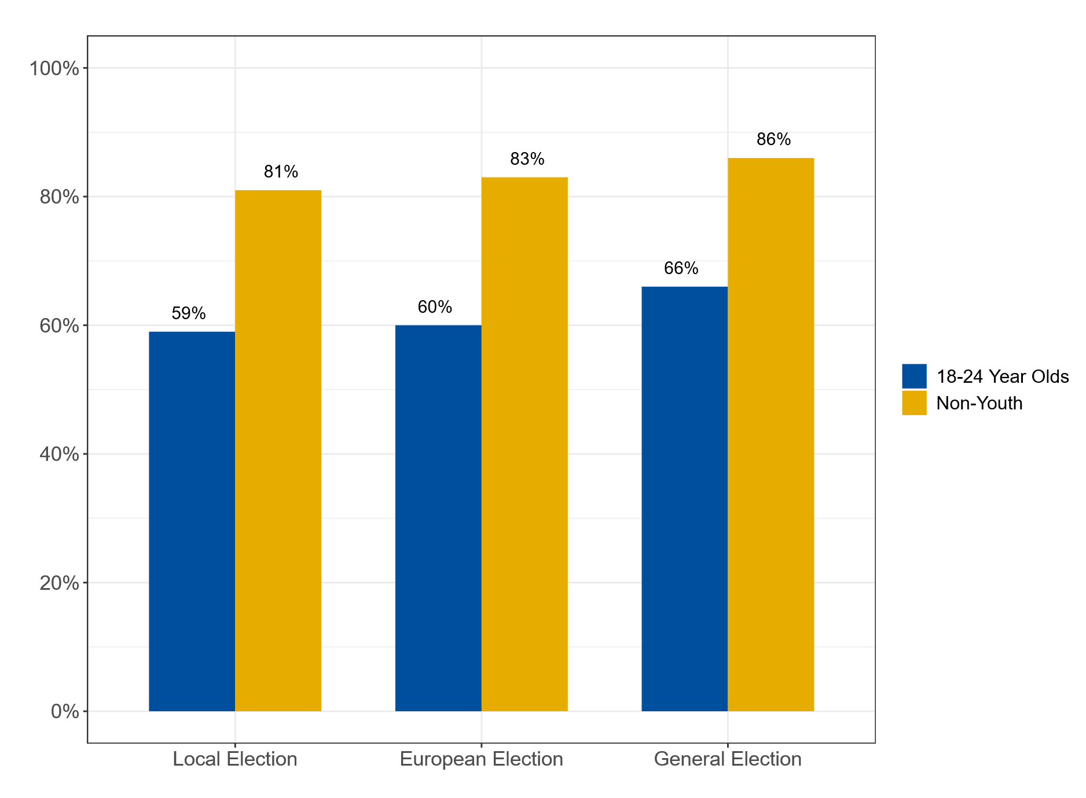Source: An Coimisiún analysis of the National Election and Democracy Study
Earlier data from the Irish National Election Studies also indicates lower levels of reported participation by younger people. Figure 9, which compares reported turnout at general elections among the 18-24 years with that of all respondents, demonstrates a clear pattern of younger people being less likely to vote.
Figure 9 Youth versus total population reported turnout (INES)

Source: An Coimisiún analysis of reported turnout (INES data)
An Coimisiún’s exploration of eleven waves of European Social Survey data is consistent with these studies. This primary study, the key findings of which we report below, demonstrates that younger people aged 18-24 report voting at remarkably lower levels than their older counterparts across all waves (2002-2023) (Figures 10 and 11).
Figure 10 Voter turnout by age across ESS waves 1-11
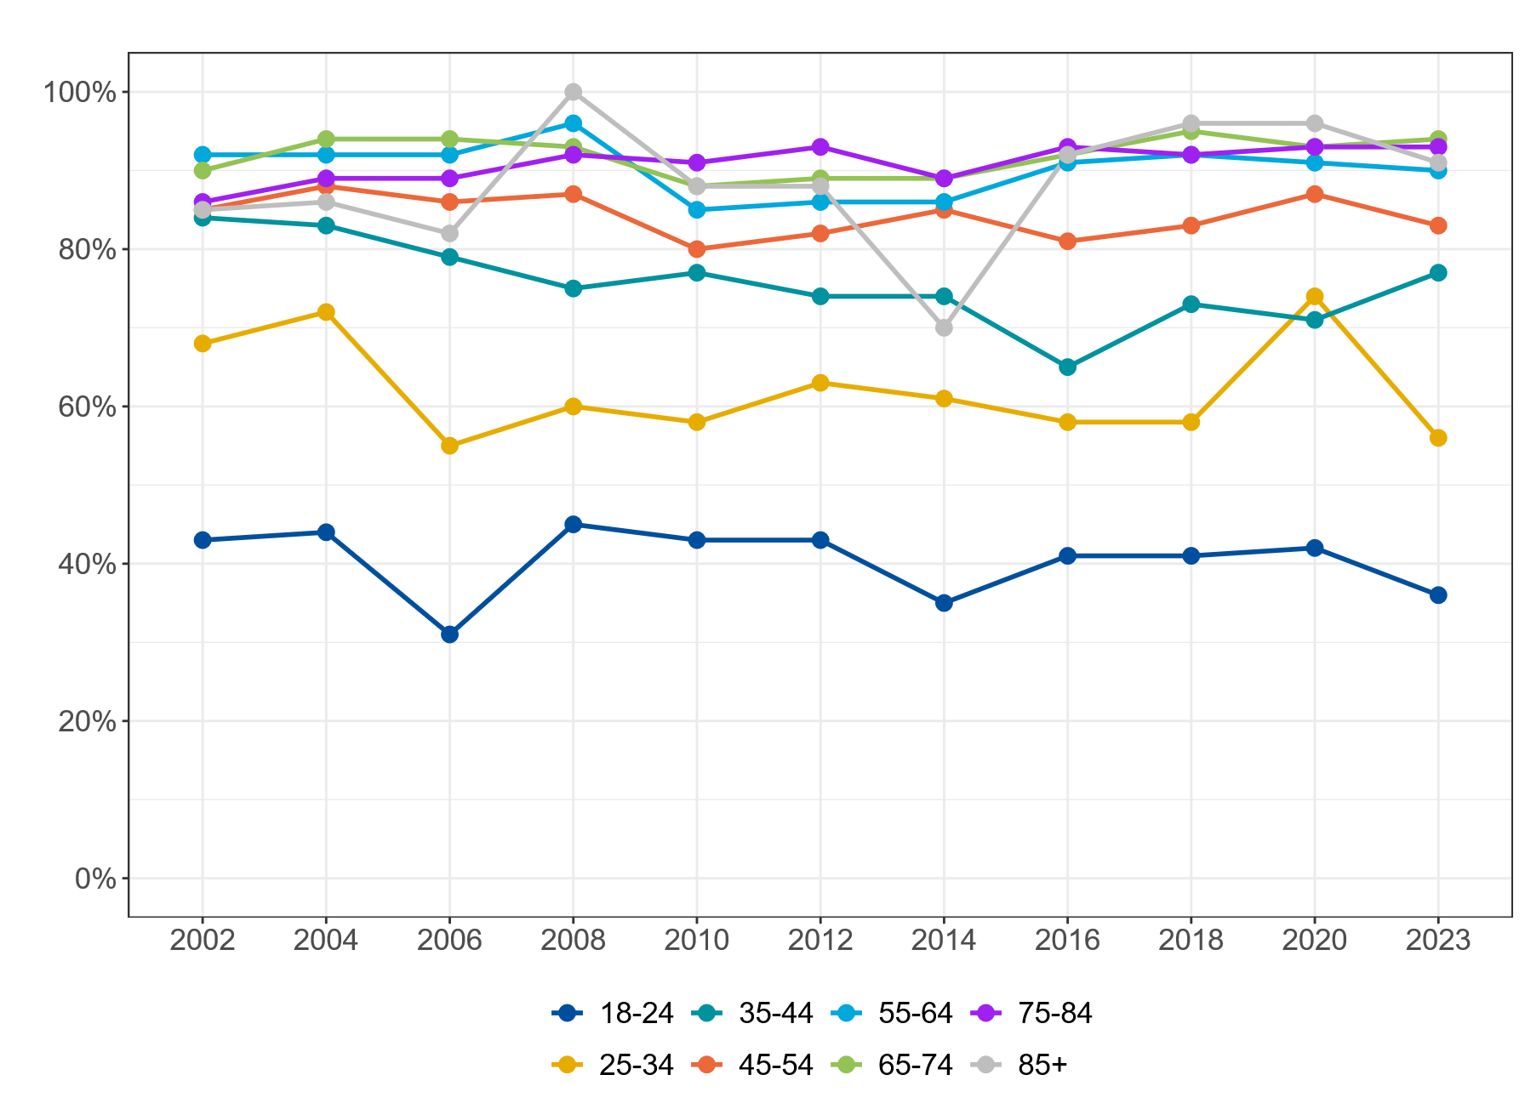
Source: An Coimisiún’s analysis of reported turnout in European Social Survey (2025)

Figure 11 Voter turnout by age (Young people and general population)
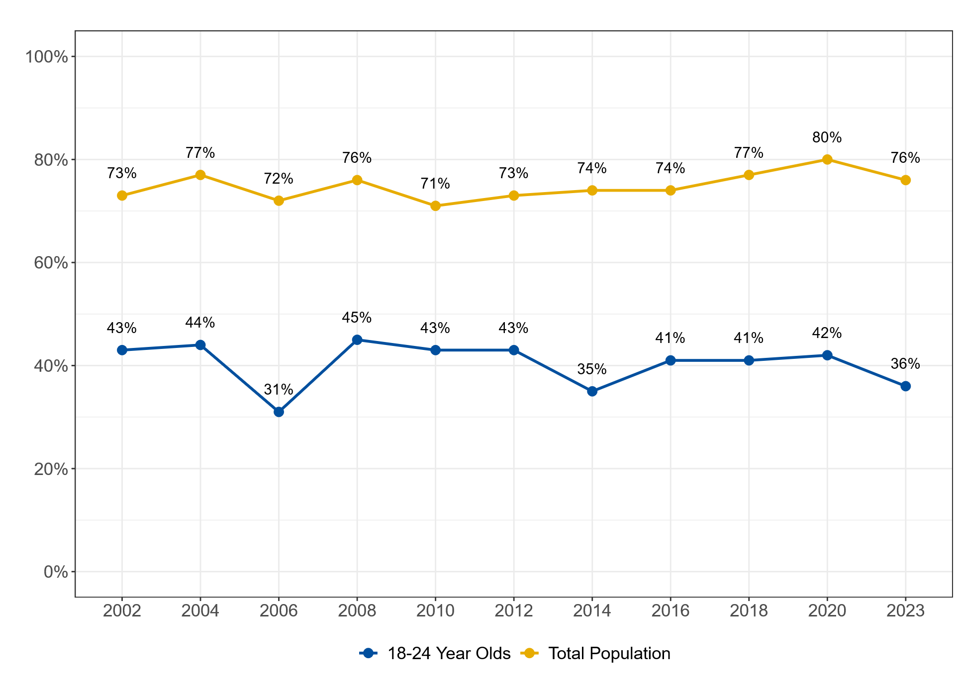
Source: An Coimisiún’s analysis of reported turnout in European Social Survey (2025)
The Eurobarometer Youth Poll surveys those aged 18-30. Of the 1,033 Irish respondents to the Eurobarometer Youth Poll in 2024, and the 568 respondents to Eurobarometer Youth Poll in 2021, 22% and 29% respectively reported that they had voted in a local, national or European election. This was lower than the EU averages of 39% and 46%.
This gap in participation is not unique to Ireland; comparative research in the EU15 (EU members before 2004 including the UK) found that young people are marginalised from electoral politics compared to the overall population and research drawing on Eurobarometer polls finds that this gap is even more pronounced in some newer EU democracies. Recent research by the UK Electoral Commission shows younger people less likely to vote and be politically engaged than other cohorts and in Australia, where voting is compulsory, younger people (aged 18-24 years) are considerably less likely to register than older people.
Low turnout among 18–24-year-olds over recent decades may have consequences for turnout in general. In a recent study, which draws on comparative aggregate-level and survey data, Blais and Kostelka link the general decline in voter turnout in stable democracies to low voting among the 18-24 cohorts. They explain that voting in the first election for which one is eligible is a strong predictor of future tendency to turnout and, therefore, that low turnout among the 18-24 age group can establish a pattern of non-voting. The extent to which this applies in Ireland is currently being explored by academics commissioned by An Coimisiún Toghcháin.

(iii) What appears to explain lower levels of participation among young people and is low turnout more pronounced among certain groups of young people?
Many theories set out to explain why younger people vote less. The tendency to vote more with age is frequently explained as the outcome of the process of developing or growing into adulthood; whereby people acquire more political knowledge and affiliations and become more settled in their community. Also, younger people are more likely to live in transient and mobile communities, with less stability and fewer deep connections to community (except perhaps from the community in which they grew up), both factors are predicted to depress turnout (see section 2 above). Lower engagement has been explained as caused by societal change - including a decline in civic duty and a rise in individualism which is itself related to a decline in mass political parties and a fracturing of politics in general. It is argued that those who reach adulthood during this time period are less likely to vote.
Other researchers focus on explaining variation of turnout within the young people group, asking whether low turnout among certain groups of young people explains the overall low turnout rate in Ireland. This is next considered.
Using voter registration as an indicator of political engagement, the Growing Up in Ireland (GUI) is a rich set of data which highlights a strong socio-economic dimension to political engagement. The GUI data shows that the strongest predictors from middle childhood (age 9) of being registered to vote at age 20 relate to family background and educational and civic context; participants were more likely to be registered to vote at age 20 if their mother has a high level of educational achievement and were least likely to be registered if they have migrant parents (or a migrant lone parent). Concerning educational and civic context, attending a school that emphasises sport and the arts and being involved in many extra-curricular activities at age 9 are strong predictors of voter registration at 20.
Looking at the strongest predictors at early adulthood (age 17) of being registered to vote at age 20, a mother’s education level continues to be associated with registration, as are a high level of family income, the individual’s educational achievement (Junior and Leaving Cert results) and the presence of a pathway to further education. Variables which measure a participant’s social networks and context – parents’ social capital and the neighbourhood’s social infrastructure – are also associated with registration. Living at home was a predictor of registration in urban areas (not rural), while membership of youth clubs is a predictor in rural areas and involvement in cultural activities a predictor in both (see Table below). Additionally, while church attendance at age 9 and age 20 was associated with registration, it was also associated with having ‘less interest in politics’ and being ‘less engaged with political activities’ than other young people. For these individuals, registration may be seen as ‘a duty’ rather than the outcome of interest in politics.

Table 5: Summary of associations between a young person’s late adolescence/early adulthood characteristics and their political engagement in early adulthood
 |  | Age of measure | N of political activities | Political interest | Voter registration
Urban-Rural | Rural (cf. Urban) | 9 | − | − | n.d.
Family background | Female (cf. Male) | 9 | + | − | +
 | Chronic illness | 9 | n.d. | n.d. | n.d.
 | Mother’s education | 9 | + | + | +
 | Lone parent (cf. Two parents) | 9 | + | n.d. | n.d.
 | Two migrant parents (or migrant lone parent) | 9 | −  (only in urban areas) | n.d. | n.d.
 | Household income | 9 | n.d. | n.d. | n.d.
 | cf. Homeowner | 9
 | Social renting | 9 | n.d. | − | n.d.
 | Private renting | 9 | n.d. | n.d. | −
 | Other | 9 | n.d. | − | n.d.
 | Child’s health past year | 9 | n.d. | n.d. | n.d.
Parental/ Peer social capital | Mother locally volunteers | 9 | n.d. | n.d. | +
 | Number of friends | 13 | n.d. | n.d. | n.d.
 | Number of friends parents have met | 13 | n.d. | n.d. | n.d.
 | Church attendance | 9 | − | n.d. | +
 | Child’s spirituality | 13 | n.d. | n.d. | n.d.
Locality | Public transport to school | 9 | n.d. | n.d. | n.d.
 | Recreational facilities for 9 y/o | 9 | n.d. | n.d. | n.d.
 | % aged 65+ in SAPS | 9 | −  (only in rural areas) | +  (only in rural areas) | n.d.
 | Local SAPS disadvantage | 9 | n.d. | n.d. | n.d.
 | Parent’s perception of disorder | 13 | n.d. | n.d. | n.d.
 | Facilities such as youth clubs, swimming clubs, sports clubs | 13 | n.d. | n.d. | n.d.
 | Local family stability and security | 13 | −  (only in rural areas) | n.d. | n.d.
Education | School importance on sports/arts extracurricular | 9 | − | − | +
 | School importance on social justice/politics extracurricular | 9 | n.d. | n.d. | n.d.
 | Child enjoyment of school | 13 | +  (high intensity only) | + | n.d.
Club involvement | Cultural (dance, drama or music lessons) | 13 | + | + | n.d.
 | Sports with coach/instructor/organised team | 13 | − | − | n.d.
 | Club/groups e.g. guides/scouts, youth club, community groups | 13 | n.d. | n.d. | n.d.
 | Special responsibilities; e.g., team leader, captain | 13 | n.d. | n.d. | n.d.
Notes: N.d. = no significant difference; + = positive and significant effect; − = negative and significant effect. SAPS = Small Area Population Statistics.
Source: Laurence and Smyth, ESRI, 2023

Box 8: Analysis of ESS Data for Ireland
Using self-reported political participation (see Box 4 in section 3.1 above) as the dependent variable, An Coimisiún’ research team drew on the full ESS (Waves 1-11) to explore the association between reported turnout among young in Ireland and a range of socio-economic factors and factors denoting social or political capital. We also look at participation by young people in other, non-electoral political activities and whether this displaces voting or is in addition to voting. The full ESS Waves 1-11 are used for descriptive statistics and waves 5-11 are used for the regression analysis as the education scale changed in between those years.
An Coimisiún’s analysis of the European Social Survey data for Ireland (2002 – 2023) (Box 8) finds that some of the variables associated with turnout among the total population (see Section 2) appear to have an even stronger association with turnout for young people.
Income has a strong effect on voter turnout with young people from higher income brackets more likely to vote than those in lower brackets. The predicted probability of young people reporting having cast a vote (41%) is lower than the population aged 25+ (79%) and the predicted probability is even lower for young people from the two lower income groups who are 13 percentage points less likely to report voting than those in higher deciles.
This is consistent with trends identified in Europe. Sloam, who used ESS data over many waves for the EU 15 (UK and EU member states prior to 2004), found a strong socio-economic dynamic to young people’s voting patterns. He concluded that young people with low levels of educational attainment who were eligible to vote did so in “alarmingly small numbers” (an average of 25% across the EU15 states). He also found low levels of other types of engagement, including contact with elected representatives. Kitanova, who pools Eurobarometer data on 28 European countries, found that young adults from a higher social class and those with higher educational attainment are more likely to engage in formal political participation such as voting.
In addition to socio-economic variables, the data from the ESS waves was used to explore the association between turnout among young people and factors denoting social/political capital (section 2). We found that being less interested in politics is a stronger deterrent on voting for young people than it is for the total population. In the first instance, 18–24-year-olds report a lower interest in politics than the older cohorts and this translates into lower turnout. In the second instance, the level of interest in politics is a powerful indicator of turnout among young people: young people who are ‘not interested in politics’ are 31 percentage points less likely to cast a vote than young people who are very interested the same level as the full sample. However, the likelihood of those who were quite interested in politics or hardly interested in politics to be voters was stronger for the full sample than young people. This suggests that older groups who lack an interest in politics may be likely than younger people who lack an interest in politics to vote. This is consistent with an analysis by Blais, Reidy et al who conclude that civic duty is a stronger predictor of voting for older groups than it is for younger groups.
The ESS data shows that the proportion of 18-24 year-olds reporting to be “not at all interested in politics” is consistently higher than it is for the rest of the population. While the size of this proportion varies depending on the survey year, 46% of young people in the 2023 ESS were not at all interested in politics” (Figures 12 and 12A).
Figure 12: Interest in politics (How interested in politics would you say you are…?’)
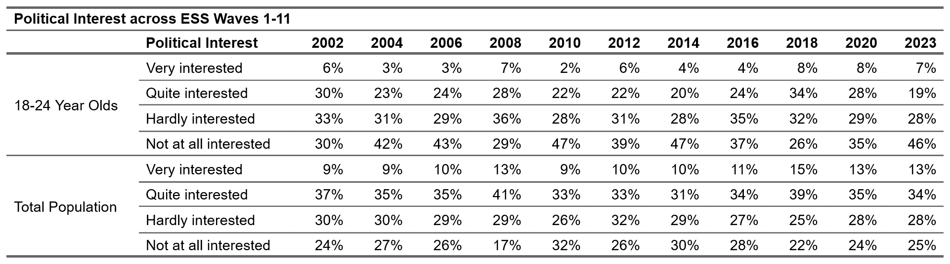
Source: An Coimisiún’s extraction from European Social Survey Data Waves 1-11.
Figure 12A Interest in politics (Respondents who were “Not at all interested” in Politics
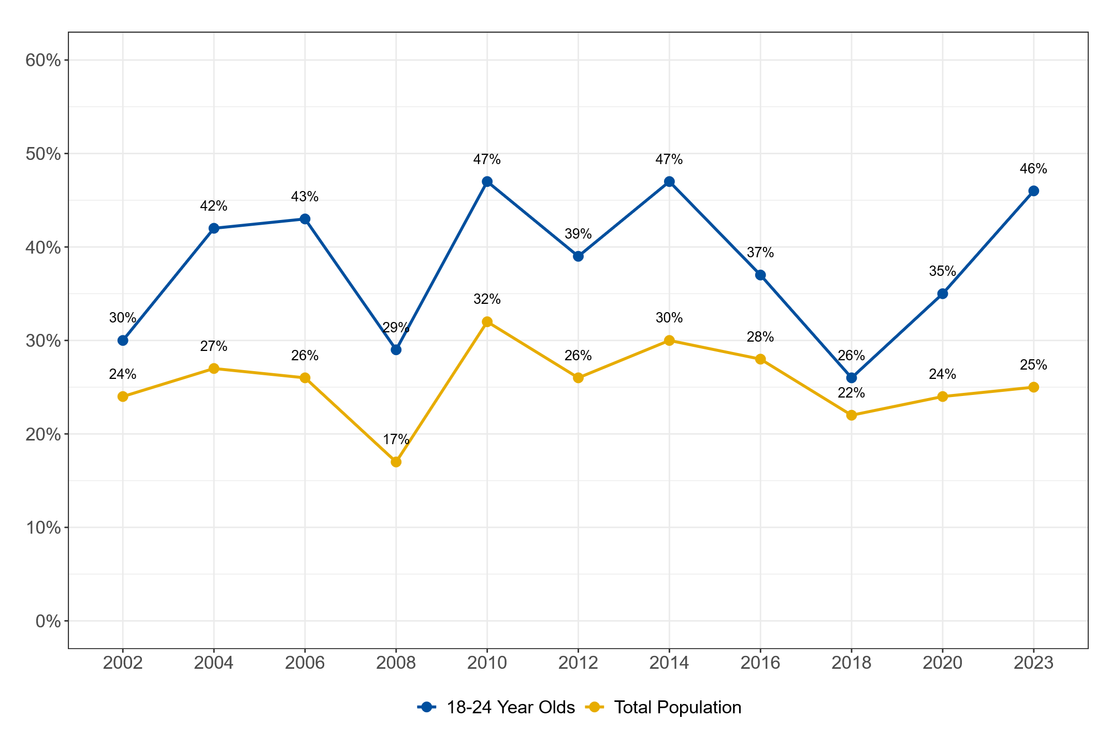
Source: An Coimisiún’s extraction from European Social Survey Data Waves 1-11 (O’Riordan, 2025).
There is a need to disentangle the concept of ‘political interest.’ Firstly, the ESS question on ‘political interest’ does not explicitly include interest in civic matters or policy-related issues which, according to some survey data, are more likely to interest younger people. In fact, our analysis of the ESS data shows that, consistent with international findings, young people in Ireland engage in different and in more ways with the political system (Figure 13).
Figure 13: During the last 12 months, have you done any of the following?
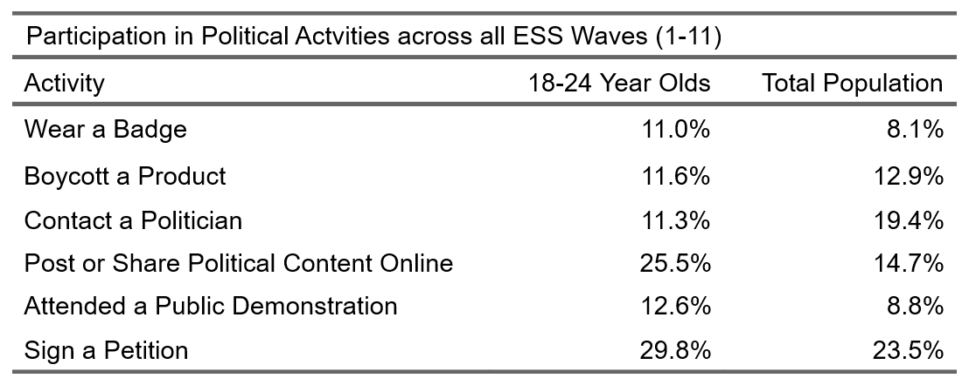
Source: An Coimisiún’s extraction from European Social Survey Data Waves 1-11.
Figure 13 shows that young people in Ireland were more likely to have worn a badge, attended a public demonstration, posted or shared a political post online and signed a petition than the total population. Whether it is primarily those who already vote, or other young people, who take part in other political activities it is important to our understanding of the data. Our analysis suggests that this depends on the activity; wearing a badge was the only activity with a statistically significant effect on the likelihood of a young person being a voter by 33 percentage points.
Secondly, that being “interested in politics” has a greater association with voting for young people than for the general population, raises questions about what determines political interest. Our analysis of NEDS data for the 2024 elections (for all age groups) finds a strong correlation between political interest and internal political efficacy (which measures confidence and knowledge to vote).Internal political efficacy is a dimension of Verba et al’s concept of civic skills. Greenwood-Hau, in focus groups which followed the UK Privilege and Participation Survey (2025), reported that “lack of confidence, the idea that politics is not for me” and “a lack of knowledge about politics” as related to low participation levels.
That disinterest in politics may not be the strongest direct explanation for lower participation by younger people, but is itself caused by other variables, is suggested in the international literature. It appears that other factors - which broadly fit in with the predictors of voting set out in section 2 and are identified in the discussion of the Growing Up in Ireland data and the ESS data - are more exaggerated in the case of young people and may cause or overlap with the level of “political interest.” These factors include:
- socio-economic barriers, sometimes connected to lack of family tradition of voting and lack of political knowledge and know-how;
- social capital and population stability; young people are more likely to reside in areas, or belong to social networks which are transient and mobile;
- Institutional factors - the voter registration process, and the voting process, is more suited to those who reside in stable residential communities;
- and the limited extent to which political parties and candidates are accessible and relevant to issues which young people see as important.
Research undertaken by TASC explored attitudes to democracy and trust in institutions through focus groups and interviews with young people living in disadvantaged communities in east Limerick and parts of Dublin. Echoing the findings of a previous TASC study (Democracy Audit, 2005), the researchers found that respondents perceived politicians as “largely interested in their own personal benefit and remaining in office, and not interested in listening to the concerns of young people especially those with experience of socio-economic disadvantage.” The exception to this appears to be when a politician responded directly to an individual’s personal problems. The same study identified a desire amongst younger people for information and news that they can both trust and access on social media (as young people primarily access news through social media platforms).

(iv) Key points and next steps
There is consistent data which enables us to conclude that young people vote in lower numbers than older people in Ireland and internationally.
There is a socio-economic dimension to electoral participation demonstrated by Growing Up in Ireland data (regarding registering to vote), and European Social Study data (in the latter case, both when data relating exclusively to Ireland is examined, and when comparative data across Europe is explored). It would appear that an individual’s socio-economic and civic context at a very young age influences the likelihood to participate when one turns 18.
Apart from socio-economic variables which are predictors of voting among this group, the evidence suggests that “political interest” is a particularly important factor in predicting turnout by younger people, more so than for the rest of the population. There is some evidence to suggest that political interest may be connected, at least for some people, to internal political efficacy which relates to knowledge and understanding of voting and politics in general. This is referred to by Greenwood-Hau as cultural capital. Further, political interest and disinterest may have slightly different meanings for young people than other age groups; the evidence from the ESS shows that younger people participate more than older age groups on other types of political activity such as wearing a badge, attending a public demonstration, posting of sharing a political post online and signing a petition.
Emphasis on policies that facilitate young people to vote – for example, by offering a postal vote for students - are likely to have a limited effect on turnout if barriers related to political interest and low cultural capital among some young people are not also considered. The approach taken by TASC to understanding young people’s attitudes to voting and to the political system in general need to be explored further.
Recognising this need for further exploration of the engagement by young people with elections and with the democratic process in general, An Coimisiún has partnered with Taighde Eireann to fund a Public Sector Research Fellowship to further research on electoral participation by younger people in Ireland and to draw on evidence to develop policy/programme-level initiatives aimed at enhancing younger people’s participation in elections. We have also commissioned research exploring the argument that reducing the voting age would increase youth electoral participation at the time of enfranchisement and in the future.

3.5 Prisoners

(i) Legislative and policy context
Prisoners in Ireland have the right to vote in all types of elections subject to age and citizenship criteria. Very significant obstacles to voting by prisoners were removed by the Electoral (Amendment) Act 2006 and the rolling register introduced by the 2022 Act facilitates registration for all people, including prisoners.
Prior to 2006, prisoners had effectively been disenfranchised as there was no practical way to cast a vote (unless a prisoner happened to be on temporary release at the time of an election). This situation had been upheld by the Supreme Court (Breathnach v Ireland, 2001) which ruled that a prisoner had no absolute right to vote under the Constitution and that his constitutional rights were suspended “as a consequence of lawful custody.” The Electoral (Amendment) Act 2006, which was in part prompted by a European Court of Human Rights ruling against the UK Government, ended this situation giving practical effect to prisoners’ voting rights by adding prisoners to the five other categories of persons entitled to apply for a postal ballot.
Procedure for casting vote
Prisoners’ votes are cast in their constituency of prior residence in (not in the constituency in which the prison is located).
Any prisoner who is on the register of electors in the local authority area in which they ordinarily reside may apply for inclusion on the postal ballot list by way of a dedicated application form (PV6) made available by the registration authority. The application is sent to the registration authority which is obliged under the legislation to notify the applicant that they have/have not been added to the postal ballot and, in the case that they have not, to explain why. While an application for inclusion on the postal voter register may occur at any time, once an election has been called the application for postal vote must be before the tight deadline specified.
As well as assigning duties to the registration authority (see above) and to returning officers to administer the postal voting process, the legislation assigns explicit duties to the prison governor to facilitate voting by prisoners. At registration, these include a duty:
- to certify as part of the application (PV6) that the person is unable to go to the polling station to vote because of his or her detention (Section 3).
- to ensure that the application for a postal vote is sent to the registration authority and, if polling-day has been appointed, that it is sent in time to meet the deadline specified in section 14(2) of the Act of 1992 (Section 3).
The Irish Penal Reform Trust highlights the responsibility placed on governors to enable prisoners to vindicate their right to vote. These include a responsibility to:
- enable prisoners to check the register to ensure that they are registered to vote (as this is a prior condition for applying for a postal vote). As a result of the Electoral Reform Act 2022 which introduced rolling electoral registers in Ireland, it is possible to check the register, and apply for inclusion on the electoral register, at any time during the year (prior to this Act there was a short window to check the register).
- ensure that relevant forms (to apply for postal vote) are made available in prisons.
Once registration is complete, and the ballot papers have been issued by the returning officer, the governor is assigned further statutory duties under Section 7 of the Act to enable a prisoner to cast a ballot. This includes witnessing the declaration of identity and ensuring that the sealed envelope is delivered to the registration authority.

(ii) Data on electoral participation
The first election after practical effect was given to prisoners’ voting rights was the General Election in 2007. Tables 5 and 6 show data on electoral participation by prisoners in general and local elections which was provided to An Coimisiún on request by officials in the Irish Prison Service and, for earlier years, by academic Cormac Behan. Data for the 2025 Presidential Election was provided to An Coimisiún by the Department of Housing, Local Government and Heritage.
Table 6: Electoral participation by prisoners (general elections)
Year | Approximate eligible voting population | Number registered |  | Approximate number of votes cast | Turnout % of Register | Turnout % of VAP
2007 | 3202 | 451 |  | 322 | 71% | 10%
2011 | 4400 | 334 |  | 254 | 76% | 6%
2016 | 3335 | missing |  | 160 |  | 5%
2020 | 3452 | missing |  | missing
2024 | 4203 | 492 |  | 318 | 65% | 8%
Source: Various including Behan Cormac (2014) and Irish Prison Service (see Appendix 1).
Table 7: Electoral participation by prisoners (Local elections)
Year | Approximate eligible voting population | Number registered | Approximate number of votes cast | Turnout % of Register | Turnout % of VAP
2009 | 3744 | 282 | 220 | 78% | 6%
2014 | 4044 |  | 104
2019 | 3981 | 224 | 143 | 64% | 6%
2024 | 4935 | 409 | 259 | 63% | 5%
Sources: Various including Behan Cormac (2014) and directly from Irish Prison Service.
In the 2018 Presidential Election, 148 of 231 prisoners who registered to vote cast a vote. This is 63% of registered voters in prison and 5.2% of the estimated eligible prisoner population. In the 2025 Presidential Election, 557 prisoners were registered to vote which is the highest number of prisoners who have registered to date. We do not have data on votes cast.
As the data shows, turnout among prisoners who are on the Register and apply for the postal vote has tended to be in line with general turnout (for example, 71% in 2007, 76% in 2011 and 65% in 2024). However, when expressed as a proportion of the overall prisoner population eligible to vote, participation by prisoners is very low (8% at the most recent general election and approximately 5% at the 2024 Local Election.
This low level of participation is consistent with international studies. Studies we consulted on the prisoner population in the USA and in the UK demonstrate low registration and/or turnout rates amongst prisoners, or former prisoners (when prisoners are not enfranchised (discussed further below)).

(iii) Explaining low levels of participation
Once registered to vote, turnout amongst prisoners is relatively high (compared to general population turnout). This suggests that there are barriers to participation at registration which could be institutional/administrative barriers connected to the registration process described above or may be explained by socio-economic or by socio-cultural factors which arise before incarceration e.g. such as no tradition of voting, disinterest, apathy or low political capacity (i.e. knowledge or experience).
The evidence we do have, which is based on an in-depth study (using survey and interviews) of prisoners and voting in Ireland published in 2014, and on international studies, would suggest that both apply.
Institutional and administrative barriers
Behan’s study, which was based on an extensive survey of all prisoners and followed up by focus groups and interviews in 2011-2012 identified legislative and practical/administrative issues affecting registration, many of which specifically affect prisoners.
Firstly, short prison sentences combined with uncertainty about the election date makes it difficult to know whether a postal vote is needed. And, once an election is called, the legislation sets out a very short window for application for a postal vote.
Secondly, because prisoners are registered at their home address, and only the electoral administration knows a person is in prison, prisoners do not receive electoral literature from candidates. Instead, they rely on their families to bring election literature to them. Behan found that only 12% of survey respondents (who were voters and non-voters) had received election literature (and most of this small number had not been in prison when they received it). Prisoners then, and now, do not have regular access to the internet where they might receive this information.
Thirdly, prisoner populations are transient and mobile. A prisoner may be uncertain if they will be in prison during an election and if so, which prison they will be in. Behan found higher registration rates in institutions housing long-term prisoners. Transience may not only be an administrative barrier; residential stability and belonging to social networks where voting is the norm are positively related to voting, as noted in section 2 of this paper (this is discussed further below).
Fourthly, the level of institutional support from the Irish Prison Service within each prison was identified in Behan’s study as a very important factor in successful registration – both in providing information about and enabling registration (as the rate of registration was very different across prisons). This is consistent with evidence presented by the Irish Penal Reform Service noted above. Empirical research by academics in the University of Cardiff on prisoners in the UK also highlight the importance of adequate facilitation and support within prisons. In addition, they stress the importance of communication between different services, and clear rules and guidance around voting, noting that all were inadequate in the UK thereby contributing to “administrative disenfranchisement.”
Fifthly, it is possible that the medium through which a vote is cast, and the voting experience, affect registration and turnout especially if voting is a social act (as proposed by some theories, see section 2 of this report). There are several ways to administer voting by prisoners as well as postal vote, for example, a mobile ballot box, a polling station in the prison. Registration and turnout among prisoners in France increased significantly after a legislative reform (the Justice Programming Act 2019) replaced proxy voting by prisoners with in-person voting via ballot booths in prisons (ballot papers were grouped and sent to a central location for counting). While 853 prisoners cast a vote in the 2017 Presidential elections in France, 5,184 prisoners (10% of the prisoner population) voted in the 2019 European parliamentary elections this being 84.78% of those who registered. This increase in turnout was in spite of the fact that turnout generally is higher in presidential than in European parliament elections. Media reports stated that turnout among prisoners at the subsequent presidential election in 2022 was 13,572 – which was of 70,000 prisoners.
Demographic, social inclusion/exclusion and social context
Other variables which predict voting/not voting amongst the general population also appear to explain voting amongst the prisoner population.
Behan found a relationship between age, education level and voting behaviour with older prisoners and those with higher educational achievement more likely to be those who register and vote. He also found that the most significant explanatory factor for whether a prisoner registers and votes was past voting tradition – indicated by voting history, identification with a particular party or candidate, trust in institutions and if a person perceived voting as a civic duty. As noted by Behan and as is clear from Section 2 of this paper, all are factors found to predict voting amongst the general population.
Concerning population stability and education, Behan’s study also found that prisons with pro-active general education programmes were more likely to encourage registration, and he found that prisons with long-term prisoners were more likely to have pro-active general education programmes.
Behan also concludes that one key explanation for low turnout amongst prisoners is that “citizens who find themselves in prison are unlikely voters in the first place.” The Irish Penal Reform Trust (2012) identify community disorganisation and socio-economic deprivation as two of five key risk factors for children and young people engaging in crime. That 1% of electoral districts accounted for nearly 24% of prisoners but less than 5% of the general population in 2010, and the majority of prisoners in Ireland were “young, male and from deprived areas,” would lend support to this explanation in that these are factors which have been found to predict non-voting (see section 2).
A number of international studies on voter engagement by prisoners (or by those just released from prison) have also found that the level of voter engagement prior to incarceration may be quite low. It is suggested by Gerber et al that demographic and life-experience differences between those who have, and have not spent time in prison, may better explain low voter engagement by prisoners and former prisoners than being in prison (or indeed, than administrative barriers). This is because incarceration is an outcome that often follows a long series of interactions with various criminal justice institutions.
This suggests that a variety of variables intersect to create barriers to electoral participation by prisoners. Work by Ian O’Donnell, which focuses on programmes to prevent recidivism by former prisoners, is relevant to understanding barriers to electoral participation and to civic engagement in general. Exploring the effects of such preventative programmes in 2020, O’Donnell discusses the challenges which “returning to an environment characterised by unstable housing, negligible employment prospects, poor family and community ties and anti-social peers” pose, concluding that the “odds are stacked against the most highly motivated offender.” While these are all factors associated with lower electoral participation, Behan noted that few of the prisoners whom he surveyed or interviewed declared themselves to have no interest in voting. It is possible that circumstances and administrative barriers prevent those with an interest from registering and casting a vote. Evidence from an ad hoc survey of prisoners in France; where administrative barriers to prisoner voting were removed in 2019, led the author to conclude that prisoners had more ‘political capital’ than politicians assume. As noted above, turnout among French prisoners increased significantly after reforms introduced in-prison voting instead of proxy voting.

(iv) Key issues and next steps
We find very low registration levels among the prison population, in spite of the legislation enacted in 2006 which enabled prisoners to use their franchise. Our review of literature identified institutional/administrative barriers and barriers related to socio-economic and social context to electoral participation for prisoners. Some of the former barriers may be reduced by practical reforms and supports to electoral administration; for example, measures to ensure that candidate information is received by prisoners, measures which account for the transience and mobility. Further, research highlights that the voting experience matters; the introduction of in-person (in prison) voting for prisoners in France, to replace proxy voting, has resulted in a remarkable increase in turnout amongst prisoners in France.

3.6 People experiencing homelessness

(i) Legislative and policy context
Box 9: Population of people experiencing homelessness (PEH)
Different functional definitions of homelessness are employed by government bodies, the CSO basing its definition on the pre-identification of accommodation where homeless people were staying on Census Night, with the Department of Housing, Local Government and Heritage using the number of people in state-funded emergency accommodation (Pathway Accommodation and Support System) for its rolling reports.
10,321 people were registered as homeless in the 2022 Census. In August 2025, the Department of Housing reported 11,208 adults accessing emergency accommodation (60% male, 40% female), this compared to 6,082 in August 2020 and 3,625 in December 2015.
5,699 (51%) were Irish citizens, 2,240 (20%) were EEA/UK citizens and 3,269 (29%) non-EEA citizens in August 2025. The majority (7,752) were residing in private emergency accommodation, with 3,353 in supported temporary accommodation (family hubs, hostels with onsite professional support). Additionally, the vast majority (71%) reside in Dublin.
Over 11,000 adults were homeless at any one time in 2025 (Box 9). These figures do not capture the full spectrum of people experiencing homelessness, housing insecurity or precarious accommodation, nor does it include dependent children. It does not include those in “own-door” temporary accommodation, domestic violence refuges, people sleeping rough, or hidden homeless.
Under the Housing Act (section 2), a person may be considered homeless where “(a) there is no accommodation available which, in the opinion of the housing authority, a person can reasonably occupy or remain in occupation of,” or the person (b) is “living in a hospital, county home, night shelter or other such institution, and is so living because the person has no accommodation referred to in paragraph (a) and is, in the opinion of the authority, unable to provide accommodation from his own resources.”
Prior to its amendment in 2022, the Electoral Act 1992 made no provision for registration for those without a fixed address. This had effectively, if not explicitly, disenfranchised people experiencing homelessness. As well as introducing a rolling electoral register and providing the option to register online, the Electoral Reform Act 2022 (section 84) made specific provision for the registration of those without a permanent address. This amendment, along with an initiative by An Post, has reduced administrative barriers to voting for people experiencing homelessness:
- Section 11 now provides, inter alia, that: those “not ordinarily resident at any premises” may register to vote through their local registration authority, or register with their PPSN through online services, the same way as the rest of the electorate and receive related correspondence at (a) an office of the local authority or at (b) an address of their choosing,
- An Post through its Address Point Service (launched in 2019) enables a person with no fixed address to register for free to receive a personal fixed correspondence address and Eircode. These addresses are accepted by local registration authorities for registration purposes.

(ii) Data on electoral participation and data on correlates of turnout
Prior to 2022, as noted, people experiencing homelessness (PEH) – without a fixed address - experienced prohibitive barriers to voting and, as such, it is likely that people were voting in very low numbers. Focus Ireland’s Voter Registration Drive for the 2024 local and general election highlighted the removal of these barriers directly encouraged PEH to register to vote. While Focus Ireland reported considerable engagement by PEH with its Voter Registration Drive, there is no data on the number of people who registered and no evaluation, and certainly no survey data on turnout among PEH in the local or general elections in 2024.
We found little data on democratic engagement by PEH in European States, and we did not encounter any which made systematic use of primary or secondary data to estimate turnout. On the other hand, a detailed survey and a follow-up paper produced by academics from the University of Adelaide for the Australian Electoral Commission found very low rates of turnout among PEH in spite of their expressing relatively high levels of political interest. They found that 56% of PEH (those accessing specialists homelessness services in the Adelaide electoral area) were enrolled to vote and 40% of this 56% regularly vote. This led them to estimate a 22% turnout rate in a system which has compulsory voting (there is a 97% enrolment rate among the general population and turnout rates of in the mid-90s). A British quasi-experimental study found a link between homelessness and low registration rates. Using administrative data, they demonstrated that a housing subsidy reduction coincided with an increase in the incidence of homelessness and was associated with lower registration rates and turnout in the Brexit referendum.
People experiencing homelessness are not a cohesive group, rather they share an experience which may be chronic or may be of a more temporary nature. And while we lack data on electoral participation by PEH in Ireland, there is evidence that those experiencing homelessness disproportionately experience socio-economic and demographic variables associated with low participation (see Section 2), most notably residing in transient communities, non-homeowners, have lower income, and experience comparatively high levels of deprivation and marginalisation. Irish research finds that many of the fundamental drivers of homelessness are structural in nature; rates of homelessness increase when housing stock is scarce or costly and are associated with broader socio-economic indicators such as unemployment or poverty. This is particularly the case with respect to families experiencing homeless, who tend to be of low and/or insecure income and become homeless due to a termination of private tenancy. Further, female lone-parents and minority ethnic group households are statistically overrepresented amongst families experiencing homelessness.
In the literature reviewed on democratic engagement and PEH, the co-occurrence of homelessness with other factors such as disability, mental illness, illiteracy or imprisonment is often identified as an important factor in the democratic engagement of PEH. There is evidence of co-occurrence in Ireland where chronic homelessness is consistently associated with psychiatric health issues, substance abuse and addiction, experiences of incarceration, and rough sleeping. A survey of prisoners in Ireland in 2011 found that that 25% were experiencing homelessness on imprisonment while 54% had experienced an episode of homelessness. Coram et al’s study of PEH in Australia and a synthesis of literature on psychiatric patients and voting, identify similar, and significant, administrative barriers to electoral participation which are further discussed below.
Given the challenging set of circumstances which face PEH, a number of common barriers to democratic engagement are identified in the literature. They can be roughly separated into three categories which broadly align with those set out above in Section 2 (Table 1) above – administrative (institutional), inhibitive (which align with social capital) and compounding (socio-economic and demographic).

(iii) Key points and next steps
There is no data on turnout amongst PEH in Ireland, and no study has directly explored turnout level or attitude to voting.
While PEH is not a cohesive group and some experience long-term and others temporary homelessness, PEH do disproportionately experience the socio-economic and other factors associated with low turnout, and homelessness co-occurs with other factors which may reduce tendency to vote. Yet a number of studies in other countries found high levels of interest in politics among PEH or groups with co-occurring experiences.
The practical barriers to voting which existed prior to the 2022 Act, suggest historically low levels of turnout. While administrative barriers have been reduced and the process for registration is less onerous than before, registration remains highly self-directed and it is unlikely to be a priority. Distinct administrative barriers – even with their removal – should not be under-estimated given the complex set of challenges experienced by PEH. Intuitively, voting will rarely be the impetus for initial engagement with social services. As indicated by Focus Ireland, the most promising enabler may be to promote voting through frontline service providers. But this may not be feasible given other administrative barriers faced by PEH.
It may be worth exploring whether bespoke voting solutions for PEH, such as mobile polling stations or automatic registration, could help to achieve concrete increases in turnout. The symbolic relevance of such solutions beyond the target population might also be worthy of exploration.
Given the number of homeless, and the many people in precarious housing situations, a study aiming to confirm the extent to which barriers are practical, or because of disinterest or lack of engagement, before the next election and registration drive would make sense. The former could establish a baseline and identify possible enablers of inclusion.

4. Concluding remarks
This research has discussed how electoral participation is measured, reviewed existing literature as well as undertaking primary analysis of NEDS and European Social Survey data for Ireland. Having mapped what we know to date about patterns of electoral participation and inclusion in Ireland, we explore, and where possible, explain participation levels by potentially-under reached or marginalised sections of society in Ireland. This was with a view to establishing the level of electoral participation and inclusion and identifying barriers to participation where relevant.
We acknowledge there is much more to be done and to learn about barriers and the type of initiatives and policies that best address them. Some of this will be achieved through further research which we are committed to conducting, undertaking with partners, or funding. While we have identified a number of possible next steps at the end of each section and in our summary and next Steps above, the following are the projects which we have already commenced or which will be commenced shortly in 2026.
- To further understand how turnout is related to socio-economic and demographic factors we have commissioned academics in UCD and UCC to conduct an aggregate-level study – Mapping Turnout Project – which will match census 2022 data and turnout data from the 2024 General Election at the ED level. This has commenced and will be complete towards the end of 2026 with publication thereafter. Drawing on the experience of this project we will consider whether such an analysis should be conducted at each electoral event.
- Two projects exploring participation and strategies for engagement have been funded by An Coimisiún Toghcháin under Taighde Eireann – Research Ireland’s New Foundations Programme, one involving survey and focus groups with people from a migrant background and another focusing on participation and engagement by young people in rural areas. These projects are undertaken by collaborations between academic researchers and non-governmental organisations.
- Recognising the need for further exploration of the engagement by young people with elections, and with the democratic process in general, an Coimisiún has partnered with Taighde Eireann (Research Ireland) to fund a Public Service Research Fellowship. The Fellow will use qualitative and quantitative methods to examine electoral and democratic participation by younger people in Ireland and ways to increase it. It is anticipated that a Fellow will commence in September / October 2026.
- We will approach the Data Advisory Group on the proposed National Disability Survey to propose that questions on electoral participation and democratic engagement are included in the Survey.
- Given the linkages between social inclusion, integration and electoral participation, there are obvious opportunities for collaboration between those studying the integration and the political participation of people from a migrant background. We will approach ESRI’s EMN team and other relevant stakeholders to propose that electoral participation is reflected in indicators of integration.
- We will commence a study which will explore and seek to explain electoral participation by the Traveller community (including understanding circumstantial, voluntary or other types of abstention), identify barriers to participation where they exist and evaluate measures to enable electoral engagement
- We propose that electoral participation is a measure of social inclusion and that it should be part of surveys which aim to understand it.
Alongside this work, we will explore the type of initiatives that enable electoral participation given what we know about participation levels and barriers. Our forthcoming Education Strategy will allow us to target interventions towards the sections of society experiencing barriers. In all this is it crucial that our work and initiatives reflect the perspectives and views of all through direct involvement in our work. We would welcome feedback on this paper and any ideas which emerge from it.

APPENDIX 1 –Statement on methodology
The methodology is guided by An Coimisiún’s Research Integrity and Ethics Policy and the principles set out within.
At inception and during planning stage, the aims and purpose of this project were identified in a transparent, objective and impartial manner as follows. The research is intended to:
- Inform our role in encouraging participation and promoting inclusion in electoral participation
- Engage with existing studies and literature on turnout in elections internationally and in Ireland with a view to gaining greater understanding of some of the factors identified as influencing participation and
- Address gaps in the literature on electoral participation in respect of potentially under-reached groups identified in the Research Programme as a concern.
Throughout the research process, we drew on political science and other literature on electoral participation, and, for Ireland, we have drawn on published (and in some cases unpublished research) in the area from leading academics. A standard systematic approach to a review of literature was applied by the authors as follows.
Given the sheer number of research studies on turnout, to identify the variables consistently found to predict electoral participation in general (internationally) we draw on three meta-analyses published in Electoral Studies which aim to evaluate and conclude on the factors most consistently found to predict turnout and we followed up searching for other articles by the same authors (as well as using these articles as a launch pad to find other, relevant articles). The categories for correlates of voting are designed to reflect different models of voting. In their meta-analysis, Smets and Van Ham identify six models of voting – the resource model, mobilisation model, socialisation model, rational choice model, psychological model and the institutional model – and categorise variables under each model. Our categories in Section 2 are collapsed into three core categories. The first – socio-economic and demographic variables largely denote the resource model while our second category is reflective of Smets and Van Ham’s mobilisation, socialisation and psychological models. The institutional/administrative model is similar to their political institutions model although elements of rational choice model – related to the costs of registering and voting - are included in our third category.
Box 10: Meta-Analysis
A meta-analysis applies quantitative methods to combine information across different studies with a view to aggregating existing knowledge on what we know about certain phenomena, in this case what seems to determine voter turnout. It generally involves a statistical analysis on the results/findings of previous studies with a view to assessing their strength as explanatory variables. A meta-analysis is conducted on the basis of clear methodological rules about which studies to select for analysis and what methods to apply (e.g. vote counting and combined tests procedures). The first, conducted by political scientists Smets and van Ham, evaluates studies that explore electoral participation at the individual level. The second conducted by Geys (2006), and third conducted by Cancela and Geys (2016), evaluate studies which explore electoral participation at the aggregate level (on methodological difference, see Section 1 above).
For research on electoral participation in Ireland, we rely on overviews of turnout by leading political scientists published in edited books and journals. Early versions of this research report – scoping documents (September and December 2024) and a draft of the full document (September 2025) - were shared with the Research Advisory Group which provided valuable feedback and information about further sources we may wish to include and consult. All sources are cited.
Regarding the sections of society or groups on which we focused in Section 3, separate literature searches were conducted using google scholar, SCOPUS and Science Direct and direct searches of the leading academic journals in electoral studies. All literature consulted is listed in the bibliography and citations are in the endnotes. Search terms named the group alongside turnout/electoral participation/democratic engagement and follow-on searches were conducted once initial results were considered.
Primary research
Where primary research was undertaken, it used data from long-standing, well-renowned surveys – the European Social Survey – as well as An Coimisiún’s National Election and Democracy Survey (NEDS). The former is overseen by an expert board at European and Irish level, and the latter has been overseen by an expert board of leading political scientists in Ireland. Where primary research was conducted but has not yet been published (see Sections 2.2, 3.1, 3.2 and 3.4), copies of the Working Papers cited in the bibliography are available on direct request from An Coimisiún Toghcháin or, in the case of Kevin Saudé, from An Coimisiún or from the author. Below additional information referred to in different sections of the Paper is provided.
Figure A replicates Figure 1 in Section 2.2 but adds data from the presidential election NEDS. Figure A is provisional analysis. The sample size for this pooled analysis is thus N=5,949, and the results shown in Figure A are derived from the Logistic Regression model ”Control”, the full table of which is shown in Saudé (2026) Table 7. This model was obtained by adding predictors one by one, achieving an R squared of 0.114, meaning that the model explains over 11 percent of the variation in turnout across these electoral events, which is considered a very solid model fit in this literature.
Figure B below, referred to in Section 2.2, is an OLS regression of political interest on its known predictors (using pooled NEDS data i.e. data from general, local and European and presidential elections). It is derived from separate OLS regression models with different model specifications (step wise) and the full model is in Saudé (2026), Table 10. Note that for this analysis, variables were rescaled between 0-1 which means that the regression output refers to percentage change in the outcome variable (political interest).
Figure A: Average marginal effect of the select predictors of turnout based on NEDS data for the general election (2024), European and local elections (2024) and presidential election (2025).
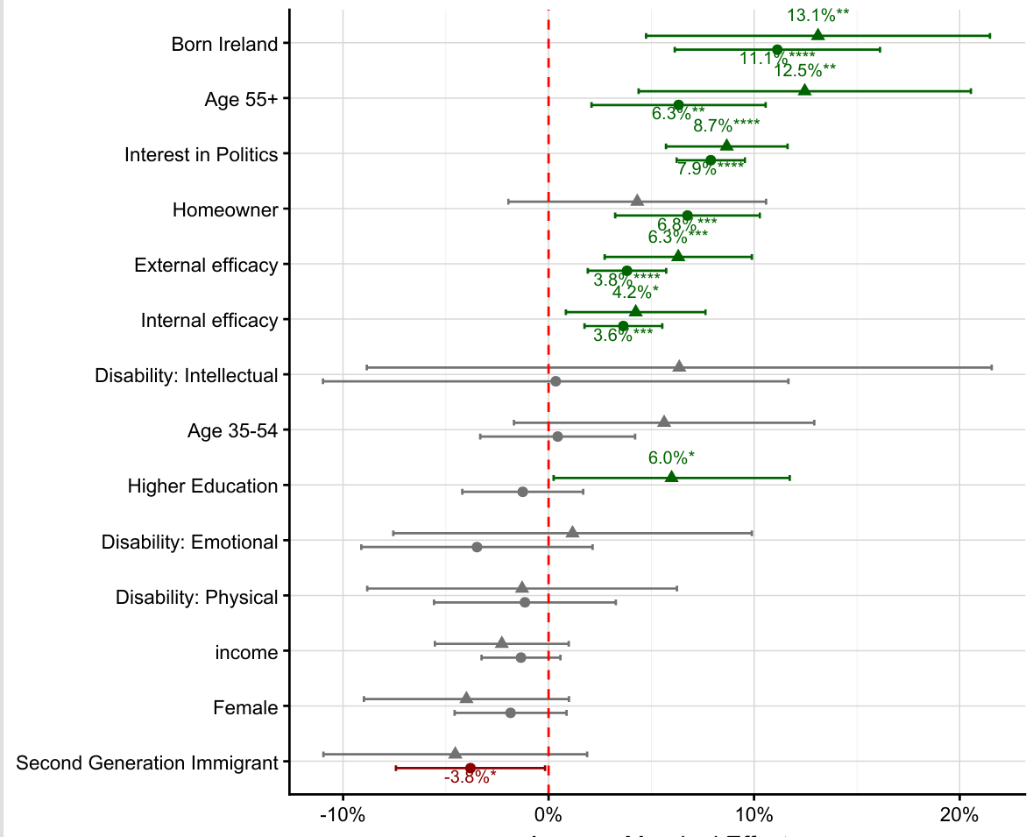Saudé (2026) p.12.

Figure B: OLS regression of political interest on its known predictors
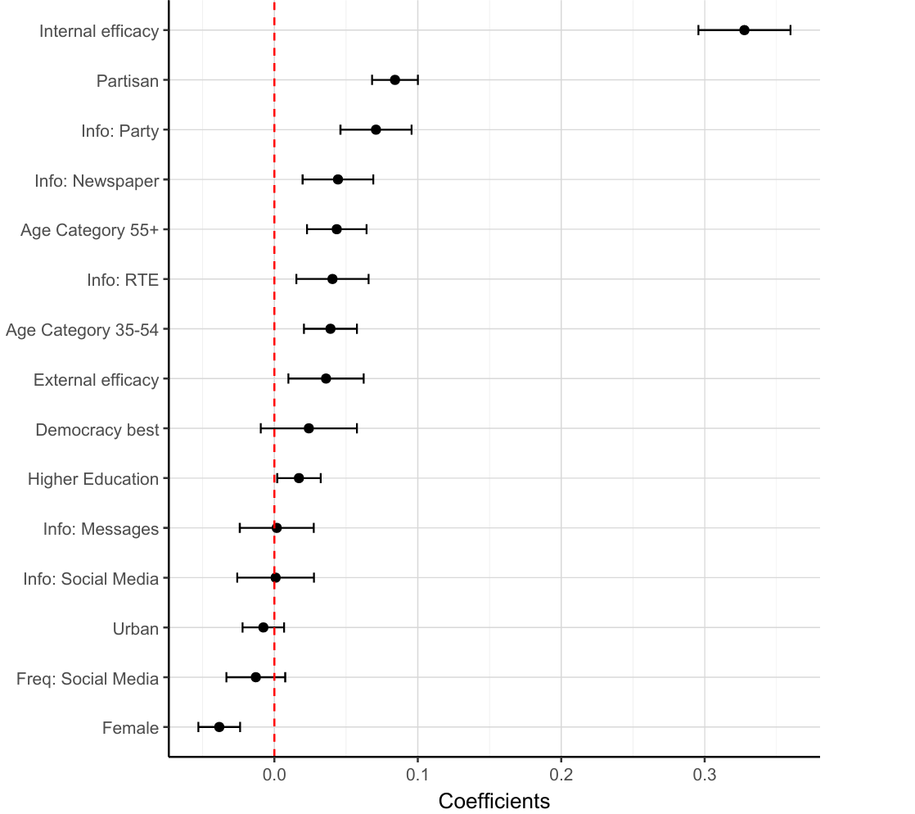
Saudé (2026), Figure 7 and Table 10.
In Section 3.2, figures behind the data in Figure 7 and Table 4 Table 4 and Box 7, are available on request from An Coimisiún. Figures for electoral registers for local elections were obtained from the Department of Housing, Local government and Heritage (October 2024). Data on population at local authority level by age group and citizenship code were provided by the CSO.
In Section 3.5, Tables 6 and 7 were compiled using data from different sources. Where data is not from Behan (2014) it was obtained directly from the Irish Prison Service. Data on total prison numbers was gleaned from Irish Prison Service monthly reports.

Glossary
BoTP – Beneficiaries of Temporary Protection
CSO – Central Statistics Office
DEIS – Delivering Equality of Opportunity in Schools
DPO – Disabled Persons’ Organisation
EEA – European Economic Area
EMN – European Minority Network
EQLS – European Quality of Life Survey
ESRI – Economic and Social Research Institute
ESS – European Social Survey
Feantsa – European Federation of National Organisations Working with the Homeless
GUI – Growing up in Ireland Survey
IMS - Irish Marketing Survey
INES – Irish National Election Study
NEDS – National Election and Democracy Study
ODIHR – Office for Democratic Institutions and Human Rights
OECD – Organisation for Economic Co-operation and Development
OSCE – Organisation for Security and Co-operation in Europe
PEER – Post Electoral-event Report
PEH – People Experiencing Homelessness
PR-STV – Proportional Representative – Singe Transferable Vote
SILC – Survey on Income and Living Conditions
TASC – Think-tank for Action on Social Change
TILDA – The Irish Longitudinal Study on Ageing
VAP – Voting Age Population

BIBLIOGRAPHY
Alagha, Y. (2022) Migrants voting and running in Irish local elections. Presentation, Seminar series: Diversity in Politics, 9 March. Immigrant Council of Ireland and Dublin City University. Available from: https://immigrantcouncil.ie/news/public-webinar-series-diversity-politics (Accessed 13 May 2026).
Albaugh, Q.M., Harell, A., Loewen P.J., Rubenson, D. and Stephenson, L.B. (2025) ‘From Gender Gap to Gender Gaps: Bringing Nonbinary People into Political Behavior Research’, Perspectives on Politics, 23 (1), pp. 286–304. https://doi.org/10.1017/S1537592724000975 (Accessed 21 May 2026).
Ammassari, S., Martinez i Coma, F. and McDonnell, D. (2025) ‘Young Voters, Abstainers and Unregistered: Generation Z Turnout in a Compulsory System’, Political Studies 74 (1), pp. 7-28.
An Coimisiún Toghcháin (2024) Research Programme 2024 – 2026. Available from: https://www.electoralcommission.ie/app/uploads/2025/07/EC_RESEARCH_PROGRAMME_ENG_ACCESSIBLE-1.pdf (Accessed 21 May 2026)
An Coimisiún Toghcháin (2024) NEDS Family and Care Referendum, Pre-poll study. Slide Deck 6.
An Coimisiún Toghcháin (2025) ‘National Election and Democracy Study: General Election 2024’. Available from https://cdn.electoralcommission.ie/app/uploads/2025/08/15160302/GE_NEDS_-report_tagged.pdf (Accessed 21 May 2026).
Angelucci, D., Carrieri, L. and Improta, M. (2024) No Participation Without Representation’: The Impact of Descriptive and Substantive Representation on the Age-Related Turnout Gap, Political Studies, 73 (1), pp. 126-148.
Angelucci D., Improta, M., Lachat, R and Vittori, D. (2024) ‘Time will tear us apart: European electoral participation dynamics in longitudinal perspective’, Electoral Studies, 90.
Ansell, B. and Gingrich, J. (2024) ‘Political Inequality’, Oxford Open Economics, 3 (1), pp 233-261.
Arlow, J. and O’Malley, E. (2025) ‘Immigration and the ‘Far Right’ in the Election’, in Gallagher, M., O’Malley, E. and Reidy, T. (eds.) How Ireland Voted 2024: The New Normal? Cham: Palgrave Macmillan, pp. 277-299.
Atkins L, Cooper M, and Konings, M. (2020) The Asset Economy. Polity Press, Cambridge.
Banks, J., Grotti, R., Fahey, É and Watson, D. (2018) Disability and Discrimination in Ireland: Evidence from the QNHS Equality Modules 2004, 2010, 2014. IHREC and ESRI. Available from: https://www.ihrec.ie/app/uploads/2018/09/Disability-and-Discrimination.pdf (Accessed 21 May 2026).
Barreto, M.A., Nuno, S., Sanchez, G.R. and Walker, H.L. (2018) ‘The racial implications of voter identification laws in America’, American Politics Research, 47 (2), pp. 238-249 Available from: https://doi.org/10.1177/1532673X18810012 (Accessed 21 May 2026).
Bartel, L. (2016) Unequal Democracy: The Political Economy of the New Gilded Age. 2nd edn. Princeton: Princeton University Press.
Baybeck, B. and McClurg, S.D. (2005) ‘What do they know and how do they know it? An examination of citizen awareness of context’, American Politics Research, 33 (4), pp. 492-520.
Behan, C. (2011) ‘‘Still Entitled to Our Say’: Prisoners’ Perspectives on Politics’, The Howard Journal of Criminal Justice, 51 (1), pp. 16–36. Available from: https://doi.org/10.1111/j.1468-2311.2011.00676.x (Accessed 21 May 2026).
Behan, C. (2014) Citizen Convicts: Prisoners, politics and the vote. Manchester: Manchester University Press.
Behan, C. and O’Driscoll, I. (2008) ‘Prisoners, politics and the polls: enfranchisement and the burden of responsibility’ The British Journal of Criminology, 48 (3), pp. 319–336.
Bird, K. (2003) The Political Representation of Women and Ethnic Minorities in Established Democracies, presented for the Academy of Migration Studies in Denmark (AMID), Aalborg University.
Bird, K., Saalfeld, T. and Wust, A.M. (2010) The Political Representation of Immigrants and Minorities: voters, parties and parliaments in liberal democracies. New York: Routledge.
Blais A. (2006) ‘What affects voter turnout?’, Annual Review of Political Science, 9 (1), pp. 111-125.
Blais, A. (2010) ‘Political participation’, in Le Duc, L., Niemi, R.G. and Norris, P. (eds.) ‘Comparing Democracies: Elections and Voting in the 21st century’. 3rd edn. London: Sage, pp. 165-183.
Blais, A., Dassonneville, R. and Kostelka, F. (2020) ‘Political equality and turnout’ in Rohrschneider, R. and Thomassen, J.J. (eds.) The Oxford handbook of political representation in liberal democracies. Oxford: Oxford University Press, pp. 396-412.
Blais, A., Galais, C. and Reidy, T. (2017) 'In the Line of Duty: The Moral Basis of Turnout in the 2011 Irish Election', in Marsh, M., Farrell, D.M. and McElroy, G. (eds.) ‘A Conservative Revolution? Electoral Change in Twenty-First Century Ireland’. Oxford: Oxford University Press, pp. 172-191.
Blondel, J., Sinnott, R. and Svensson, P. (1998) People and Parliament in the European Union. Oxford: Oxford University Press.
Brady, H.E., Verba, S. and Schlozman, K.L. (1995) ‘Beyond SES: A Resource Model of Political Participation’, American Political Science Review. 89 (2), pp. 271-294.
Burch, T. (2011) ‘Turnout and party registration among criminal offenders in the 2008 general election’, Law & Society Review, 45 (3), pp. 699-730.
Campbell, A., Gurin, G. and Miller, W.E. (1955) The Voter Decides. Evanston, IL: Row, Peterson and Co.
Cancela, J. and Geys, B. (2016) ‘Explaining voter turnout: A meta-analysis of national and subnational elections’, Electoral studies, 42, pp. 264-275.
Carrera, S., Toth, J., Luk, N.C. and Guerin, J. (2018) Political Participation of the Roma in the European Union, Pilot Study for the EU-CITZEN Type A Report. Brussels: CEPS. Available from: https://commission.europa.eu/document/download/e1ed36e2-131a-4871-bdbb-6ae1e270e9ee_en?filename=Pilot%20Study%20on%20Political%20Participation%20of%20the%20Roma%20in%20the%20European%20Union (Accessed 21 May 2026).
Central Statistics Office (2023a) Census of Population 2022 Profile 4 – Disability, Health and Carers. Available from: https://www.cso.ie/en/releasesandpublications/ep/p-cpp4/censusofpopulation2022profile4-disabilityhealthandcarers/disability/ (Accessed 21 May 2026).
Central Statistics Office (2023b) Census of Population 2022 Profile 5 – Diversity, Migration, Ethnicity, Irish Travellers & Religion. Available from: https://www.cso.ie/en/releasesandpublications/ep/p-cpp5/censusofpopulation2022profile5-diversitymigrationethnicityirishtravellersreligion/irishtravellers/ (Accessed 21 May 2026).
Central Statistics Office (2023c) Census of Population 2022 Profile 6 – Homelessness. Available from: https://www.cso.ie/en/releasesandpublications/ep/p-cpp6/censusofpopulation2022profile6-homelessness/keyfindings/ (Accessed 21 May 2026)
Cihan Koca-Helvaci, Z. (2016) ‘Social misfits or victims of exclusion? Contradictory representations of Irish Travellers in the Irish press’, Irish Journal of Applied Social Studies, 16 (1), pp. 36-55.
Clancy, P., Hughes, I. and Brannick T. (2005) Public Perspectives on Democracy in Ireland. Democratic Audit Ireland. TASC. Available from: https://www.tasc.ie/assets/files/pdf/democratic_audit_ireland_survey.pdf (Accessed 21 May 2026).
Cohen, S. and McDonough, T. (2024) ‘Citizens’ Attitude to Democracy and the Rule of Law: TASC’ [Presentation] Joint Committee on European Affairs debate. 23rd October.
Cosnard, D. (2022) ‘2022 presidential elections: French inmates choose Emmanuel Macron over Marine Le Pen’, Le Monde, 27 April. Available from: https://www.lemonde.fr/en/2022-presidential-election/article/2022/04/27/2022-presidential-elections-french-inmates-choose-emmanuel-macron-over-marine-le-pen_5981704_16.html# (Accessed 27 May 2026).
Coram, V., Louth, J., Hill, L., Tually, S. and Goodwin-Smith, I. (2019) An Exploration of Homelessness and Electoral Participation. Adelaide: University of South Australia and University of Adelaide. Available from: https://www.aec.gov.au/About_AEC/research/files/an-exploration-of-homelessness-and-electoral-participation.pdf (Accessed 21 May 2026).
Coram, V., Louth, J. and Hill, L. (2022) ‘Does My Vote Matter? The Electoral Behaviour and Attitudes of People Experiencing Homelessness’, European Journal of Homelessness, 16 (2), pp. 47-71. Available from:https://www.feantsa.org/files/Observatory/Journals/Volume-16/EJH_16-2_A2.pdf (Accessed 21 May 2026).
Cunningham, K. and Marsh, M. (2024) ‘Voting behaviour’, in Coakley, J., Gallagher, M., O’Malley, E. and Reidy, T. (eds.) ‘Politics in the Republic of Ireland’. 7th edn. London; New York: Routledge, pp. 156-185.
Dahl, R. A. (1998) On Democracy. Yale: Yale University Press.
Dahl, R. A. (2006) A Preface to Democratic Theory, Expanded Edition. Chicago: University of Chicago Press.
Dáil Eireann (2017) Traveller Ethnicity: Statements – Dáil Éireann (32nd Dáil) – Wednesday, 1 Mar 2017 – Houses of the Oireachtas 941(1) Traveller Ethnicity: Statements – Dáil Éireann (32nd Dáil) – Wednesday, 1 Mar 2017 – Houses of the Oireachtas.
Dáil Éireann (2006) ‘Electoral (Amendment) Bill 2006: Second Stage Debate’ 5 October, 624 (5).
Electoral (Amendment) Bill 2006: Second Stage. – Dáil Éireann (29th Dáil) – Thursday, 5 Oct 2006 – Houses of the Oireachtas.
Dalton, J.D. (2006) Citizen Politics: Public Opinion and Political Parties in Advanced Industrial Democracies. New York: NY Chatham House.
Dalton, J.D. (2017) The Participation Gap: Social Status and Political Inequality. Oxford: Oxford University Press.
Daly, A., Craig, S. and O’Sullivan, E. (2018) ‘The institutional circuit: Single homelessness in Ireland’, European Journal of Homelessness, 12 (2), pp. 79-94.
Dassonneville, R. and Kostelka, F. (2021) ‘The Cultural Sources of the Gender Gap in Voter Turnout’, British Journal of Political Science, 51 (3), pp. 1040–1061. Available from: https://doi.org/10.1017/S0007123419000644 (Accessed 21 May 2026).
Davies, G. and Jones, R. (2024) ‘The administrative disenfranchisement of prisoner in England and Wales’, Prison Service Journal, 270, pp. 12-19.
Department of Children, Disability and Equality and the Central Statistics Officer (CSO) Growing Up in Ireland Survey. Available from: https://www.growingup.gov.ie/ (Accessed 21 May 2026).
Department of Children, Disability and Equality (2023) National Action Plan Against Racism. Available from: https://assets.gov.ie/static/documents/national-action-plan-against-racism.pdf (Accessed 27 May 2026).
Department of Children, Disability and Equality (2025) National Human Rights Strategy for Disabled People 2025-2030. Available from: https://assets.gov.ie/static/documents/33a36e70/National_Human_Rights_Strategy_for_Disabled_People_WEB_04.09.25.pdf (Accessed 27 May 2026).
Department of Education and Youth (2024) Traveller and Roma Education Strategy 2024-2030. Available from: https://www.gov.ie/en/department-of-education/consultations/traveller-and-roma-education-strategy/ (Accessed 25 February 2026).
Department of Health (2010) All Ireland Traveller Health Study. Available from https://assets.gov.ie/static/documents/all-ireland-traveller-health-study-our-geels-technical-report-1-health-survey-findings.pdf (Accessed 25 February 2026).
Department of Housing, Local Government and Heritage (2025) Homeless Report August 2025 Available from: https://www.gov.ie/en/department-of-housing-local-government-and-heritage/publications/homeless-report-august-2025/ (Accessed 21 May 2026).
De Rooij, E.A. (2012) ‘Patterns of Immigrant Political Participation: Explaining differences in types of political participation between immigrants and the majority population in Western Europe’, European Sociological Review, 28 (4), pp. 455-481.
Devlin A., McGuinness S. and Whelan, A. (2025) Barriers to social inclusion in Ireland: change over time and space 2016-2022. ESRI Research Series 212. Dublin: Economic and Social Research Institute.
Doherty, D., Schade, M. and Garbarski, D. (2025) ‘Descriptive representation and attitudes about local government: An experimental test using real-world stimuli’, Research and Politics, 12 (2).
Doorley K., Kakoulidou, T. and Simon, A. (2025) Adjusting Estimates of poverty for the cost of disability. ESRI and IREC.
Dublin City Council (2024) Culture, Recreation and Economic Services, Public Sector Equality and Human Rights Duty Implementation Plan. Available from: https://www.dublincity.ie/sites/default/files/2024-11/culture-recreational-and-economic-services-final-22.11.24-implementatikon-plan-22nd-november-2024.pdf (Accessed 21 May 2026).
Durkan, W. (2021) Political Disengagement and Spaces of Neglect in the Current Political System. PhD thesis, National University of Ireland, Maynooth.
Durkan, W. and Kavanagh, A. (2025) ‘Migrant Integration and Electoral Participation: Local Election 2019 in Dublin, Ireland’, GEOgraphia, 27 (58).
Electoral Commission UK (2025) Young Voices on Democracy: What they know and what they need. Available from: https://www.electoralcommission.org.uk/sites/default/files/2025-08/Young Voices on Democracy 2025.pdf (Accessed 4 May 2026).
Engdahl, M., Lindgren, K.O. and Rosenqvist, O. (2018) The role of local voting rights for foreign citizens – a catalyst for integration? Working Paper Series 2018:3, Institute for Evaluation of Labour Market and Education Policy Upsalla. Available from: https://www.econstor.eu/bitstream/10419/201441/1/1019837934.pdf (Accessed 21 May 2026).
European Union Agency for Fundamental Rights (2019) Travellers in Ireland: Key Results from the Roma and Travellers Survey 2019. Country Sheet. Available from: https://fra.europa.eu/sites/default/files/fra_uploads/fra-2020-roma-and-travellers-survey-country-sheet-ireland_en.pdf (Accessed 21 May 2026).
European Union Agency for Fundamental Rights (2024) Roma Survey – Country Data - Ireland. Available from: https://fra.europa.eu/sites/default/files/fra_uploads/fra-country_data-roma_survey-ireland_0.pdf (Accessed 21 May 2026).
Fanning, B. and Michael, L. (2019) Immigrants as outsiders in the two Irelands. Manchester: Manchester University Press.
Fanning, B. and O’Boyle, N. (2010) ‘Immigrants in Irish Politics: African and East European Candidates in the 2009 Local Government Elections’ Irish Political Studies, 25 (3), pp. 417-435.
Feantsa/Focus Ireland (2025) Inspiring Practice: Voter Registration Drive Brief 15. Available from: https://www.feantsa.org/epoch-files/Inspiring-Practice-Briefs/BRIEFS/BRIEF-15.pdf (Accessed 21 May 2026).
Fetzer, T., Sen, S. and Souza, P.C.L. (2019) Housing Insecurity, Homelessness and Populism: Evidence from the UK. CEPR Discussion Paper No. DP14184. Available from: https://ssrn.com/abstract=3504613 (Accessed 21 May 2026).
Finn, C. (2017) Deepening participation, deepening local democracy? The state of local participatory governance in Ireland. PhD dissertation, University of Limerick.
Focus Ireland (2024) ‘Focus Ireland launch a Voter Registration Drive – March 26th 2024’, Focus Ireland Advocacy and Campaigns. Available from: https://www.focusireland.ie/advocacy-campaigns/voter-registration%20drive/ (Accessed 27 May 2026).
Gay, C. (2001) ‘The effect of Black congressional representation on political participation’, American Political Science Review, 95 (3), pp. 589–602.
Geese, L. (2022) ‘Does Descriptive Representation Narrow the Immigrant Gap in Turnout? A Comparative Study across 11 Western European Democracies’, Political Studies, 71(4), pp. 1277-1297.
Gerber, A.S., Huber, G.A., Meredith, M., Biggers, D., and Hendry, D.J. (2017) ‘Does incarceration reduce voting? Evidence about the political consequences of spending time in prison’. The Journal of Politics, 79 (4), pp. 1130-1146.
Geys, B. (2006) ‘Explaining voter turnout: A review of aggregate-level research’, Electoral studies, 25 (4) pp. 637-663.
Goddhard, J. (2026) ‘Housing and electoral behaviour: the changing face of class voting in advanced democracy’, Electoral Studies, 99.
Górecki, M.A. and Marsh, M. (2014) ‘A decline of ‘friend and neighbours voting’ in Ireland? Local candidate effects in the 2011 Irish ‘earthquake election’’, Political Geography, 41, pp. 11-20.
Government of Ireland. Electoral (Amendment) Act (2006) Dublin: Irish Statute Book.
Grahn, M. (2024) ‘Still proud at the polls? LGBT+ rights don't dilute the sexuality turnout gap’, European Journal of Political Research, 63 (3), pp. 973-996.
Greenwood-Hau, J. (2025) Capital, Privilege and Participation. London: The British Academy.
Gulati, G., Keating, N., O’Neill, A., Delaunois, I., Meagher, D. and Dunne, C.P. (2019) ‘The prevalence of major mental illness, substance misuse and homelessness in Irish prisoners: systematic review and meta-analyses’, Irish journal of psychological medicine, 36 (1), pp. 35-45.
Haselswerdt, M.V. (2009) ‘Con job: An estimate of ex‐felon voter turnout using document‐based data’, Social Science Quarterly, 90 (2), pp. 262-273.
Hayes, M., Wong, C., Bloeser, A., Fredrickson, M. and LaForge, C. (2022) ‘Elected Officials, Empowered Voters: The Impact of Descriptive Representation on Voter Turnout’, Political Behaviour, 46, pp. 185-207.
Haynes, A., Joyce, S. and Schweppe, J. (2021) ‘The significance of the declaration of ethnic minority status for Irish Travellers’, Nationalities Papers, 49 (2), pp. 270-288.
Hearne, R. and McSweeney, K. (2023) Ireland’s Hidden Homelessness Crisis: Applying the ETHOS approach to defining and measuring homelessness and housing exclusion in Ireland. Maynooth University. Available from: https://www.maynoothuniversity.ie/sites/default/files/assets/document/Ireland%E2%80%99s%20Hidden%20Homelessness%20Crisis.pdf (Accessed 21 May 2026).
Hennessy, M. (2020) ‘‘They’re not seen and definitely not heard’: Why it’s time for a homeless ‘Rock the Vote’ in Ireland’, The Journal, 5th February. Available from: https://www.thejournal.ie/homeless-rock-the-vote-4993071-Feb2020/ (Accessed 21 May 2026).
Herzog‐Evans, M. and Thomas, J. (2020) ‘French prisoners cast their vote in the 2019 European elections: An ad hoc analysis of their electoral choices and political attitudes’, The Howard journal of crime and justice, 59 (4), pp 505-530.
Hjalmarsson, R. and Lopez, M. (2010) ‘The voting behavior of young disenfranchised felons: Would they vote if they could?’ American Law and Economics Review, 12 (2), pp. 356-393.
Hoffmann-Martinot, V. (1994) Voter Turnout in French Municipal Elections. Conference Presentation, Local Elections in Europe, Institut de Ciències Polítiques i Socials, Barcelona.
Holmes, J. (2019) ‘Registering the missing millions’, The UK Electoral Commission. Available from: https://www.electoralcommission.org.uk/blog/registering-missing-millions (Accessed 21 May 2026).
Hooghe, M. (2014) ‘Citizenship and Participation’, in LeDuc, L., Niemi, R.G. and Norris, P. (eds.) ‘Comparing Democracies 4. Elections and Voting in the 21st century’. Thousand Oaks: Sage, pp. 59–75.
Immigrant Council of Ireland (2024) Strength in Diversity II: Experiences of election candidates of a migrant background in the Irish local elections 2024. Available from: https://www.immigrantcouncil.ie/sites/default/files/2024-09/Strength%20in%20Diversity%20II%20Final.pdf (Accessed 21 May 2026).
Ingram, C., Buggy, C, Elabbasy, D. and Perrotta, C. (2024) ‘Homelessness and health-related outcomes in the Republic of Ireland: a systematic review, meta-analysis and evidence map’, Journal of Public Health, 32 (10), pp. 1855-1876.
Irish Human Rights and Equality Commission (2024) The Public Sector Duty (Implementing the equality and human rights public sector duty). Available from: https://www.ihrec.ie/publications/implementing-the-public-sector-equality-and-human-rights-dut (Accessed 21 May 2026).
Irish Human Rights and Equality Commission (2025) IHREC Annual Poll 2025. Available from: https://www.ihrec.ie/uploads/banners/HTML/uploads/banners/IHREC-2025-poll.pdf (Accessed 27 May 2026).
Irish National Organisation of the Unemployed (2023) Census 2022 Key Statistics. Available from: https://www.inou.ie/analysis/e-bulletin/2023/12/08/census-2022-key-statistics/ (Accessed 21 May 2026).
Irish Penal Reform Trust (2024) Voting in prison in Ireland. Available from: https://www.iprt.ie/elections-2024/voting-in-prison-in-ireland/ (Accessed 28 April 2025).
Irish Traveller Movement (2024) Submission to the Task Force on Safe Participation in Political Life. Available from: https://data.oireachtas.ie/ie/oireachtas/parliamentaryBusiness/other/2024-05-15_submission-irish-traveller-movement-itm_en.pdf (Accessed 21 May 2026).
James, T.S. and Garnett, H.A. (eds.) (2021) Building Inclusive Elections Routledge, Taylor and Francis, London and New York, pp. 1-13.
Joint Committee on Disability Matters (2022) Participation of People with Disabilities in Political, Cultural, Community and Public Life. Dublin: Houses of the Oireachtas. Available from: https://data.oireachtas.ie/ie/oireachtas/committee/dail/33/joint_committee_on_disability_matters/reports/2022/2022-10-11_participation-of-people-with-disabilities-in-political-cultural-community-and-public-life_en.pdf (Accessed 26 May 2026).
Joo, M., Lemi, D.C., Merolla, J.L. and Sellers, A.H. (2026) “Only for Some Women: Experimental Evidence on Descriptive Representation and Political Engagement”, Political Behaviour.
Joyce, S. (2018) Mincéirs Siúladh: an ethnographic study of young Travellers’ experiences of racism in an Irish city. PhD Thesis, University of Limerick. Available from: https://researchrepository.ul.ie/server/api/core/bitstreams/5fbe8c79-9959-46ea-be8a-1d42e39cf0d2/content (Accessed 21 May 2026).
Kavanagh, A. (2002) Social deprivation, political alienation and community empowerment: the geography of voter turnout in Ireland, 1997-2002, and its Association with Social Deprivation. PhD thesis, National University of Ireland Maynooth.
Kavanagh, A. (2012) ‘Voter turnout in Dublin city in 2011 – a geographical perspective’, Irish Elections: Geography, Facts and Analyses (Blog). 3 May. Available from: https://adriankavanaghelections.org/2012/05/03/voter-turnout-in-dublin-city-in-2011-a-geographical-perspective/ (Accessed 21 May 2026).
Kavanagh, A. (2016) ‘Voter Turnout at the 2011 General Election: A Geographical Overview’, Irish Elections: Geography, Facts and Analyses (Blog). 26 February. Available from: https://adriankavanaghelections.org/2016/02/26/voter-turnout-at-the-2011-general-election-a-geographical-overview/ (Accessed 26 May 2026).
Kavanagh, A. (2016) ‘A Geography of Voter Turnout at the 2016 General Election: A Focus on Dublin City’, Irish Elections: Geography, Facts and Analyses (Blog). 15 April. Available from: https://adriankavanaghelections.org/2016/04/15/a-geography-of-voter-turnout-at-the-2016-general-election-a-focus-on-dublin-city/ (Accessed 26 May 2026).
Kavanagh, A. and D'Arcy, C. (2025) ‘The 2024 County and City Council elections in the Republic of Ireland’, Irish Political Studies, 40 (2), pp. 287–315.
Kavanagh, A. and Durkan, W. (2020) ‘Getting out the vote: what influences voter turnout?’, RTÉ News, The Brainstorm Long Read, 14 June. Available from: https://www.rte.ie/brainstorm/2020/0114/1005247-voter-turnout-elections-ireland/ (Accessed 21 May 2026).
Kavanagh, A., Mills, G. and Sinnott, R. (2004) ‘The Geography of Irish Voter Turnout: A Case Study of the 2002 General Election’, Irish Geography, 37 (2), pp. 177-186.
Kayran, E.N. and Nadler, A.L. (2022) ‘Non-citizen voting rights and political participation of citizens: evidence from Switzerland’, European Political Science Review, 14 (2), pp. 206–225. Available from: https://doi.org/10.1017/S1755773922000029 (Accessed 21 May 2026).
Kelly, B.D. (2014) ‘Voting and mental illness: the silent constituency’, Irish Journal of Psychological Medicine, 31 (4), pp. 225-227. Available from: https://doi.org/10.1017/ipm.2014.52 (Accessed 21 May 2026).
Kitanova, M. (2020) ‘Youth political participation in the EU: evidence from a cross-national analysis’, Journal of Youth Studies, 23 (7), pp. 819-836.
Klofstad, C.A. and Bushin, B. G. (2014) ‘Do Social Ties Encourage Immigrant Voters to Participate in Other Campaign Activities?’ Social Science Quarterly, 95 (2), pp. 195-210.
Kostelka, F. and Blais, A. (2021) ‘The generational and institutional sources of the global decline in voter turnout’, World politics, 73 (4), pp. 629-667.
Krause, S. (2007) Mapping the Electoral Participation of Roma in South-Eastern Europe. Expert paper for the ODIHR – European Commission Joint Project ‘Roma Use Your Ballot Wisely!’. Available from: https://cdn.osce.org/sites/default/files/f/documents/5/7/27299.pdf (Accessed 26 May 2026).
Kudrnáč, A. and Lyons, P. (2017) ‘Parental Example as a Motivation for Turnout among Youths’, Political Studies, 65 (15), pp. 43-63.
Kuhn, R. and Culhane, D.P. (1998) ‘Applying cluster analysis to test a typology of homelessness by pattern of shelter utilization: Results from the analysis of administrative data’, American journal of community psychology, 26 (2), pp. 207-232.
Laurence, J. and Smyth, E. (2023) Civic and political engagement among young adults in Ireland. ESRI Research Series 171.
Lima, V. (2020) Strength in Diversity: The experience of migrant candidates in the 2019 local elections. Immigrant Council of Ireland. Available from: https://www.immigrantcouncil.ie/sites/default/files/2021-09/Migrant%20candidates%20experience_LA2019.pdf (Accessed 21 May 2026).
Lima, V., Hearne, R. and Murphy, M.P. (2023) ‘Housing financialisation and the creation of homelessness in Ireland’, Housing studies, 38 (9), pp. 1695-1718.
Lyons P. (2008) Public opinion, politics and society in contemporary Ireland. Dublin; Portland, Or.: Irish Academic Press.
Lyons, P. and Sinnott, R. (2003) ‘Voter Turnout in 2002 and Beyond’, in Gallagher, M., Marsh, M. and Mitchell, P. (eds.) How Ireland Voted 2002. London: Palgrave Macmillan, pp. 143-158.
Mansbridge, J. (1999) ‘Should Blacks Represent Blacks and Women Represent Women? A Contingent “Yes”’, The Journal of Politics, 61 (3), pp. 628-657.
Marsh, M., Sinnott, R., Garry, J. and Kennedy, F. (2008) The Irish Voter: the nature of electoral competition in the Republic of Ireland. Manchester: Manchester University Press.
Marsh, M., Farrell, D. and McElroy, G. (2017) A conservative revolution?: electoral change in twenty-first century Ireland. Oxford: Oxford University Press.
Matilla, M. and Papageorgiou, A. (2017) ‘Disability, perceived discrimination and political participation’, International Political Science Review, 38 (5), pp. 505-519.
McGinnity, F., Carron-Kee, E., Alamir, A., Dalton, C., Darmody, M., Hingre, G., Murphy, K. and Quinn, E. (2025) European Migration Network (EMN) Monitoring Report on Integration 2024. Dublin: Economic and Social Research Institute. Available from https://www.esri.ie/publications/monitoring-report-on-integration-2024 (Accessed 26 May 2026).
McGrath, L. (2016) ‘For Dublin’s Homeless, a Precarious Right to Vote’, Dublin Inquirer, 13 January. Available from: https://www.dublininquirer.com/for-dublin-s-homeless-a-precarious-right-to-vote/ (Accessed 14 May 2026).
Melamed, Y., Donsky, L., Oyffe, I., Noam, s., Levy, G. and Gelkopf, M. (2013) ‘Voting of hospitalized and ambulatory patients with mental disorders in parliamentary elections’, Israel Journal of Psychiatry, 50 (1), pp. 13-16.
Morgan-Williams, S. (2022) Barriers to justice for Irish Travellers: Rediscrimination within the Irish equality system. Available from: https://cora.ucc.ie/server/api/core/bitstreams/3f78837b-a8cb-47b7-a7db-0f028b071793/content (Accessed 21 May 2026).
Munley, V., Garcia-Rodriguez, A. and Redmond, P. (2023) ‘The impact of voter turnout on referendum outcomes: evidence from Ireland’, Public Choice, 194, pp. 369-393.
National Disability Authority (2023) How’s it going? Wellbeing and Social Inclusion Survey Report. January 2023.
Norman, N. H., Junn, J. and Stehlik-Barry, K. (1996) Education and Democratic Citizenship in America. Chicago: Chicago University Press.
O’Donnell, I. (2020) An evidence review of recidivism and policy responses. Department of Justice and Institute of Criminology and Criminal Justice, School of Law, University College Dublin. Available from: https://assets.gov.ie/static/documents/an-evidence-review-of-recidivism-and-policy-responses-may-2020.pdf (Accessed 26 May 2026).
Oireachtas Library and Research Service (2016) Election Turnout in Ireland: measurement, trends and policy implications. L&RS Note. Available from: https://data.oireachtas.ie/ie/oireachtas/libraryResearch/2016/2016-01-28_l-rs-note-election-turnout-in-ireland-measurement-trends-and-policy-implications_en.pdf (Accessed 21 May 2026).
O’Riordan, C. (2025) ‘Youth voter turnout: an analysis of the voter turnout of young people using European Social Survey data 2014-2023’, An Coimisiún Toghcháin. Unpublished paper.
Phillips, A. (1998) The Politics of Presence. Oxford: Oxford University Press.
Pitkin, H. (1967) The Concept of Political Representation. Berkeley; Los Angeles; London: University of California Press.
Priestly, M., Stickings, M., Loja, E., Grammenos, S., Lawson, A. and Waddington, L. (2016) ‘The political participation of disabled people in Europe: Rights, accessibility and activism’, Electoral Studies, 42, pp. 1-9.
Prince, M.J. (2007) The electoral participation of persons with special needs. Working paper series on electoral participation and outreach practices. Elections Canada. Available from: https://elections.ca/res/rec/part/paper/special_needs/special_needs_e.pdf (Accessed 25 August 2025).
Prinsloo, B., Parr, C. and Fenton, J. (2014) ‘Mental illness among the homeless: prevalence study in a Dublin homeless hostel’, Irish Journal of Psychological Medicine, 29 (1), pp. 22-26. Available from: https://doi.org/10.1017/s0790966700017560 (Accessed 21 May 2026).
Prpic, M. (2024) Prisoner voting rights in European Parliament elections. Briefing. Brussels: European Parliamentary Research Service. Available from: https://www.europarl.europa.eu/RegData/etudes/BRIE/2023/751459/EPRS_BRI(2023)751459_EN.pdf (Accessed 14 May 2026).
Pszczółkowska, D. and Lesińska, M. (2022) ‘One step forward, two steps back in political integration: why are Polish candidates not making progress in Irish local elections?’, Irish Political Studies, 37 (1), pp. 125-146.
Quinlan, S. (2015) ‘Facilitating the electorate: a multilevel analysis of election timing, registration procedures and turnout’, Irish Political Studies, 30 (4), pp. 482-509.
Quinlan, S. (2017) ‘Facilitating the Electorate: A Multilevel Analysis of Election Timing, Registration Procedures and Turnout’ in Buckley, F. and Reidy, T. (eds.) ‘Electoral Management: Institutions and Practices in an Established Democracy’. London: Routledge, pp. 482-509.
Rath, V. (2021) Opening Statement by the DSG to the Joint Oireachtas Committee on Disability Matters. Presented on behalf of the Disability Stakeholder Group with Dempsey-Clifford, R. and Costello, A. Available from: https://data.oireachtas.ie/ie/oireachtas/committee/dail/33/joint_committee_on_disability_matters/submissions/2021/2021-09-23_opening-statement-renee-dempsey-clifford-et-al-independent-chairperson-disability-stakeholders-group_en.pdf (Accessed 25 May 2026).
Redmond, P., Staffa, E., Ciprikis, K., McGuinness, S. and Gilmore, O. (2023) Sub-minimum wages in Ireland. ESRI Research Series 167. Dublin: Economic and Social Research Institute. Available from: https://doi.org/10.26504/rs167 (Accessed 21 May 2026).
Redmond, P., Munley, V., and Garcia Rodriguez, A. (2023) ‘The impact of voter turnout on referendum outcomes: evidence from Ireland’, Public Choice, 194, pp. 369–393. Available from: https://doi.org/10.1007/s11127-023-01045-0 (Accessed 21 May 2026).
Rettig, L. and Isermann, L. (2026) ‘Just like me? Testing descriptive attributes as voting heuristics’, Electoral Studies, 100, pp. 1-13.
Rolfe, M. (2012) Voter turnout: A social theory of political participation. Cambridge: Cambridge University Press.
Ruedin, D. (2018) ‘Participation in local elections: ‘Why don’t immigrants vote more?’’ Parliamentary Affairs, 71 (2), pp. 243-262.
Saudé, K. (2025a) A step too high? A reassessment of the disability gap in political participation in Ireland: A comparative perspective between 2016-2023. Working Paper. University of Limerick and An Coimisiún Toghcháin.
Saudé, K. (2025b) The predictors of turnout in Ireland in the General, European, and Local elections 2024. Working Paper 1 NEDS. University of Limerick and An Coimisiún Toghcháin.
Saudé, K. (2026) Comparative analysis of the individual-level drivers of electoral turnout in Ireland between 2024-2025. Working Paper 2 NEDS. University of Limerick and An Coimisiún Toghcháin.
Schlozman, K.L., Brady, H.E. and Verba, S. (2018). Unequal and Unrepresented: Political Inequality and the People’s Voice in the New Gilded Age. Princeton; Oxford: Princeton University Press.
Schur, L., Ameri, M. and Adya, M. (2017) ‘Disability, voter turnout, and polling place accessibility’, Social Science Quarterly, 98 (5), pp. 1374-1390.
Schur, L., Shields, T., Kruse, D. and Schriner, K. (2002) ‘Enabling democracy: Disability and voter turnout’, Political Research Quarterly, 55 (1), pp. 167-190.
Schur, L., Kruse, D. and Ameri, M. (2023) Disability and Voter Turnout in the 2022 Elections: Supplemental Analysis of Census Voter Turnout Data. U.S. Election Assistance Commission and Rutgers University.
Shlay, A.B. and Rossi, P.H. (1992) ‘Social science research and contemporary studies of homelessness’, Annual review of sociology, 18 (1), pp. 129-160.
Shelton, K.H., Taylor, P.J., Bonner, A. and van den Bree, M. (2009) ‘Risk factors for homelessness: Evidence from a population-based study’, Psychiatric services, 60 (4) pp. 465-472.
Shineman, V. (2021) ‘Restoring voting rights: evidence that reversing felony disenfranchisement increases political efficacy’ in James and Garnett (2020) pp.19-29.
Sloam, J. (2013) ‘Voice and equality: Young people’s politics in the European Union’, West European Politics, 36 (4), pp. 836-858.
Sloam, J. (2016) ‘Diversity and voice: The political participation of young people in the European Union’, The British Journal of Politics and International Relations, 18 (3), pp. 521-537.
Smets, K. and van Ham, C. (2013) ‘The embarrassment of riches? A meta-analysis of individual-level research on voter turnout’, Electoral studies, 32 (2), pp. 344-359.
Smets, K. and van Ham, C. (2014) ‘Meta-analysis: why do citizens vote (or abstain) in national elections’, Sage Research Methods Cases Part 1. SAGE Ltd. Available from: https://doi.org/10.4135/978144627305014529528 (Accessed 23 May 2026).
Smith, C. (2021) ‘No ID, No vote: Government voter ID plans will discriminate against Gypsy, Roma & Traveller people’, The Traveller Movement, 13th February. Available from: https://travellermovement.org.uk/news/no-id-no-vote (Accessed 23 May 2026).
Smyth, E. and Banks, J. (2024) ‘The Representation of Traveller Students Across Different School Contexts in Ireland’, in Rose, R. and Shevlin, M. (eds.) ‘International Perspectives on Inclusive Education (Vol 23). Including Voices: Respecting the Experiences of People From Marginalised Communities’ Leeds: Emerald Publishing Limited, pp. 217-229.
Stangler, C. (2022) ‘In French Presidential Election, Thousands More Vote from Prison’, Bolts, 21 April. Available from: https://boltsmag.org/french-presidential-election-prisons/ (Accessed 27 May 2026).
Syed, I., Bishop, M., Brannon, S., Hudson, E. and Lee, K. (2022) ‘Designing Accessible Elections: Recommendations from Disability Voting Rights Advocates’, Election Law Journal: Rules, Politics, and Policy, 21 (1), pp. 60-83.
Teglbjærg, J.H., Mamali, F.C., Chapman, M. and Dammeyer, J. (2022) ‘The disability gap in voter turnout and its association to the accessibility of election information in EU countries’, Disability & society, 37 (8), pp. 1342-1361.
Turnbull-Dugarte, S. J., & Townsley, J. (2020) ‘Political engagement and turnout among same-sex couples in Western Europe’, Research & Politics, 7 (4), pp. 1-8. Available from: https://doi.org/10.1177/2053168020976952 (Accessed 23 May 2026).
Van Deth, J.A. (2014) ‘A conceptual map of political participation’ Acta Politica, 49 (3), pp. 349-367.
Van Hees, S.G.M., Boeije, H.R., and de Putter, I. (2019) ‘Voting barriers and solutions: the experiences of people with disabilities during the Dutch national election in 2017’, Disability & Society, 34 (5), pp. 819-836.
Van Londen, M., Phalet, K. and Hagendoorn, L., (2007) ‘Civic engagement and voter participation among Turkish and Moroccan minorities in Rotterdam’, Journal of Ethnic and Migration Studies, 33 (8), pp. 1201-1226.
Waldron, R., Redmond, D. and O'Donoghue-Hynes, B. (2024) ‘Understanding the emergency accommodation use patterns of homeless families’, Cities, 155, 105465.
Wass, H. Blais, A, Morin-Chassé, Weide M. (2015) ‘Engaging immigrants? Examining the correlates of electoral participation among voters with migration backgrounds’, Journal of Elections, Public Opinion and Parties, 25 (4), pp. 407-424.
Watson, D. (2004) Living in Ireland Survey – Technical Report and Codebook for Data Users, ESRI Working Paper 163. Dublin: ESRI. Available from: https://www.esri.ie/publications/living-in-ireland-survey-technical-report-and-codebook-for-data-users (Accessed 26 May 2026).
Watson, D., Kenny, O. and McGinnity, F. (2017) A Social Portrait of Travellers in Ireland. Research Series Number 56, Economic and Social Research Unit. Available from: https://www.esri.ie/system/files/publications/RS56_0.pdf (Accessed 23 May 2026).
Wattenberg, M.P. (2002) Where have all the voters gone? Cambridge MA: Harvard University Press.
Weaver, V.M. and Lerman, A.E. (2010) ‘Political consequences of the carceral state’, American Political Science Review, 104 (4), pp. 817-833.
Yuanyuan M. (2017) ‘Civic returns to education: voter turnout in Ireland’, The Economic and Social Review, 48 (2), pp. 145-169.

ENDNOTES


Available on An Coimisiún Toghcháin’s website and can be viewed https://view.officeapps.live.com/op/view.aspx?src=https%3A%2F%2Fcdn.electoralcommission.ie%2Fapp%2Fuploads%2F2025%2F09%2F05120902%2FResearch-Integrity-and-Ethics-policy-FINAL.docx&wdOrigin=BROWSELINK [April 2026].
Van Deth (2014) p. 351; Dalton (2017).
Hooghe (2014) p. 73.
Pitkin (1967), Dahl (1998, 2006). Kostelka and Blais (2021) write that for many the decline in turnout across democratic states calls into question the principle of democratic equality.
For example, Wattenberg (2002); Dalton (2006); Blais (2010) and discussed in Quinlan (2015). See also Dalton (2017) p. 5 and Bartel (2016).
See Bartel (2016); Dalton (2017) who draws on International Social Survey Programme data to undertake a cross-national analysis and shows that the socio-economic correlates of voting are magnified when it comes to other forms of participation (p. 43, pp. 53-55, p. 210); Ansell and Gingrich (2024) and Greenwood-Hau (2025) find that when there is unequal participation in voting, there is even more unequal participation rates in other modes of participation. As such, Dalton argues that voting is the form of participation that is potentially most accessible to all.
Ansell and Gingrich (2024).
Substantive representation is that an elected representative acts on the behalf of and in the interest of the represented. Substantive representation is obtained if the interests and needs fulfilled by public representatives reflect those that exist in a society. For effective substantive representation, all groups in society must have access to voting, and have their interests and demands placed on, the political agenda regardless of who their representative is. Where the dominant political culture inadvertently or purposefully prevents this access, substantive representation is severely weakened. Descriptive representation, on the other hand, refers to the extent to which representatives share the same characteristics, experiences and social background as the population being represented (Pitkin, 1967). To obtain it, public representatives should directly reflect/mirror the diversity that exists in society (e.g. age, race, ethnicity, gender, income, education, employment). While there is some evidence that increasing the descriptive representation of marginalised groups can encourage participation - as it presents role models to underrepresented groups and ensures that the particular interests and perspectives of marginalised groups are represented (Mansbridge, 1999; Phillips, 1998) - descriptive representation alone can be problematic for political accountability, risks essentialism, and may overemphasise differences in the electorate (Bird, 2003). Empirical evidence for whether descriptive representation increases participation and turnout for marginalized groups is mixed: some studies show significant effects, some find null effects, and some find conditional effects (Joo et al., 2026). Hayes et al (2022), Angelucci, Carrieri and Improta (2024) and Geese (2022) respectively find that the descriptive representation of Black voters, young voters, and citizens of immigrant origin can have an empowering effect and reduce turnout gaps among these groups. Other studies show more modest or inconclusive findings on the effects of descriptive representation on participation (e.g., Gay, 2001; Doherty, Schade and Garbarski, 2025) or vote choice (Rettig and Isermann, 2026). There is a lack of research on the relationship between representation and participation in an Irish context.
An Coimisiún Toghcháin (2024a) p 18.
[i] Research under Strand B is linked to An Coimisiun Toghcháin’s powers under Section 66 of the 2022 Act.
The Research team is in contact with the Department and the CSO and questions on electoral participation will be included in the pilot which is being rolled out later in 2026.
Wass et al (2015).
For this type of approach in Ireland, see Kavanagh (2002), Kavanagh et al (2004); Durkan (2021), Lyons and Sinnott (2002).
One example is Kostelka and Blais (2021).
An Coimisiún Toghcháin (2024a) pp 18-19.
This point is regularly raised by the ESRI researchers in its Monitoring Report on Integration. Most recently see McGinnity et al (2025) pp ix-x, where the authors write that the addition of migrant or ethnic-minority boost samples would allow finer-grained distinctions of migrant groups.
Department of Children, Disability and Equality (2025).
Smets and van Ham (2013).
Cancela and Geys (2016).
Dalton (2017) pp. 42-3 who cites several other studies.
Brady, Verba and Schlozman’s (1995) civil voluntarism model highlights the role of civic skills as resources.
See Geys (2006) and Cancela and Geys (2016).
Age is frequently found to have a curvilinear relationship to voting with the young and oldest cohorts less likely to vote (age squared reflects this).
Smets and Van Ham (2013) and recently Angelucci et al (2024) who cite many other studies including some cited in this study such as Dalton (2017), Bartel (2016).
Smets and van Ham (2013) and numerous studies since including Blais, Dassonneville and Kostelka (2020).
Smets and van Ham (2013); Geys (2006); and Cencela and Geys (2016, p. 644). The latter find that with few exceptions, population stability (measured by homeownership levels and a measure of population mobility) and turnout are positively related, and this is statistically significant. They conclude that it is an important determinant of voter turnout.”
The role of family, and social context created by friends and peers, is considered centrally important by those who study voting using a political socialisation framework. For a discussion see Kudrnáč and Lyons (2017); Rolfe (2012).
All studies that include compulsory voting as a variable explaining individual turnout confirm its positive correlation, but results are less conclusive regarding voter facilitation rules. However, the former studies do not frequently consider the effect of imposing of a system of compulsory voting on turnout.
See Rolfe (2012) p.8.
See Cunningham and Marsh (2024) p.180; Rolfe (2012) pp. 8-12.
See Cunningham and Marsh (2024) pp. 180-182; Rolfe (2012); Blais (2006).
Rolfe (2012) p.16 cites many academics who have documented the influence of social context on political behaviour. Social context is described as formed by the ‘drip feed’ of everyday life by Baybeck and McClurg (2005), cited in Rolfe (2012).
Marsh, Farrell and McElroy (2017) p.175.
Brady, Verba and Schlozman (1995) and Schlozman et al (2018) and summarised by Greenwood-Hau (2025) pp. 25-26.
Blondel, Sinnott and Svensson (1998) pp. 94-98; Marsh (1991) pp. 8-10.
Political efficacy is used in studies of political behaviour to assess citizens’ trust in their ability to change the government and citizens’ belief that they can understand and influence political affairs. While initially a unidimensional concept introduced by Campbell, Gurin and Miller (1952), it was refined in the 1970s to include two dimensions. Internal political efficacy refers to a belief or self-confidence in one’s own ability to understand what is going on in politics and to participate in political affairs. External political efficacy, on the other hand, is the belief that the political system is response to citizen input.
Lyons and Sinnott (2002, 147), citing from Verba, Schlozman and Brady (1995)’s well-known investigation of this model of voting, summarise resources as “time, money and civic skills.”
Saudé (2025b).
Marsh et al (2008) who draws on data from the Irish National Election Study; Munley, Garcia-Rodriguez and Redmond (20230 pp.387-88; A number of post-referendum studies undertaken by Referendum Commissions all cited in Oireachtas Library and Research Service (2016), Sloam (2013) (2016) who draws on European Social Survey data; Laurence and Smyth (2023) who use GUI survey; Cunningham and Marsh (2024).
For example, Durkan’s (2021) exploration of data at electoral division level from the 2016 general and 2019 local and by-elections finds that areas with high populations of young people are notably more likely to have a low level of electoral engagement.
Sloam (2013); Laurence and Smyth (2023) p. ix.
Analysis undertaken with the Research team by Kévin Saudé. See Saudé (2025b) and Saudé (2026).
Saudé (2025b).
Saudé (2026).
Reported in Blais, Galais and Reidy (2017) p.182.
Respondents reported intention to voting/not vote in next election and the study used a probit model to regress an individual’s reported voting behaviour was associated with age, church attendance and wages (with higher wages denoting higher income). See Laurence and Smyth (2023) pp. 387-88.
Lyons and Sinnott (2003) p. 156.
Many studies including Kavanagh (2002, 2012) and Kavanagh and Durkan (2020), most recently Laurence and Smyth (2023) p. ix.
Durkan (2021) pp. 402-403.
Yuanyuan (2017) pp.146-147.
Yuanyuan (2017), Cunningham and Marsh (2024).
Rolfe (2012) p.17-18, citing work by Nie, Jane and Stehlik-Barry (1996).
Kavanagh and Durkan (2020); Kavanagh (2012).
Devlin, McGuinness and Whelan (2025).
Atkins, Cooper and Konings (2020).
Goddhard (2026).
Smets and van Ham (2013).
Holmes (2019) finds that 92% of those who have lived in their home for 16 years were registered to vote, compared with 36% of people who have lived at an address for less than a year.
Rolfe (2012); also see references below.
Kavanagh (2002); Kavanagh and Durkan (2020); Durkan (2021); Cunningham and Marsh (2024); Laurence and Smyth (2023) p. x; Marsh et al (2008).
Geys (2006) p. 643, quoting Hoffmann-Martinot (1994) and discussing the literature on urbanisation theory in general.
Kavanagh (2002).
See Cunningham and Marsh (2024) and Durkan (2021) p.402.
Durkan (2021) p.407.
Blais, Galais and Reidy (2017) p.182
Saudé (2025b).
Brady, Verba and Schlozman (1995) pp. 273-4 – “Civic skills are defined as “communicative and organisational capacities that enable political participation. They present civic skills as a combination of pre-existing skills – educational attainment, verbal and interpretative language skills - acquired through formal education, the home and involvement in collective extra-curricular activities – along with opportunities to practice or use these skills in a way that enhances communicative and organisational capacities. Opportunities to practice civic skills arise in work environments and in community and voluntary collective settings such as charities, church, or sporting or other associations.”
Greenwood-Hau (2025). This is an empirical study of political participation in the UK drawing on the UK Privilege and Participation Survey. A random sample survey was followed by focus groups and interviews.
Greenwood-Hau (2025) p. 209.
Marsh et al (2008) p.213. On knowing a candidate - Kavanagh (2002); Laurence and Smyth (2023) p.10. See also Górecki and Marsh (2014).
Durkan (2021) p.407.
See James and Garnett (2021) pp.1-13.
Central Statistics Office (2023a).
Central Statistics Office (2023a).
A person with an illness or disability must complete a PV4 form, which requires certification by a medical practitioner. And while an eligible voter may apply for a postal vote at any time, after an election has been called there is a cut-off point after which a postal vote may not be sought (22 days before polling day or, for a general election, two days after the Dáil has been dissolved).
Teglbjaerg et al (2022) p.1345; Banks et al (2018). The Irish Human Rights and Equality Authority monitors its implementation while the National Disability Authority has a statutory role in advising on policy and practice for people with disabilities. The Oireachtas Joint Committee on Disability Matters (2022) examined the inclusion of people with disabilities in public political, cultural, community and public life in the context of the UN Convention.
Teglbjaerg et al (2022, p. 1343) summarised some of the key findings about disability and voting in the USA where studies on electoral participation have included disability as a category for decades.
See Schur, Kruse and Ameri (2023).
See Schur et al (2002), cited in Priestly et al (2016); Van Hees, Boeije and de Putter (2019); Schur, Ameri and Adya (2017). For example, Schur, Ameri and Adya found a disability gap of 17.7% for individuals with cognitive disabilities and a gap of -0.7% for those who are deaf or hard of hearing in the 2012 US Presidential Election. In a previous study, Schur found that the disability gap was “highest amongst disabled people who were older, poorer or with significant mobility impairments.”
Schur, Ameri, and Adya (2017).
Teglbaerg et al (2022) p. 1348.
The word ‘impairment’ was used in the European Quality of Life Survey’ and is therefore the terminology used here.
The authors note a drawback that this measure is not in line with the social model of disability and because it does not enable one to distinguish between disability type (e.g. physical, intellectual, visual or hearing impairment).
Teglbaerg et al (2022) p. 1353.
The last round was conducted in 2016 – 2017 and published in 2018. It is usually undertaken every four to five years.
Mattila and Papageorgiou (2017, p. 512) measure perceived discrimination using questions from Module C of the ESS from 32 countries over six waves. C16 - Would you describe yourself as being a member of a group that is discriminated against in this country? C17 - On what grounds is your group discriminated against? This is followed by a list which includes disability. The study does not report at a country level because the sample sizes were too small. With the comparative data, those who are disabled and believe that disabled people are discriminated against was 0.53% of the 270,000 responses. While very small it amounts to 1,536 individuals which they report is a sufficient number for an analysis of categorical dependent variables with several predictors.
Mantilla and Papageorgiou (2017) pp. 515-516. It was not possible to establish the causal direction here – whether a person perceives discrimination and, as a consequence, becomes politically active or whether one becomes politically active and then perceives discrimination.
Teglbaerg et al (2022) p.1353.
Saudé (2025a). The paper draws on European Social Survey data.
Saudé (2025a) p.17.
Saudé (2025a) p.21.
Saude (2026) pp.22-3.
For conceptualisation of ‘mobility/visual’ and ‘print-related’ disabilities, see Syed et al (2022).
Dr Rath (2021), Trinity College Dublin and a member of the Disabilty stakeholder group, conducted a survey of disabled voters with Maria Ní Fhlatharta in the National University of Ireland, Galway, NUIG. Dr Rath reported to the Joint Oireachtas Committee that some 52% of disabled voters surveyed after General Election 2020 reported that they faced barriers to voting. Including inaccessible polling stations and inadequate arrangements - unable to vote in private, as ad hoc arrangements were put in place, a lack of information in accessible formats and not knowing how to vote, or not being able to vote or to follow electoral debates, as a result of the inaccessible information. There was a lack of personal assistants. There is no longer a copy of this survey and its methodology available. The information was reported to an Oireachtas committee.
An Coimisiún Toghcháin’s Post-Electoral Event Reviews can be found at https://www.electoralcommission.ie/publications/post-electoral-event-reviews/
Doorley, Kakoulidou and Simon (2025). See also Banks et al (2018).
Priestly et al (2016).
National Disability Authority (January 2023) p.4 and chapters 6 and 7.
Saudé (2025a).
Saudé (2025a) p.7. The dependent variable is based on an ESS question about how regularly the respondent meets with friends or whether they live with a spouse. It was recoded into three categories, never/sometimes/often.
The ESS questions C2-C4 measure frequency of meeting socially; number of people with whom one can discuss intimate and personal issues and taking part in social activities. Another approach would be to use these questions as a proxy for social connectedness.
Banks et al (2018) p.54.
McGinnity et al (2025).
See Immigrant Council of Ireland (2024) p.5 for a discussion.
In comparable states, for example in Denmark, Sweden and Finland, non-citizen residents may vote in local elections after they have lived three years in the country. Non-citizen residents who have resided for five years may vote in local elections in Luxembourg, Belgium, Netherlands, Estonia and Portugal (in the latter case, it is reduced to four years for persons from Portuguese-speaking countries.
In 2023, 22% of the population were born outside the State: just over half of this subgroup was born in the United Kingdom (UK – including Northern Ireland) or the EU, while the remainder was born across a diverse range of non-EU countries. This is an increase from 20% born outside the State in 2021. 140,467 non-EEA nationals aged 16 and over naturalised between 2005 and 2023. This is 26.1% of resident population of non-EEA origin. The ESRI, which conducts an annual Monitoring Report on Integration (McGinnity et al, 2025), has noted the drawbacks of its reliance on data from a series of national household surveys which were not designed to survey migrants or people from migrant background. It has suggested the inclusion of migrant and ethnic minority boost samples in the existing surveys to address the issue of small sample sizes or that a representative survey of the migrant population is undertaken in and of itself (to gather information specific concerning integration of migrants into society). If the latter approach is adopted, questions about electoral participation should be included.
Saudé Kevin (2026) p.23 and Figure 6 and Table 11.
Because local electors are denoted on the electoral register (and this is the only category of voter who are local electors only) (Appendix 1).
Migrants who are citizens are entitled to vote in general elections, and it is not possible to see registration rates from the electoral register.
Note that in our calculations we have excluded UK citizens living in Ireland from the estimated voting-age population of non-citizens as they are entitled to vote in general elections. We did not establish whether the analysis undertaken by Lima (2020) for the Immigrant council of Ireland did the same thing (data reported below).
All data is set out in the Appendix. Note that the data was not updated to include 16-17 year olds a portion of whom would have become eligible between 2022 and 2024. This data is held.
Lima (2020).
Pszczółkowska and Lesińska (2021).
Fanning and O’Boyle (2010).
Discussed at a seminar run by DCU and Immigrant Council of Ireland in 2022, surveys of the Muslim community in Ireland undertaken by Alagha (2022) found that 68% did not vote and 52% did not know who their local TD or councillor was. An Coimisiún Toghcháin was unable to ascertain the methodology and survey selection method.
Cited in Ruedin (2018). Cites also Bird, Saalfeld and Wust (2010) and de Rooij (2012).
Bird, Saalfeld and Wust (2010); de Rooij (2012).
McGinnity et al (2025).
McGinnity et al (2025).
Fanning and O’Boyle (2010).
Alagha (2022).
Klofstad and Bushin (2014), cited in Reudin (2018).
Wass et al (2015).
Engdahl, Lindgre and Rosenqvist (2018).
De Rooij (2012).
Engdahl, Lindgre and Rosenqvist (2018).
Kayran and Nadler (2022).
Van Londen, Phalet and Hagendoorn (2007).
Fanning and O’Boyle (2010).
Fanning and Michael (2019) p. 229. In the Irish Human Rights an Equality Commission’s (2025) most recent survey of attitudes to migrants, 80% of those polled in 2025 agree that everyone should be treated equally regardless of who they are or where they come, compared to 84% in 2024 and 85% in 2023. Over the course of 2023 and 2024, Arlow and O’Malley conclude that the ‘range of ideas that are considered politically acceptable’ when it comes to the integration of migrants has shifted. This is evidenced in the finding that 22% of respondents to the NEDS (general election) believed that ‘the establishment is replacing white-Irish people with non-Irish immigrants.” (An Coimisiún Toghcháin, 2025). As noted in the Government’s action plan against racism, there are shortcomings in data on ethnic equality and racism and we cannot hope to understand the prevalence and impact of racism in our society without it (Department of Children, Equality, Disability, Integration and Youth, 2023, p. 26).
Central Statistics Office (2023b)
Central Statistics Office (2023b)
Finn (2017)
As noted in Haynes, Joyce and Schweppe (2021), the Employment Equality Act defines “Traveller community” as the community of people commonly so called who are identified (both by themselves and others) as people with a shared history, culture and traditions including, historically, a nomadic way of life on the island of Ireland.”
Dáil Éireann (2017).
Haynes, Joyce and Schweppe (2021) p.277.
Smith (2021).
Traveller and Roma Communities are two distinct ethnic groups and are not directly comparable to one another. There is much richer evidence regarding Roma engagement with electoral politics in other EU jurisdictions and this may be useful in uncovering some of the potential barriers faced by Travellers in Ireland. See Carrera et al (2018); Krause (2007).
Irish National Organisation of the Unemployed (2023).
European Union Agency for Fundamental Rights (2024).
European Union Agency for Fundamental Rights (2019).
European Union Agency for Fundamental Rights (2024).
European Union Agency for Fundamental Rights (2024).
Department of Education and Youth (2024).
Department of Education and Youth (2024).
Department of Education and Youth (2024).
Smyth and Banks (2024).
Dublin City Council (2024). See also European Union Agency for Fundamental Rights (2024), which reported that 96% of Travellers in Ireland are at risk of poverty, compared to 12% of the general Irish population and that 40% live in severe material deprivation, compared to 4% of the overall population.
Department of Health (2010).
See Irish Human Rights and Equality Commission (2024)
Cihan Koca-Helvaci (2016).
Dublin City Council (2024).
European Union Agency for Fundamental Rights (2024).
European Union Agency for Fundamental Rights (2019).
An Coimisiún Toghcháin (2025).
Finn (2017) p. 54.; Joyce (2018) p. 104. According to Central Statistics Office (2023b), 8% of Travellers residing in private accommodation lived in temporary accommodation (including caravans and mobile homes) in 2022.
Carrera et al. (2018); Krause (2007).
Smith (2021)
Krause (2007).
See Durkan (2021); Watson, Kenny and McGinnity (2017).
Morgan-Williams (2022).
Morgan-Williams (2022).
See Irish Traveller Movement (2024).
European Union Agency for Fundamental Rights (2024).
Ibid.
European Union Agency for Fundamental Rights (2019).
Finn (2017).
Finn (2017).
Durkan (2021).
Carrera et al. (2018); Krause (2007).
Krause (2007).
Under the legislation, the application for postal voting by a full-time student must be certified. While an application can be made at any time, once an election has been called the individual has two days to make the application. See application form here.
Cunningham and Marsh (2024).
An Coimisiún Toghcháin (2024b).
See reference to Irish National Election Studies 2002, 2007,2011 in Oireachtas Library and Research Service (2016); and 2016 and 2020 information provided to An Coimisiún by Saudé Kevin, University of Limerick. INES data is now held at the Irish Social Science Data Archive, UCD.
The question in the ESS was – Did you vote in the last national election?’ and anyone who answered ‘not eligible’ were removed from the vote variable.
O’Riordan (2025).
O’Riordan (2025).
See Sloam (2016) and Kostelka and Blais (2021)
Kitanova (2020).
Electoral Commission UK (2025).
At the end of 2023, 2% of general Australian population were not registered while 10% of 18-24 years olds were not registered. Provided by Australian Electoral Commission and reported in Ammassari, Martinez I Coma and McDonnell (2025).
Kostelka and Blais (2021).
The Growing up in Ireland Survey is a longitudinal study which commenced in 2006 with people aged 9 (born in 1998). It allows researchers to draw on the data from middle-childhood (age 9) and aged 13 and early adulthood (prior to turning 18) and relate it to different forms of political engagement including registering to vote. See Laurence and Smyth (2023).
Laurence and Smyth (2023).
O’Riordan (2025) The paper sets out the methodology and data in detail. The dependent variable is reported turnout and explanatory variables include political interest, other political activities and socio-demographic variables determining income, educational achievement, gender. Many, but not all variables, were available for all waves. Where they were not, the analysis was conducted using the waves for which the data was available.
Sloam (2016)
Kitanova (2020).
O’Riordan (2025).
Blais, Galais, and Reidy (2017).
It is worth noting that while young people may engage more in these activities than their older counterparts, the level of engagement in these alternative activities overall is low (compared with voting).
Saudé (2025b).
Greenwood-Hau (2025) used a random sample survey followed by focus groups interviews, to categorise barriers to participation.
Sloam (2013, 2016); Ammassari, Martinez I Coma and McDonnell (2025); Kitanova (2020).
There was also a European dimension to the research with partners in Spain and Poland. See Clancy, Hughes, and Brannick (2005).
See Cohen and McDonagh (2024).
Behan and O’Driscoll (2008) p. 223.
Described in detail in Behan and O’Driscoll (2008).
See Dáil Debate on Electoral (Amendment) 2006 Bill 5 October 2006 Second Stage. One of the reasons for the 2006 Act was a European Court of Human Rights ruling against the UK Government which found that the UK government’s blanket ban on voting for sentenced prisoners, and failure to provide a means for remand prisoners to vote, breached their human rights.
Electoral (Amendment) Act 2006 Section 2.
The registration authority is obliged to add the applicant to the postal ballot list once it is satisfied that the application complies with sections 2 and 3 of the Act. If it is not satisfied, section 6 sets out a procedure which is followed and this includes that the applicant is notified of the reason and may appeal this in writing to the country registrar under Part VII of the Second Schedule of the Electoral Act1992.
This deadline depends on the election; for general elections the application received on or after the third day after the dissolution of the Dáil is invalid. For a presidential, European or local election it must be received 21 days before polling day (disregarding excluded dates).
The relevant official is the person in charge of the prison, or an employee of the Irish Prison Service authorised by the governor (relevant official).
A charity which campaigns for rights in the penal system and progressive reform of Irish penal policy.
See Irish Panel Reform Trust (2024).
In many States in the USA, prisoners do not have the right to vote and in some States this dis-enfranchisement continues after they have been released from prison. There
Davies and Jones (2024).
See Prpic (2024).
Herzog-Evans and Thomas (2020).
Cosnard (2022). This information was also reported by Bolt, a nonprofit corporation operated by the Political Report Inc and a member of LION Publishers (Stangler, 2022). Awaiting figures from French Ministry of Justice and from French language media.
Behan (2014) p. 131.
Behan (2014) p.113.
Behan (2014) pp. 113-116.
Haselswerdt (2009); Hjalmarsson and Lopez (2010); Weaver and Lerman (2010).
Gerber et al (2017).
O’Donnell (2020).
Herzog-Evans and Thomas (2020).
Relevant categories include private emergency accommodation, supported temporary accommodation, temporary emergency accommodation, family hub, mixed, unknown, domestic violence refuge, rough sleeper.
Hearne and McSweeney (2023) point out that this definition fails to capture those in precarious or inadequate private accommodation, as well as those who self-exclude from, or are otherwise be unable to avail of, State-funded services.
Central Statistics Office (2023c).
Department of Housing, Local Government and Heritage (2025).
Hearne and McSweeney (2023).
Feansta/Focus Ireland (2025). The Department does a regular count of rough sleepers but this is not included in these figures.
Section 2 of the Housing Act 1988 (as amended). Version is text is edited to shorten.
It was possible for voting to be facilitated through individual workarounds stemming from engagement between service providers and local councils, there is little evidence that this occurred at any significant scale. See McGrath (2016); Hennessy (2020).
Direct contact between the Electoral Commission and representative from Focus Ireland (October 2024) on the subject of the local election registration drive in June 2024.
Feansta/Focus Ireland (2025) p.3.
Methodology for review is in Appendix 1. Note that our literature review does not pick up non-English language sources.
Coram et al (2019).
Fetzer, Sen and Souza (2019).
Only a minority experience chronic homelessness characterised by long-term repeated exposure to episodes of homelessness. Waldron, Redmond and O’Donoghue-Hynes (2024) explored PASS data between 2012-2016 and estimated that 12% experienced chronic homelessness. Gulati et al. (2019).
Shlay and Rossi (1992); Lima, Hearne and Murphy (2023).
Waldron, Redmond and O'Donoghue-Hynes (2024).
Waldron, Redmond and O'Donoghue-Hynes (2024).
Prince (2007).
See Ingram et al (2024); Daly, Craig, and O’Sullivan (2018); Shelton et al (2009); Kuhn and Culhane (1998); Gulati et al. (2019); Prinsloo, Parr, and Fenton (2012).
Kelly (2014).
https://www.focusireland.ie/advocacy-campaigns/voter-registration-drive/#:~:text=The%20campaign%20aims%20to%20increase%20voter%20registration%20among,by%20people%20who%20are%20homeless%20or%20at%20risk.
Smets and van Ham (2013) included for consideration studies in peer-reviewed journals, concerning parliamentary elections in established democracies, and they include articles published between 2000 and 2010 in top 10 political science journals (which are listed on page 346, Table1). Geys (2006) and Cancela and Geys (2016, p. 266) use Web of Science, Scoptus, Google Scholar and EBSCO and Proquest to identify studies and using search terms – ‘voter turnout’ and ‘electoral participation.’ For a study to be included, turnout is defined as % of registered electorate or % of voting age population in a given area and at least one of a list of 14 variables must have been included to explain it 9out of socio-economic, political variables and institutional variables).
Combined methods are preferable to vote country methods as the former takes into account the size of the effect of a certain variable on the dependent variable and not just whether there is an effect. See Geys (2006) p. 640.

