Appendix 1: Research Programme Progress

July 2024- September 2026
Box 1: Key outputs to date

- National Election and Democracy Study (NEDS) launched, and 8 studies conducted to date.
- Research and recommendations to Government published on candidates’ addresses on the ballot paper.
- Five Post Electoral Event Reviews (PEERs) conducted & published, covering all electoral events since 2024.
- Research on election postering commissioned & published with recommendations made to Government.
- Research Report published on Electoral Participation and Inclusion.
- Research on Spatial Analysis of Turnout Data, Reducing the Voting Age, Postal and Advance Voting and Electoral Participation at the 2026 Bye-Elections commissioned and well advanced.
- Review of the 1997 Electoral Act underway, with a consultation process ongoing.
- Several Research Partnerships developed & underway

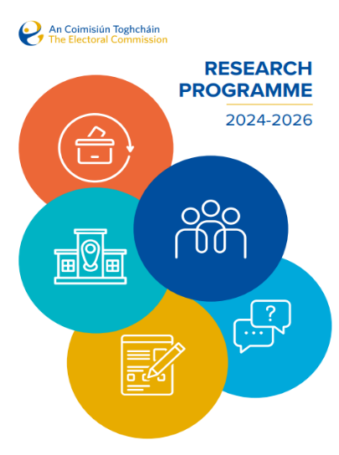
Section 64 of the Electoral Reform Act, 2022 provides that An Coimisiún Toghcháin, the Electoral Commission may commission or conduct research on electoral policy and procedure, including on matters relating to the discharge of its functions under the Act, and may, arising from that research, make such recommendations to the Minister and the Government as it considers appropriate.
An Coimisiún published its inaugural Research Programme 2024-2026 on 10 July 2024, following the publication of a draft research programme and a period of public consultation. The Research Programme was organised according to five thematic strands and a range of priority projects across each strand were identified for commencement between 2024 and 2026. These projects were selected following engagement with An Coimisiún’s Research Advisory Group (RAG), and consideration of submissions received as part of the public consultation process.
As we approach the expiration of this Research Programme, we set out below the progress of An Coimisiún’s research work to date.


Strand A: Longitudinal survey research and data collection

As an early priority, An Coimisiún committed to establishing a National Election and Democracy Study (NEDS) to inform its wider research projects and functions, and to “provide stakeholders, the public, the media and the political system with high quality information about the state of our democracy.’
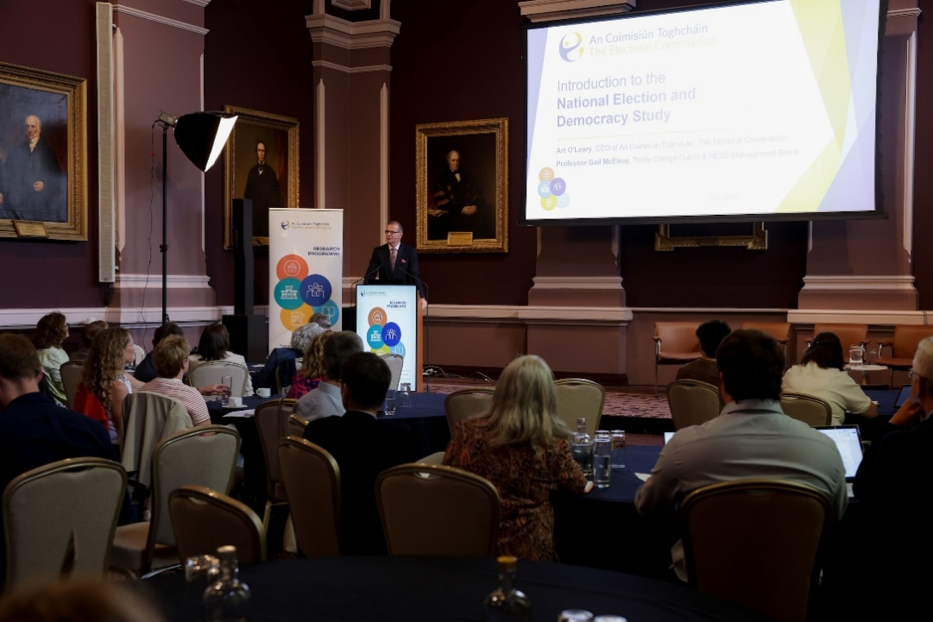
To further this objective, An Coimisiún established a NEDS Management Board (now renamed the NEDS Scientific Board) of six political scientists, including one international expert, to provide guidance regarding the methodology and contents of NEDS surveys. For each survey, An Coimisiún includes a number of questions which are of direct interest and relevance to An Coimisiún in providing information to support it in delivering its functions covering topics like voter experience, voter knowledge and voter engagement. The NEDS Scientific Board selects additional questions informed by existing academic Election Studies. These support the development of quality electoral research for Ireland and bring Ireland into line with data collected for other countries, thereby allowing participation in international and comparative studies. The RAG has also advised on the development and delivery of the NEDS.
In consultation with the NEDS Scientific Board and the Research Advisory Group, An Coimisiún has commissioned NEDS surveys for all national electoral events held since An Coimisiún’s establishment (as well as the 2024 Limerick Mayoral Election):

Summary reports of survey results have been published following the conclusion of each study on a dedicated NEDS website, and all data and codebooks are available on request. NEDS data has been used extensively by academics in Ireland and overseas, second and third level students and their teachers, political actors and the media.


Strand B: Electoral law, electoral systems and electoral infrastructure

An Coimisiún’s Research Team prepared and, on 20 November 2025, published a research report on the issue of candidates’ addresses on the ballot paper after focused stakeholder consultation. An Coimisiún submitted recommendations to the Minister arising from the research.
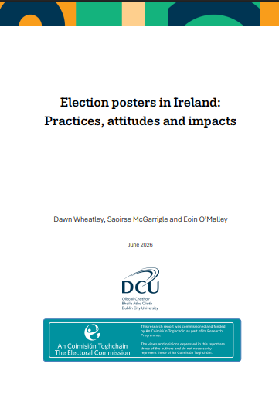
The issue of candidates’ addresses on the ballot paper is one element of the broader topic of ballot paper design. The Research Team has conducted preparatory research on this topic and is scoping a broader research project on the issue.
On 24 June 2026, An Coimisiún published recommendations on election postering alongside an independent research report commissioned from two academic experts entitled ‘Election Posters in Ireland: practices, attitudes and impacts.’ A public consultation process was conducted as part of this research, which attracted 1,104 responses. A summary of the responses received was published alongside the research report and recommendations paper.
An Coimisiún has commissioned the International Institute for Democracy and Electoral Assistance (IDEA) to conduct research on the topics of postal and advance voting. The project seeks to identify and assess the potential merits and drawbacks of possible reforms to Ireland’s postal voting system, and the potential for other forms of advance voting to be introduced. All potential reforms will be carefully considered in the context of safeguarding electoral integrity and the practicalities of implementation.
The project is supported by an Advisory Committee, established by An Coimisiún, comprising experts in election administration, political science, electoral law and disability affairs. The research process included a fact-finding visit by International IDEA to Ireland in June 2026 to engage with stakeholders including our Research Advisory Group & NEDS Board, politicians, election administrators, leading academics and representatives of groups who may be impacted by any electoral reform in this area. Completion of the project is expected in early 2027.
The Review of the Electoral Act, 1997 (as amended) continues to progress. The first phase is complete, and a detailed process of stakeholder consultation is currently underway. One of the core issues that has given rise to debate on the 1997 Act over the past two decades has been the definitions of “political purposes” as contained in section 22(2) (aa) of the 1997 Act (as inserted by section 49 of the Electoral (Amendment) Act, 2001) and how it relates to ‘third parties’. This is being considered as part of the review as well as developments at EU and international levels relating to political party funding, how civil society is regulated, and how funding regimes can be impacted by foreign interference. Any proposed amendments to the current regime will be considered in the context of a keen adherence to constitutional rights, particularly freedom of expression and association, along with An Coimisiún Toghcháin’s role in safeguarding the integrity of elections and the democratic process in Ireland.


Strand C: Integrity of electoral events

Section 68 of the Electoral Reform Act, 2022 provides that ‘the Commission may, after each electoral event… prepare and publish… a report on the administration of the electoral event concerned.’ Reflecting An Coimisiún’s focus on empirical, data driven evaluation, the Research Programme committed that Post Electoral Event Reviews (PEERs) would be conducted for all electoral events in 2024, 2025 and 2026. These were based on field visits by An Coimisiún staff and members to polling stations as well as data collected through the NEDS. As per the provisions of the Act pertaining to PEERs, these reviews place a particular focus on the assistance provided to electors (particularly electors with a disability) by election administrators and must be published within six months of polling day.
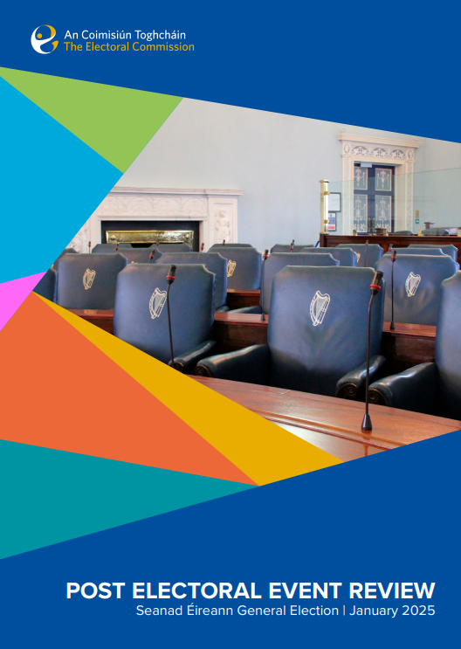
An Coimisiún has now published five PEER reports, covering the 2024 Family and Care Referendums; the 2024 Local, European and Limerick Mayoral Elections; the 2024 General Election; the 2025 Seanad General Election; and the 2025 Presidential Election. A PEER report for the 2026 Galway West and Dublin Central Bye-Elections will be published by 22 November 2026. As part of this process, An Coimisiún has now conducted a total of 427 polling station visits, covering every county and Dáil constituency in the State, including seven offshore islands. An Coimisiún has also collaborated with returning officers to observe other key stages of electoral processes, such as the issuing of postal votes, the conduct of the special vote, the finalisation of panels at Seanad elections, and election counts. The PEER team has also conducted a number of case studies as part of these reports, which involved observer pairs accompanying wheelchair users and voters with Down syndrome as they attend their polling stations, as well as dedicated observations in Gaeltacht areas.
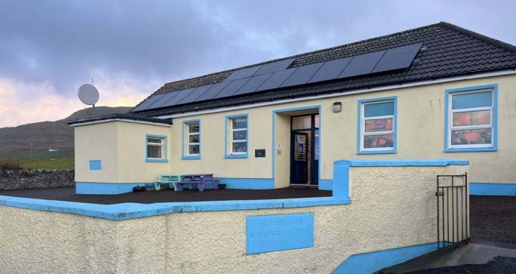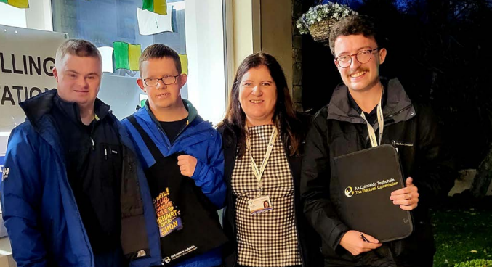
Based on our observations during electoral periods and our continued dialogue with election administrators, An Coimisiún has made a range of recommendations in our PEER reports which are provided to the Minister and to returning officers.


Strand D: Education, public engagement and inclusion

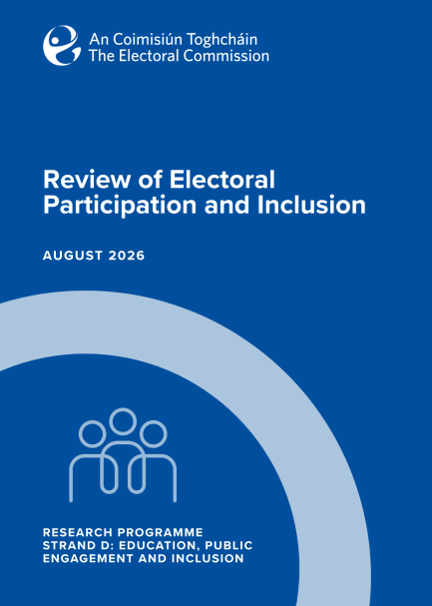
An Coimisiún’s Research Team published a research report on 27 August 2026 identifying and analysing existing data on political participation and inclusion, including for certain demographic or socio-economic groups in Irish society. The report which benefitted significantly from input and advice from our Research Advisory Group helps to develop an evidence-based foundation for additional research projects under Strand D, as well as to inform voter education and engagement work by An Coimisiún and others.
The research report identifies further research priorities (next steps) which will improve this evidence base now and into the future.
Stemming from the findings of this research project, An Coimisiún has commissioned research designed to produce a spatial analysis of turnout at the electoral division level from the 2024 General Election with a view to further understanding how turnout is related to socio-economic and demographic factors. This dataset will enable the study of demographic and socio-economic correlates of turnout.
In light of its research on political participation and inclusion, An Coimisiún has collaborated with Taighde Éireann to fund a Public Service Research Fellowship on youth engagement, as well as funding two research projects under the New Foundations Research Call (designed to understand and design strategies to enable participation among communities found to be less likely to vote).
To deepen our understanding of electoral participation, An Coimisiún has also commissioned research to coincide with the 2026 Galway West and Dublin Central Bye-Elections. Substantial data collection via survey and focus groups have been conducted in both constituencies with a specific focus on non-voters. A research report stemming from the project will be published in early 2027.
We will be conducting further follow up research arising from this paper on political participation and inclusion. Some work has already begun to scope a project on electoral participation by members of the Travelling Community, and we will identify and conduct further projects highlighted through this consultation process.
One of the topics most frequently raised in our public research consultation was that of the voting age. An independent research project commissioned by An Coimisiún Research to examine the topic of “Reducing the Voting Age” is well advanced and expected to be completed by the end of 2026. This empirical project was scoped taking account of the organisation’s referendum information function and thus will not be accompanied by recommendations from An Coimisiún.


Strand E: Blue-sky/curiosity-driven research

An Coimisiún’s Research Programme also included a fifth strand, designed to promote innovative and inclusive research pertaining to An Coimisiún’s research objectives and wider organisational values and goals. An Coimisiún launched its first Research Call entitled “New Directions – Research to support Elections and Democracy in a Changing World” on 27 March 2026. An Coimisiún has granted funding to six research projects (see details in Table 1 below) submitted under this research call.
These will be completed during 2027.
Table 1: Projects granted funding under An Coimisiún’s research call
Project Title | University | Related Strand
COTHROM: Constituency Optimisation Through Hamiltonian Representation of Mandates - Phase II | Trinity College Dublin | B & D
Generative AI as a Political Information Source: Supply, Demand and Misinformation in Irish Elections | University College Dublin & University of Strathclyde | C
Mapping and Modelling Political Agnosticism in Ireland | Queen's University Belfast | D
Mediating Multilingual Democracy (MM-DEM) | University of Limerick | D
Misperceptions of Income Inequality and Voter Participation | Ollscoil na Gaillimhe, University of Galway | D
Reimagining 'Common Culture': Democracy, Inclusion and Civic Participation in a Changing Ireland | University College Dublin | D

Research Collaborations and Research Infrastructure
An Coimisiún is also committed to collaborating with other research bodies, NGOs and stakeholders to deliver high-quality research projects and to promote democratic research in the community. As already mentioned we have partnered with Taighde Éireann to fund projects under the New Foundations Research Call and to fund a Public Sector Research Fellowship.
In partnership with the Central Statistics Office, An Coimisiún developed questions related to elections for the Trust Survey 2025. Findings from the survey were published by the CSO on 29 June 2026. Building on this experience we are in contact with the CSO, ESRI and other bodies regarding the potential for inclusion of questions in other surveys including related to some of the groups highlighted in our political participation paper recently published.
In early 2024, An Coimisiún established an expert Research Advisory Group (RAG) to offer guidance regarding the direction and contents of our research, and to support us in the delivery of key research projects. The RAG was chaired over this period by Professor Caroline Fennell and comprises twelve other members, including representatives of potentially under-reached groups in society and experts in fields such as political science, law and sociology, as well as an international member.
The RAG has been invaluable in advising and supporting the development and delivery of the Research Programme and it is intended that the RAG will continue under the next Research Programme.
In consultation with the RAG, An Coimisiún developed a Research Integrity and Ethics Policy, which outlines the key principles and objectives that underpin all stages of the research process. It also includes provisions regarding the use of Artificial Intelligence in our research. All research projects conducted or commissioned by An Coimisiún adhere to this policy, which is guided by our organisational vision and values.
An Coimisiún has created and developed a dedicated research section on its website, with pages dedicated to An Coimisiún’s research publications, research call and research opportunities. There is also a dedicated page featuring details of the NEDS, to complement the standalone NEDS website. The first phase of the NEDS website was launched by An Coimisiún in 2026, with plans for the site to be significantly expanded in the future with features such as interactive dashboards which will be available to the public.
We are happy to answer any queries or take feedback on our progress to date.

